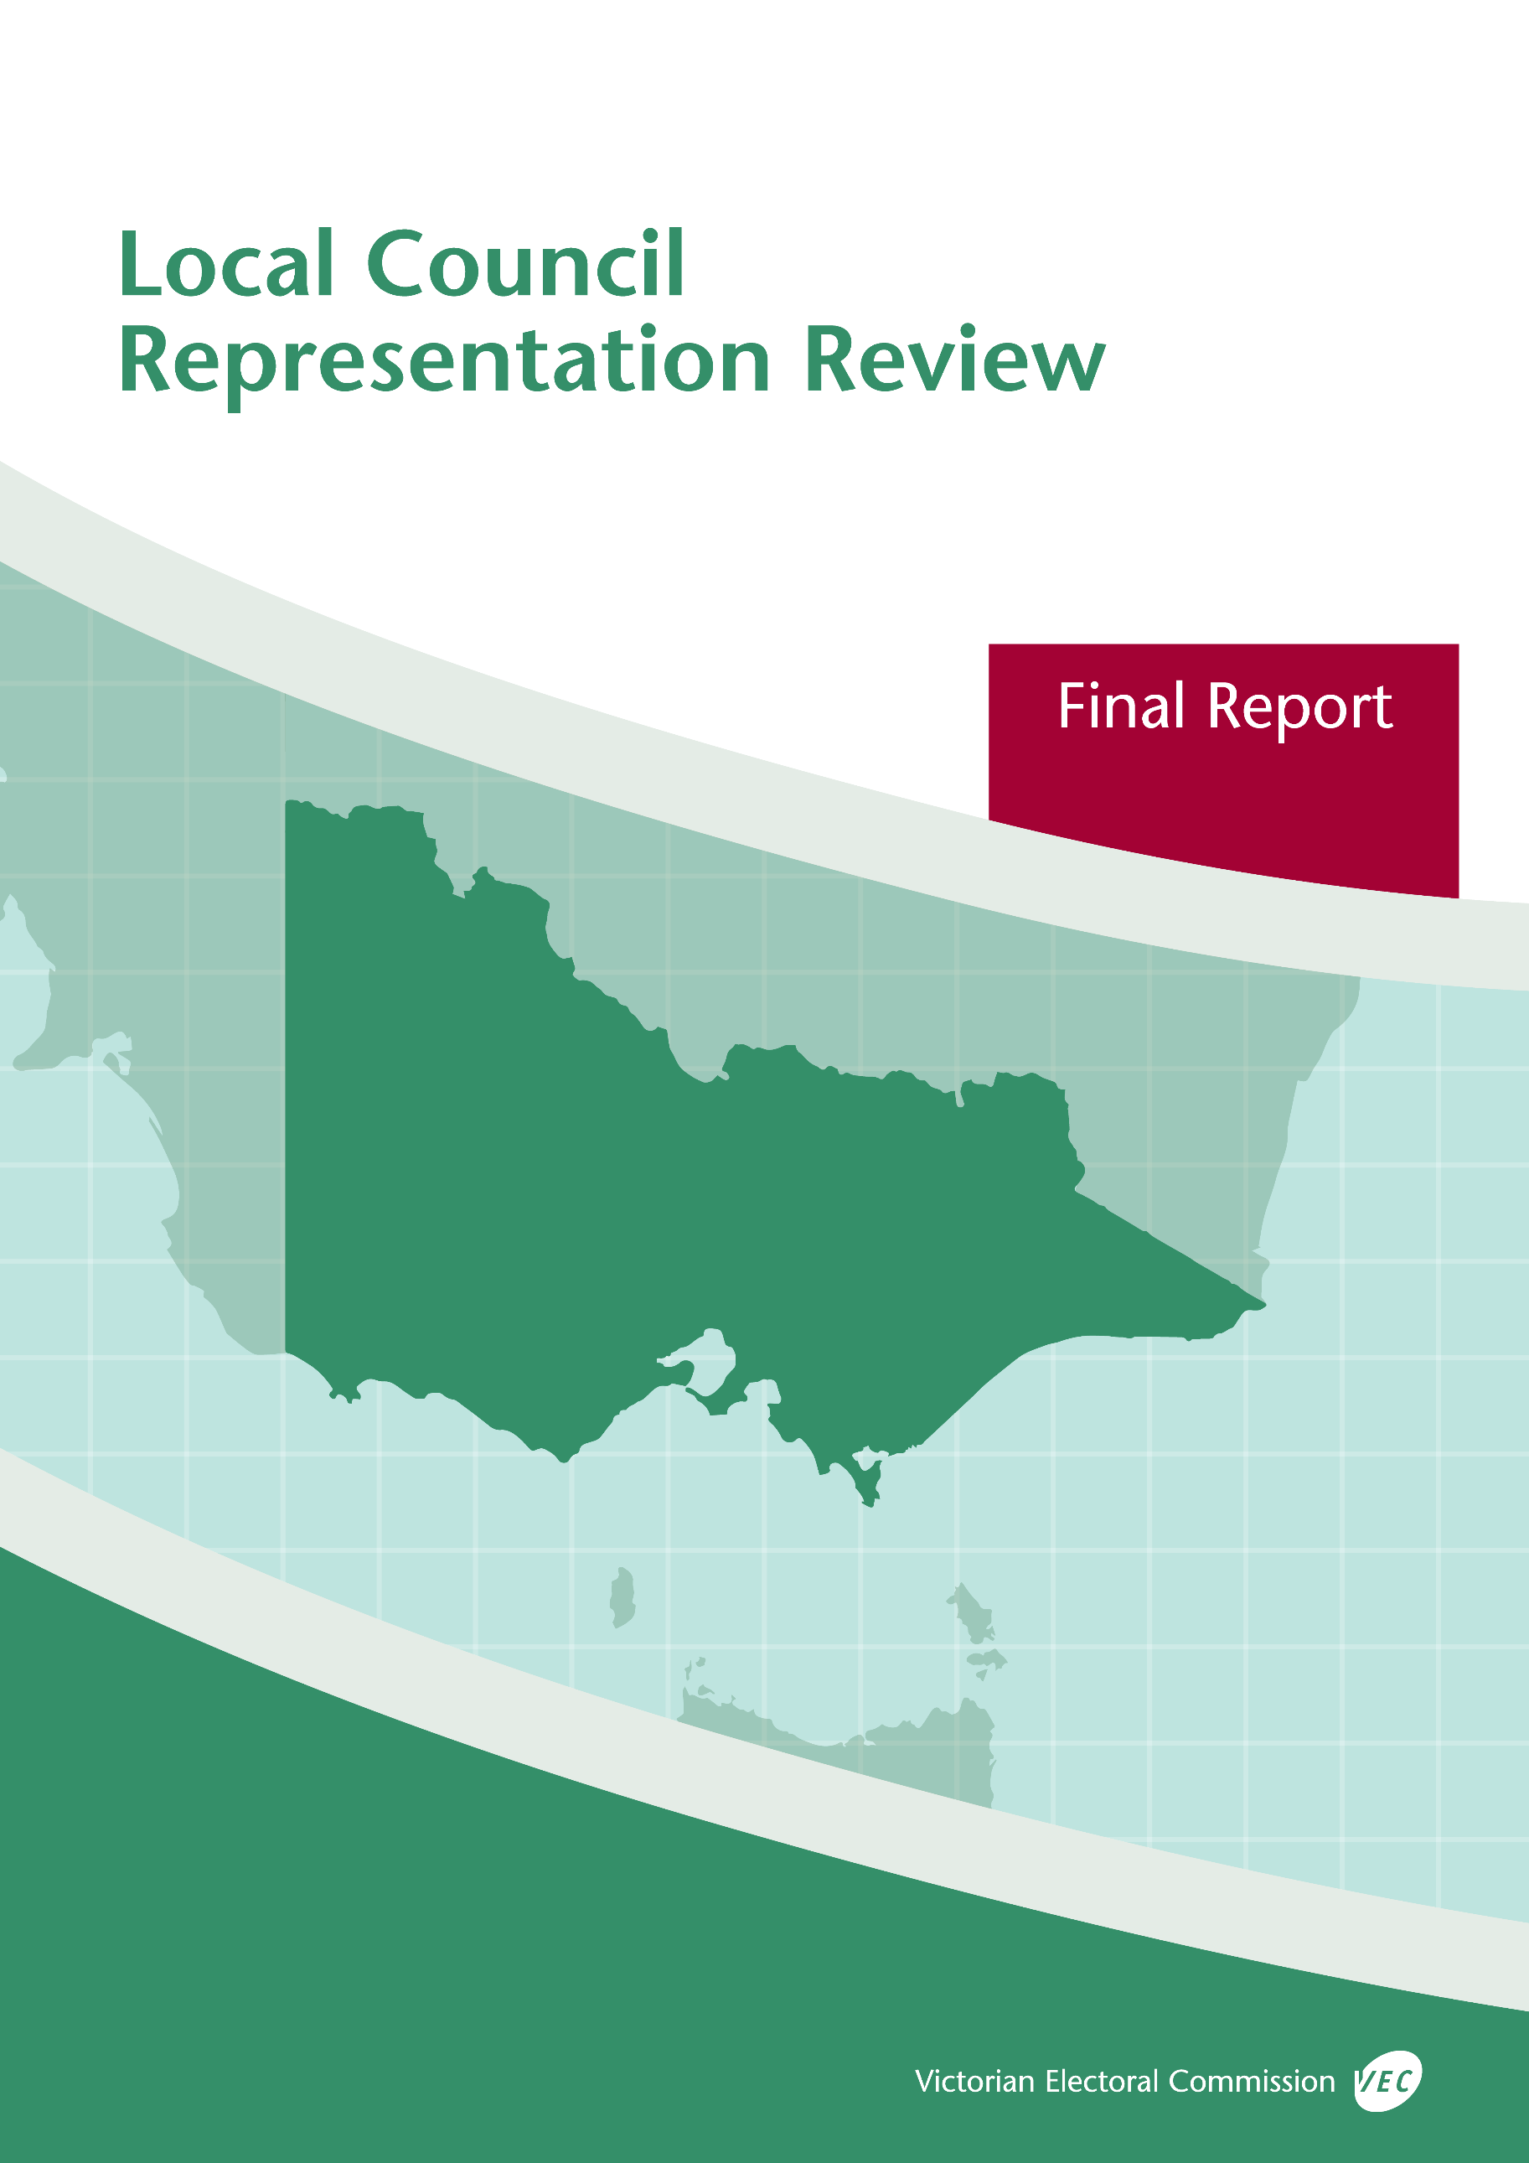



**Benalla Rural City Council**

**May 2019**

© State of Victoria (Victorian Electoral Commission)   
29 May 2019

Version 1  
  
cid:image001.png@01D4D431.F774F3F0

This work, Local Council Representation Review Final Report – Benalla Rural City Council, is licensed under a Creative Commons Attribution 4.0 licence [<http://creativecommons.org/licenses/by/4.0/>]. You are free to share this work under that licence, on the condition that you do not change any content and you credit the State of Victoria (Victorian Electoral Commission) as author and comply with the other licence terms. The licence does not apply to any branding, including Government logos.

Contents

Recommendation 2

Executive summary 3

Legislative basis 5

Public engagement 5

The VEC’s principles 6

Developing recommendations 7

Benalla Rural City Council representation review 9

Profile of Benalla Rural City Council 9

Current electoral structure 10

Preliminary submissions 10

Preliminary report 11

Public response 14

Response submissions 14

Public hearing 15

Findings and recommendation 16

The VEC’s findings 16

The VEC’s recommendation 17

Appendix 1: Public involvement 18

Appendix 2: Map 19

Appendix 3: Public information program 21

Recommendation

The Victorian Electoral Commission recommends that Benalla Rural City Council continue to consist of seven councillors elected from an unsubdivided electoral structure.

This recommendation is submitted to the Minister for Local Government as required by the *Local Government Act 1989*.

Please see Appendix 2 for a map of this recommended structure.

Executive summary

The *Local Government Act 1989* (the Act) requires the Victorian Electoral Commission (VEC) to conduct an electoral representation review of each municipality in Victoria before every third council general election.

The purpose of an electoral representation review is to recommend an electoral structure that provides fair and equitable representation for people who are entitled to vote at a general election of the council. The matters considered by a review are:

* the number of councillors
* the electoral structure of the council (whether the council should be unsubdivided or divided into wards and, if subdivided, the details of the ward boundaries and the number of councillors per ward).

The VEC conducts all reviews based on three main principles:

1. taking a consistent, State-wide approach to the total number of councillors
2. if subdivided, ensuring the number of voters represented by each councillor is within   
   plus-or-minus 10% of the average number of voters per councillor for that local   
   council
3. ensuring communities of interest are as fairly represented as possible.

Current electoral structure

Benalla Rural City Council currently comprises seven councillors elected from an unsubdivided electoral structure. Prior to the last representation review in 2007, Benalla Rural City Council consisted of seven councillors elected from seven single-councillor wards.

Visit the VEC website at [vec.vic.gov.au](http://www.vec.vic.gov.au/) to access a copy of the 2007 review final report.

Preliminary submissions

Preliminary submissions opened at the commencement of the current review on Wednesday   
6 February 2019. The VEC received four submissions for the representation review of Benalla Rural City Council by the deadline at 5.00 pm on Wednesday 6 March 2019.

Preliminary report

A preliminary report was released on Wednesday 3 April 2019 with the following option for consideration:

* Option A (preferred option)  
  **Benalla Rural City Council consist of seven councillors elected from an unsubdivided electoral structure.**

The VEC modelled possible alternative options, but none progressed as viable alternative options for further consultation through the preliminary report.

Response submissions

The VEC received two submissions responding to the preliminary report by the deadline at   
5.00 pm on Wednesday 1 May 2019.

Public hearing

The VEC scheduled a public hearing for those wishing to speak about their response submission at 6.00 pm on Tuesday 7 May 2019. There were no requests to speak so the hearing was not held.

Recommendation

**The Victorian Electoral Commission recommends that Benalla Rural City Council continue to consist of seven councillors elected from an unsubdivided electoral structure.**

This electoral structure was designated as the preferred option in the preliminary report. Please see Appendix 2 for a map of this recommended structure.

Background

Legislative basis

The Act requires the VEC to conduct a representation review of each local council in Victoria before every third general council election, or earlier if gazetted by the Minister for Local Government.

The Act states that the purpose of a representation review is to recommend the number of councillors and the electoral structure that provides ‘fair and equitable representation for people who are entitled to vote at a general election of the Council.’[1]

The Act requires the VEC to consider:

* the number of councillors in a local council
* whether a local council should be unsubdivided or subdivided.

If a local council is subdivided, the VEC must ensure that the number of voters represented by each councillor is within plus-or-minus 10% of the average number of voters per councillor for that local council.[2] On this basis, the review must consider the:

* number of wards
* ward boundaries
* number of councillors that should be elected for each ward.

Public engagement

### Public information program

The VEC conducted a public information program to inform the community of the representation review, including:

* public notices printed in local and state-wide papers
* a public information session to outline the review process and respond to questions from the community
* a media release announcing the commencement of the review and the release of the preliminary report
* a submission guide to explain the review process and provide background information on the scope of the review
* an information email campaign targeted at known community groups and communities of interest in the local council area
* sponsored social media advertising geo-targeted to users within the local council   
  area
* ongoing information updates and publication of submissions on the VEC website.

More information on the VEC’s public information program for the representation review of Benalla Rural City Council can be found at Appendix 3.

### Public consultation

Public input was accepted by the VEC via:

* preliminary submissions at the start of the review
* response submissions to the preliminary report.

Public submissions are an important part of the review process but are not the only consideration. The VEC ensures its recommendations comply with the Act and are formed through careful consideration of public submissions, independent research, and analysis of all relevant factors.

The VEC’s principles

Three main principles underlie all the VEC’s work on representation reviews:

1. **Taking a consistent, State-wide approach to the total number of councillors.**

The VEC is guided by its comparisons of local councils of a similar size and category to the council under review. The VEC also considers any special circumstances that may warrant the local council having more or fewer councillors than similar local councils.

1. **If subdivided, ensuring the number of voters represented by each councillor is within plus-or-minus 10% of the average number of voters per councillor for that local council.**

This is the principle of ‘one vote, one value’, which is enshrined in the Act. This means that every person’s vote counts equally.

1. **Ensuring communities of interest are as fairly represented as possible.**

Each local council contains a number of communities of interest. Where practicable, the electoral structure should be designed to ensure they are fairly represented, and that geographic communities of interest are not split by ward boundaries. This allows elected councillors to be more effective representatives of the people and interests in their particular local council or ward.

Developing recommendations

The VEC bases its recommendations for particular electoral structures on the following information:

* internal research specifically relating to the local council under review, including data from the Australian Bureau of Statistics and .id[3]; voter statistics from the Victorian electoral roll; and other State and local government data sets
* the VEC’s experience conducting previous electoral representation reviews of local councils and similar reviews for State elections
* the VEC’s expertise in mapping, demography and local government
* careful consideration of all input from the public in written submissions received during the review
* advice from consultants with extensive experience in local government.

### Deciding on the number of councillors

The Act allows for a local council to have between five and 12 councillors but does not specify how to decide the appropriate number.[4] In considering the number of councillors for a local council, the VEC is guided by the Victorian Parliament’s intention for fairness and equity in the local representation of voters under the Act.

The starting point in deciding the appropriate number of councillors for a local council is comparing the local council under review to other local councils of a similar size and type (Principle 1). Generally, local councils that have a larger number of voters will have a higher number of councillors. Often large populations are more likely to be diverse, both in the nature and number of their communities of interest and the issues of representation.

However, the VEC also considers the particular circumstances of each local council which could justify fewer or more councillors, such as:

* the nature and complexity of services provided by the Council
* geographic size and topography
* population growth or decline
* the social diversity of the local council.

### Deciding the electoral structure

The Act allows for a local council ward structure to be unsubdivided—with all councillors elected ‘at-large’ by all voters—or subdivided into a number of wards.

If the local council is to be subdivided into wards, there are three options available:

1. single-councillor wards
2. multi-councillor wards
3. a combination of single-councillor and multi-councillor wards.

A subdivided electoral structure must have internal ward boundaries that provide for a fair and equitable division of the local council.

The Act allows for wards with different numbers of councillors, as long as the number of voters represented by each councillor is within plus-or-minus 10% of the average number of voters per councillor for that local council (Principle 2). For example, a local council may have one   
three-councillor ward with 15,000 voters and two single-councillor wards each with 5,000 voters. In this case, the average number of voters per councillor would be 5,000.

Over time, population changes can lead to some wards in subdivided local councils having larger or smaller numbers of voters. As part of the review, the VEC corrects any imbalances and considers likely population changes to ensure ward boundaries provide equitable representation for as long as possible.

In considering which electoral structure is most appropriate, the VEC considers the following matters:

* the VEC’s recommendation at the previous representation review and the reasons for that recommendation
* the longevity of the structure, with the aim of keeping voter numbers per councillor within the 10% tolerance for as long as possible (Principle 2)
* communities of interest, consisting of people who share a range of common concerns, such as geographic, economic or cultural associations (Principle 3)
* the number of candidates in previous elections, as large numbers of candidates can lead to an increase in the number of informal (invalid) votes
* geographic factors, such as size and topography
* clear ward boundaries.

Benalla Rural City Council representation review

Profile of Benalla Rural City Council

The Rural City of Benalla is located in Victoria’s north-eastern region, approximately 180 kilometres from Melbourne. Benalla Rural City covers an area of 2,375 square kilometres and is home to 13,861 people, the majority of whom reside in the urban centre of Benalla.

Benalla Rural City is predominantly rural with a diverse local economy including manufacturing, community services, retail and agriculture (dairying, cropping, meat and wool production). The Hume Highway is considered a dividing line between cropping areas in the north-west of the local council and grazing areas in the south-east. Natural features include Lake Benalla, Mount Meg Nature Conservation Reserve, Mount Samaria State Park, Reef Hills State Park, part of Warby-Ovens National Park, and the Winton Wetlands.

The local council has one main urban centre of Benalla (population 10,330) and a substantial rural population. Rural localities include Baddaginnie, Devenish, Goorambat, Molyullah, Swanpool, Tatong, Warrenbayne and Winton.

The median age of residents in Benalla Rural City is 49 years,[5] which is higher than the median for regional Victoria (42 years). The largest age group is people aged 45–64 years (29.3%). Compared to the averages for regional Victoria,[6] younger residents (below 44 years) comprise a smaller percentage of Benalla Rural City’s population, while residents aged 45 and above comprise a larger percentage.

Approximately 83% of people in the local council were born in Australia. Common birthplaces for those born overseas include England (2.3%), Germany (0.7%), New Zealand (0.7%), Netherlands (0.5%) and India (0.4%). At the 2016 Census, the top five ancestries of residents were: Australian, English, Irish, Scottish and German. About 3% of the population speak a language other than English, which is lower than the average of 6% for regional Victoria.[7]

The recognised traditional owners of the land are the Taungurung People and the Yorta Yorta People.[8] Aboriginal and Torres Strait Islander peoples comprise 1.6% of the population of Benalla Rural City, which is equal to the regional Victorian average.[9]

The unemployment rate for Benalla Rural City is 5.3%, which is lower than the average for rural and regional Victoria (6%). The five main employment industries are health care and social assistance (14.3% of the workforce), agriculture, forestry and fishing (9.8% of the workforce), retail trade (9%), manufacturing (8.8%), and construction (8.4%).[10]

The median weekly personal income for employed people aged 15 years and over is $537, which is slightly lower than the median for regional Victoria ($576). Households in Benalla Rural City have a median weekly income of $946, which is less than the median weekly income for households across regional Victoria at $1,124.[11]

The population number has remained steady in Benalla Rural City, with a slight increase since the 2011 Census (13,647)[12] compared to the current estimate (13,861 in the 2016 Census). The population is not expected to change significantly between now and 2031.[13]

Current electoral structure

Benalla Rural City Council currently comprises seven councillors elected from an unsubdivided electoral structure. Prior to the last representation review in 2007, Benalla Rural City Council consisted of seven councillors elected from seven single-councillor wards.

Visit the VEC website at [vec.vic.gov.au](http://www.vec.vic.gov.au/) to access a copy of the 2007 review final report.

Preliminary submissions

At the close of submissions on Wednesday 6 March 2019, the VEC had received four submissions for the representation review of Benalla Rural City Council. A list of people who made a preliminary submission can be found in Appendix 1.

Submissions were received from three individuals from the Benalla community and one organisation based outside of the local council area. The submissions were made available on the VEC website.

### Number of councillors

Three preliminary submissions supported leaving the number of councillors at seven for Benalla Rural City Council. These submissions reasoned that seven councillors is consistent with other Regional Centre local councils with a similar size and number of voters, and that there were no special circumstances within Benalla Rural City Council that would justify an increased number of councillors. Of these three submissions, one also supported reducing the number of councillors to five if there was strong justification and community support for such a change.

The fourth preliminary submission did not clearly indicate a preferred number of councillors.

There were no calls for increasing the number of councillors in any of the preliminary submissions.

### Electoral structure

Three preliminary submissions supported keeping the current unsubdivided electoral structure in Benalla Rural City Council. The fourth preliminary submission did not clearly indicate a preferred electoral structure.

A move to a subdivided electoral structure for Benalla Rural City Council was not supported by any preliminary submissions.

Submissions that supported the current unsubdivided electoral structure argued that this structure was an improvement on the subdivided electoral structure previously in place in Benalla Rural City Council. Submitters felt that the unsubdivided electoral structure encouraged councillors to take a ‘whole-of-shire’ approach to representation, and that this had resulted in fairer representation and improved strategic development and planning for the entire local council area. It was also argued that elections in unsubdivided local councils use the proportional representation system, which was considered by the submitter to be the fairest system because it maximises the number of effective votes. Other arguments in favour of the unsubdivided electoral structure were that it provides voters with the greatest choice of candidates, encourages councillors to be informed about the entire local council area, supports representation for non-geographic communities of interest, removes confusion about the location of ward boundaries and removes the need to make periodic re-adjustments to ward boundaries to cater for changes in enrolment numbers.

Preliminary report

A preliminary report was released on Wednesday 3 April 2019. The VEC considered public submissions and research findings when formulating the options presented in the preliminary report.

### Number of councillors

When considering the appropriate number of councillors for a local council, the VEC reviews population data and assesses other factors which may warrant an increase or decrease in the number of councillors, such as projected population growth or special circumstances relating to distinct communities of interest.

Compared to other local councils of similar size and number of voters, Benalla Rural City Council has the second smallest voter population of all Regional Centre local councils and sits well within the seven-councillor range. Benalla Rural City Council has a stable population and is not expected to experience significant population growth or decline over the mid- to long-term.[14] The population within the local council is largely socially and linguistically homogenous, and rural areas have below average levels of disadvantage compared to other local councils in regional Victoria[15]. On the other hand, the population is ageing[16] and the Benalla urban area is experiencing higher than average levels of disadvantage[17], but these factors alone are not sufficient to require an increased number of councillors. The VEC therefore recommended no change be made to the current number of seven councillors.

### Electoral structure

In its preliminary report, the VEC observed that Benalla Rural City Council had a higher level of informal voting at the 2016 general election (7.56%) compared to previous general elections in 2008 (2.92%) and 2012 (3.80%). There were also 20 candidates at the 2016 election, which was a significant increase compared to the 2008 election (14 candidates) and 2012 election (nine candidates). The 2016 election was the first time a high level of informal voting has been observed for this local council. While this is not an ongoing pattern, the VEC explored both unsubdivided and subdivided electoral structures for Benalla Rural City Council to ascertain whether a subdivided electoral structure may provide some benefit by reducing the possibility of a high informal vote rate recurring at a future election. However, the VEC found the uneven distribution of voters across the local council area, including a significant population concentration in the Benalla urban area, to be a major limitation for developing satisfactory subdivided electoral structures for the local council.

The VEC considered subdivided structures based purely on single-councillor wards but found that this arrangement would be inappropriate for Benalla Rural City Council. A single-councillor ward structure would require the Benalla urban area to be divided into wards, splitting the Benalla community of interest. Single-councillor wards would also pose challenges for widespread and non-geographic communities of interest to be represented in the local council. This model also brought a risk of uncontested elections, which was a problem under the previous seven single-councillor ward structure that was in place prior to the 2007 review. A risk of uncontested or failed elections would be particularly strong for any ward in the rural north of the local council, as there was only one candidate that stood from this area at the 2008 general election, and no candidates at all from this area in 2012 or 2016. Single-councillor wards would also limit the number of councillors that could be elected from rural areas.

The VEC also considered a three-ward electoral structure, consisting of a five-councillor ward for the Benalla urban area and its immediate surrounds, and two single-councillor wards for the remaining areas north and south of the Hume Freeway. This model was based on the first alternative option from the VEC’s last representation review of Benalla Rural City Council in 2007, with modified ward boundaries. This model aimed to provide representation for the three distinct regions of the local council. However, due to the uneven distribution of the population, these regions could not be cleanly represented by this model. As for the single-councillor ward model, this three-ward model also brought a risk of uncontested elections for the single-councillor wards (especially for a rural north ward) and would limit the number of councillors that could be elected to represent those rural areas. There was little public support expressed for this option during the 2007 representation review, and no support expressed in preliminary submissions for the current review.

After investigating and modelling possible alternatives, the VEC considered that the current unsubdivided electoral structure continued to be the best option for providing fair and equitable representation for voters within Benalla Rural City Council. The VEC considered the current electoral structure to have many benefits, such as supporting a Shire-wide approach to representation and community identity, providing voters with the widest choice of candidates, allowing multiple councillors to be elected from any area of the local council, reducing the risk of uncontested elections, and providing geographic and non-geographic communities of interest the opportunity for representation on local council.

### Options

After careful consideration, the VEC put forward the following option:

* Option A (preferred option)  
  **Benalla Rural City Council consist of seven councillors elected from an unsubdivided electoral structure.**

The VEC modelled possible alternative options, but none progressed as viable alternative options for further consultation through the preliminary report.

Public response

Response submissions

The VEC accepted submissions responding to the preliminary report from Wednesday 3 April 2019 until 5.00 pm on Wednesday 1 May 2019. The VEC received two response submissions, both in support of the preferred option. The submitters were both from outside the local council area. A list of people who made a response submission can be found in Appendix 1.

Both submissions dealt with the inherent strengths of an unsubdivided structure rather than the particular circumstances of Benalla Rural City.

Chris Curtis stated that Option A was fair and equitable for the voters in Benalla Rural City, and fully agreed with the benefits of continuing with the current unsubdivided electoral structure outlined in the preliminary report. Mr Curtis argued that Option A gives the greatest number of voters a vote that counts, and in contrast to wards, would not allow a minority group to gain a majority of positions, and would not discriminate against any voters in the local council. Mr Curtis argued that an unsubdivided structure provides voters the greatest freedom when voting, as they are able to use their vote to support any issue or community of their choice. It was also argued that, in contrast to wards, voters are not forced to act as a geographic community of interest under an unsubdivided electoral structure, though if voters do wish to vote for local candidates they can still do so. Mr Curtis reasoned that, if voters do not vote for someone from their geographic community, this simply indicates that their geographic community of interest is not as important to them as other issues. Mr Curtis also supported the number of councillors remaining an uneven number, arguing that this avoids issues relating to tied votes on council decisions.

The Proportional Representation Society of Australia (Victorian-Tasmania) Inc. (PRSA) argued that Option A provides a high-quality electoral system for Benalla Rural City, as a high percentage of voters would continue to be represented by a person that they voted for, and the council would continue to be representative of voters’ wishes. The PRSA supported the number of councillors remaining at seven and argued that an unsubdivided electoral structure is the only structure that allows proportional representation to be applied in an even-handed manner when there are seven-councillors. The PRSA also provided similar arguments to those seen in preliminary submissions, arguing that an unsubdivided electoral structure maximises the choice of candidates for voters, encourages councillors to be equally informed about the entire local council area, and facilitates representation for non-geographic communities of interest. The PRSA also argued that an unsubdivided structure is less confusing for voters as there are no ward boundaries, and there is no need to make periodic re-adjustments to ward boundaries to cater for changes in enrolment numbers.

Public hearing

The VEC scheduled a public hearing for those wishing to speak about their response submission at 6.00 pm on Tuesday 7 May 2019 at the Community Care Centre, Coster Street, Benalla. There were no requests to speak so the hearing was not held.

Findings and recommendation

The VEC’s findings

Compared to other local councils of similar size and number of voters, Benalla Rural City Council sits well within the seven-councillor range. The local council also has a stable population and is not expected to experience significant population growth or decline. While Benalla Rural City Council has its own characteristics and challenges, the VEC’s analysis and information provided in submissions did not identify any special circumstances that would support a recommendation to change the number of councillors.

The VEC considers there to be one concern with the current unsubdivided electoral structure: an increased level of informal voting seen at the 2016 general election. In 2016, 7.56% of votes were informal, compared to 3.80% for 2012 and 2.92% for 2008. While it is not certain what caused this significant increase in informal votes in 2016, the VEC has generally observed informal voting rates tend to increase as more candidates are listed on the ballot paper[18]. This is one of the drawbacks of an unsubdivided electoral structure, which can encourage larger fields of candidates at elections and lengthier ballot papers. Longer ballot papers can be confusing for voters, leading to higher levels of informal voting through voter error. Although this is certainly a potential drawback of the unsubdivided model, the VEC also observed that the longer-term pattern has been for fairly moderate numbers of candidates at Benalla Rural City Council elections compared with the significant increase in the number of candidates observed at the last election in 2016. On balance, the VEC considers that there is not yet a substantial ongoing risk of high informal voting for this local council under the unsubdivided electoral structure.

There has been no indication during this review that voters within Benalla Rural City wish for a change to the electoral structure, and likewise no call for change from the Benalla Rural City Council. Although few submissions were received during the current review, all public submissions that addressed topics within the scope of the review supported the current unsubdivided electoral structure and the current number of councillors.

Overall, the VEC has found that the general arguments in support of an unsubdivided electoral structure outlined in the 2007 representation review still apply for Benalla Rural City Council, and there have been no significant changes within the local council since 2007 that would alter the findings of this review. The VEC therefore considers that the preferred option continues to be the best option for providing fair and equitable representation for all voters within Benalla Rural City Council.

The VEC’s recommendation

**The Victorian Electoral Commission recommends that Benalla Rural City Council continue to consist of seven councillors elected from an unsubdivided electoral structure.**

This recommendation is submitted to the Minister for Local Government as required by the *Local Government Act 1989*. The model was designated as the preferred option in the VEC’s preliminary report for this review. Please see Appendix 2 for a map of this recommended structure.

# Appendix 1: Public involvement

Preliminary submissions

Preliminary submissions were received from:

Connors, Margaret

Marshall, Heidi

Mullett, Wendy

Proportional Representation Society of Australia (Victoria-Tasmania) Inc.

Response submissions

Response submissions were received from:

Curtis, Chris

Proportional Representation Society of Australia (Victoria-Tasmania) Inc.

# Appendix 2: Map

The map is provided on the next page.

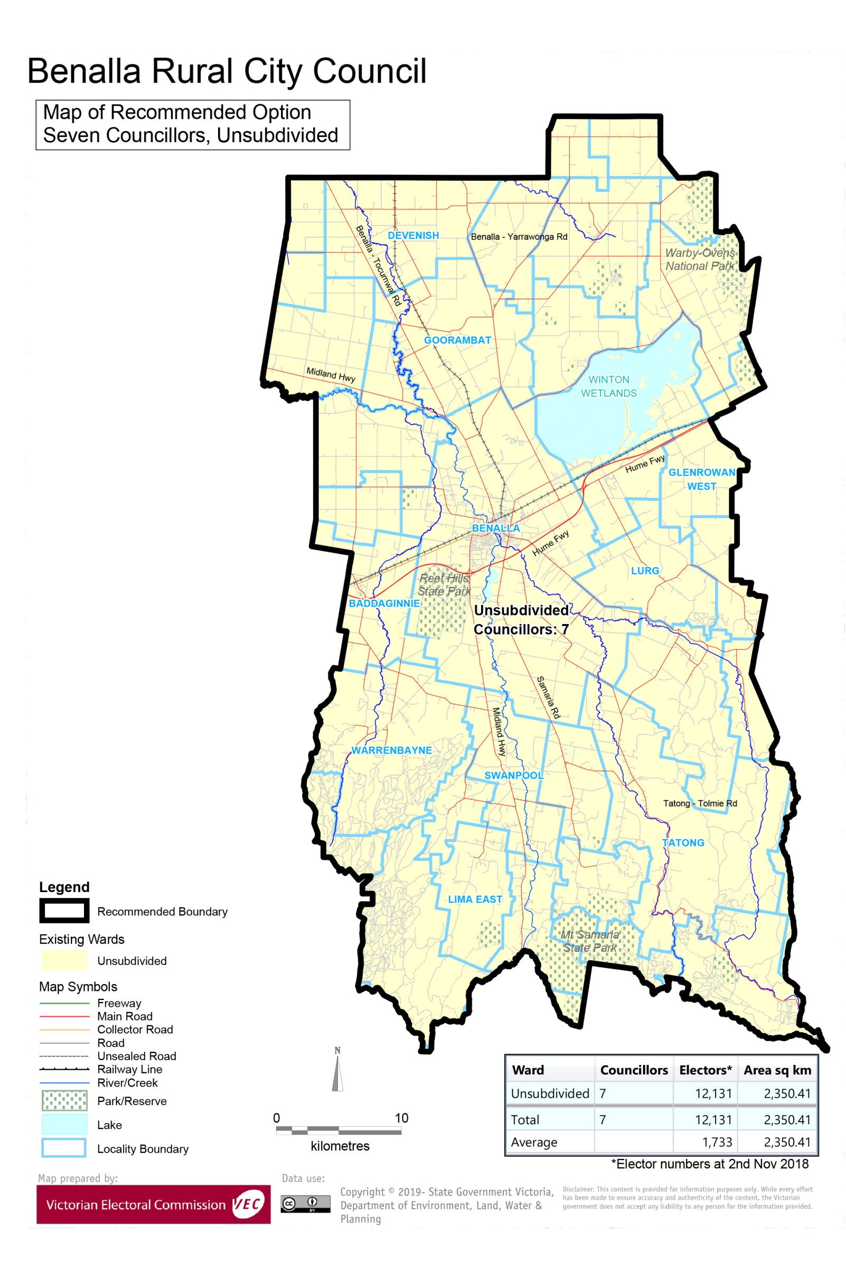

# Appendix 3: Public information program

Advertising

In accordance with the Act, public notices of the review and the release of the preliminary report were placed in the following newspapers:

|  |  |  |
| --- | --- | --- |
| **Newspaper** | **Notice of review** | **Notice of preliminary report** |
| *Herald Sun* | Thursday 17 January | Wednesday 20 March |
| *Benalla Ensign* | Wednesday 30 January | Wednesday 3 April |
|  |  |  |

Media releases

A media release was prepared and distributed to local media to promote the commencement of the review on Wednesday 6 February 2019. A further release was distributed with the publication of the preliminary report on Wednesday 3 April 2019. A final media advisory was circulated on the publication date of this final report.

Submission guide

A submission guide was developed and made available on the VEC website, or in hardcopy on request, throughout the review timeline. The submission guide provided information about the review, the review timeline and how to make submissions to the review.

Online submission tool

An online submission tool was developed and made available during the submission periods of the review. The tool allowed people to make a submission from the VEC website. During the preliminary submission stage, users also had the opportunity to map out their preferred subdivisions through the online submission tool using Boundary Builder. Boundary Builder included real elector numbers so that users could see if their preferred structures and numbers of councillors met the plus-or-minus 10% rule.

VEC website

The VEC website delivered up-to-date information to provide transparency and facilitate public participation during the review process. All public submissions were published on the website.

Email and social media engagement

The VEC delivered an information email campaign targeted at known community groups and communities of interest in the local council area. This included a reminder email at each milestone of the representation review process.

The VEC also published sponsored social media advertising that was geo-targeted to users within the local council area. This included advertising at both the preliminary submission and response submission stages. The total reach of these posts was 3,698 during the preliminary submission stage and 3,040 during the response submission stage.

Council communication resources

The VEC provided the Council with a communication pack that included information on the review in various formats. While the council is encouraged to distribute this information and raise awareness about the review, the VEC is an independent reviewer and all communications resources include reference and links to the VEC website and core materials.

This page has been left intentionally blank

This page has been left intentionally blank

This page has been left intentionally blank



1. Section 219D of the *Local Government Act* *1989.*
2. ibid.
3. .id is a consulting company specialising in population and demographic analysis and prediction information products in most jurisdictions in Australia and New Zealand.
4. Section 5B(1) of the *Local Government Act 1989.*
5. Australian Bureau of Statistics, ‘2016 Census QuickStats – Benalla (RC)’, <https://quickstats.censusdata.abs.gov.au/census_services/getproduct/census/2016/quickstat/LGA21010?opendocument>, accessed 14 May 2019.
6. Australian Bureau of Statistics, ‘2016 Census QuickStats – Rest of Vic.’, <https://quickstats.censusdata.abs.gov.au/census_services/getproduct/census/2016/quickstat/2RVIC?opendocument>, accessed 14 May 2019.
7. Australian Bureau of Statistics, ‘2016 Census QuickStats – Benalla (RC)’, loc. cit.
8. Aboriginal Victoria, ‘Welcome to Country and Acknowledgements Map’, <https://achris.vic.gov.au/weave/wca.html>, accessed 14 May 2019.
9. Australian Bureau of Statistics, ‘2016 Census QuickStats – Benalla (RC)’, loc. cit.
10. ibid.
11. ibid.
12. Australian Bureau of Statistics, ‘2011 Census QuickStats: Benalla (RC)’, <http://quickstats.censusdata.abs.gov.au/census_services/getproduct/census/2011/quickstat/LGA21010?opendocument&navpos=220>, accessed 14 May 2019.
13. Department of Environment, Land, Water and Planning, ‘Victoria in Future 2016: Benalla Rural City’, <https://www.planning.vic.gov.au/__data/assets/pdf_file/0030/97608/Victoria-in-Future-2016-FINAL-web.pdf>, accessed 14 May 2019.
14. Department of Environment, Land, Water and Planning, ‘Victoria in Future 2016’, <https://www.planning.vic.gov.au/__data/assets/pdf_file/0030/97608/Victoria-in-Future-2016-FINAL-web.pdf>, accessed 14 May 2019.
15. .id, ‘Benalla Rural City: SEIFA by profile area’, <https://profile.id.com.au/benalla/seifa-disadvantage-small-area>, accessed 20 March 2019.
16. Department of Environment, Land, Water and Planning, loc. cit..
17. .id, loc. cit..
18. Victorian Electoral Commission, *2016 Local Government Elections Report*, 2017, Figure 9, pp. 26, <https://www.vec.vic.gov.au/files/Report%20on%20the%20conduct%20of%20the%202016%20Local%20Government%20Elections.pdf>