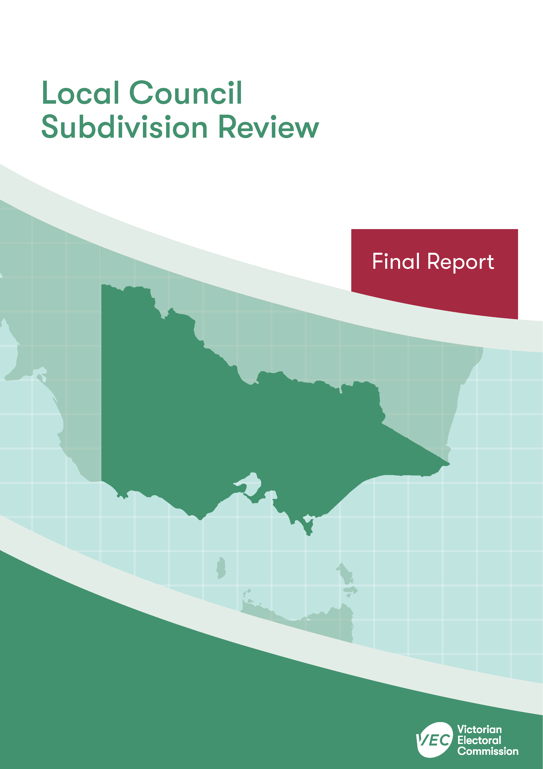



**April 2020**

**Monash City Council**

Contents

Recommendation 1

Executive summary 2

Background 4

Legislative basis 4

The VEC’s approach 5

Profile of Monash City Council 7

Population trends 8

Current number of councillors and electoral structure 9

Current subdivision review 10

Preliminary report 10

Public response 12

Response submissions 12

Public hearing 13

Findings and recommendation 15

The VEC’s findings 15

The VEC’s recommendation 18

Appendix 1: Public involvement 19

Appendix 2: Recommended ward boundaries map 20

Appendix 3: Public information program 22

Recommendation

The Victorian Electoral Commission recommends adjustments to the boundaries of the following wards within Monash City Council:

* Glen Waverley Ward
* Mount Waverley Ward
* Mulgrave Ward
* Oakleigh Ward

This recommendation is submitted to the Minister for Local Government as required by the *Local Government Act 1989*.

Please see Appendix 2 for a detailed map of the recommended ward boundaries.

Executive summary

The *Local Government Act 1989* (LG Act) requires the Victorian Electoral Commission (VEC) to conduct a subdivision review to ensure the equitable representation of all voters in a local council.[1] The LG Act prescribes that the number of voters per councillor in each ward must be within plus-or-minus 10% of the average number of voters per councillor across the local council. [2] This is known as the ‘equality requirement’.

As population changes affect voter numbers and distribution in subdivided local councils, one or more wards may be unlikely to meet this requirement at the next general election. In such circumstances, the VEC recommends adjustments to internal ward boundaries to ensure that all wards meet the equality requirement before the next election and ideally, until the next scheduled electoral representation review.

Current number of councillors and electoral structure

Monash City Council currently comprises 11 councillors elected from four wards (three three-councillor wards and one two-councillor ward). More information on Monash City Council is available on the VEC website at [vec.vic.gov.au](http://vec.vic.gov.au).

In 2018, the VEC notified the Minister for Local Government that one or more wards were unlikely to meet the equality requirement at the 2020 general election. Accordingly, the Minister notified the VEC that a subdivision review of Monash City Council was required before the 2020 general election.

Preliminary report

A preliminary report was released on Wednesday 26 February 2020 proposing adjustments to the boundaries that affect all wards within Monash City Council:

* Glen Waverley Ward
* Mount Waverley Ward
* Mulgrave Ward
* Oakleigh Ward

Response submissions

The VEC received two submissions responding to the preliminary report by the deadline of 5.00 pm on Wednesday 25 March 2020.

Public hearing

The VEC conducted a public hearing for those wishing to speak about their response submission at 7.00 pm on Wednesday 1 April 2020. One person spoke at the hearing.

Recommendation

The Victorian Electoral Commission recommends adjustments to the boundaries of the following wards within Monash City Council:

* Glen Waverley Ward
* Mount Waverley Ward
* Mulgrave Ward
* Oakleigh Ward

This recommendation is submitted to the Minister for Local Government as required by the *Local Government Act 1989*.

Please see Appendix 2 for a detailed map of the recommended ward boundaries.

Background

Legislative basis

The *Local Government Act 1989* (LG Act) requires the Victorian Electoral Commission (VEC) to conduct a subdivision review to ensure the equitable representation of all voters in a local council. The LG Act prescribes that the number of voters per councillor in each ward must be within plus-or-minus 10% of the average number of voters per councillor across the local council. [3] This is known as the ‘equality requirement’.

As population changes affect voter numbers and distribution in subdivided local councils, one or more wards may be unlikely to meet this requirement at the next general election. In such circumstances, the VEC recommends adjustments to internal ward boundaries to ensure that all wards meet the equality requirement before the next election and ideally, until the next scheduled electoral representation review.

Subdivision reviews only apply to subdivided councils:

* that are not scheduled for an electoral representation review before the next general election

and

* where, two years before the council is to hold a general election, the VEC considers one or more wards are unlikely to meet the equality requirement at the time of the next general election.

### Scope

A subdivision review only considers the location of ward boundaries. A subdivision review cannot consider changes to the number of councillors or wards.

These changes are considered in an electoral representation review. Following the passing of the *Local Government Act 2020*, such matters will be considered by an electoral representation advisory panel.

A subdivision review also cannot change the external boundaries of the local council, divide local councils, or amalgamate local councils. These changes can only be made by an Order in Council.

The VEC’s approach

### Public information program

The VEC conducted a public information program to inform the community of the subdivision review, including:

* a public notice printed in local papers
* a media release announcing the release of the preliminary report
* an information email campaign targeted at known community groups and communities of interest in the local council area
* sponsored social media advertising geo-targeted to users within the local council   
  area
* ongoing information updates and publication of submissions on the VEC website.

More information on the VEC’s public information program for the subdivision review of Monash City Council can be found at Appendix 3.

### Public consultation

Public input was encouraged by the VEC via:

* response submissions to the preliminary report
* a public hearing that provided an opportunity for people who had made a response submission to expand on their submission.

### Developing recommendations

The VEC bases its recommendations for ward boundaries on:

* internal research specifically relating to the local council under review, including voter statistics from the Victorian electoral roll
* small area forecasts provided by .id[4]
* the VEC’s expertise in mapping, demography and local government
* consideration of all input from the public in written submissions received during the review.

In determining which ward boundaries are most appropriate, the VEC considers the:

* number of voters in each ward, to ensure that each ward meets the equality requirement for the next election
* number of voters affected by the changes, with the aim of affecting as few voters as possible
* communities of interest
* significance of natural and man-made features (such as roads and waterways), to ensure clear and identifiable ward boundaries
* geographic factors, such as size and topography
* longevity of the structure.

### Communities of interest

Each local council contains a number of communities of interest. Where practicable, ward boundaries should be designed to ensure they are fairly represented, and that geographic communities of interest are not split. This allows communities with shared concerns to elect a councillor.

Monash City Council

Profile of Monash City Council

Monash City Council is located in the eastern suburbs of Melbourne, about 20 kilometres south-east of the CBD. It is primarily residential, but also contains parklands, commercial centres and large areas of industrial land. It includes Monash University, the Australian Synchrotron and Monash Medical Centre. The City is serviced by the Monash Freeway, the Glen Waverley and Pakenham-Cranbourne train lines and major arterial roads, including Princes Highway, Ferntree Gully Road, Springvale Road and Blackburn Road.

There are well-established suburbs in the north and east of the City, including Mount Waverley, Glen Waverley and Wheelers Hill, and these areas tend to house more mature families.[5] Suburbs in the south and west, such as Clayton and Oakleigh, attract large numbers of younger adults and students.[6]

There is a high rate of home ownership across the council area and a high proportion of family households.[7] Overall, the City rates well on measures of social and economic advantage and well above the averages for Greater Melbourne and the State.[8]

The professional, scientific and technical services industry has the largest number of businesses in the City of Monash, closely followed by construction and rental, hiring and real estate services.[9] The main industries of employment are health care and social assistance (12.1%), professional, scientific and technical services (10.5%) and retail (10.6%).[10] Over 30% of the working population are employed as professionals.[11]

Migration has been a significant driver of population growth and change, with high rates of migration from overseas, significant gains in tertiary students and some loss of young adults in search of housing opportunities outside of the council area.[12] The City is culturally diverse with almost 50% of the resident population born overseas, including large numbers from China, India and Sri Lanka.[13] In some suburbs, such as Clayton and Notting Hill, the proportion of the population born overseas exceeds 60%.[14]

Population trends

Between 2011 and 2018 the population of Monash City Council grew by almost 13%, from 177,345 to 200,077.[15] The number of voters grew by 5,296, from 120,779 to 126,075, over about the same period.

Population growth is expected to continue to occur at an annual rate of 1.2% for the 2018-36 period. At this rate the population is likely to be 221,230 by 2026, 234,750 by 2031 and 248,930 by 2036.[16]

Since 2011, population growth has been greatest in the suburbs of Clayton and Notting Hill, significantly lower in the suburbs of Mount Waverley, Glen Waverley and Wheelers Hill and close to the Council’s average growth in most other suburbs.[17]

As a result of these trends, voter numbers in Glen Waverley and Mulgrave Wards have declined since the last review, so that the average number of voters per councillor in both wards exceeds minus 10% of the average across the Council. In Oakleigh Ward the number of voters has increased substantially bringing the average number of voters per councillor to more than 10% above the average.

Current number of councillors and electoral structure

Monash City Council currently comprises 11 councillors elected from four wards (three three-councillor wards and one two-councillor ward).

Diagram 1 illustrates this structure and voter statistics by ward as at 15 October 2019.

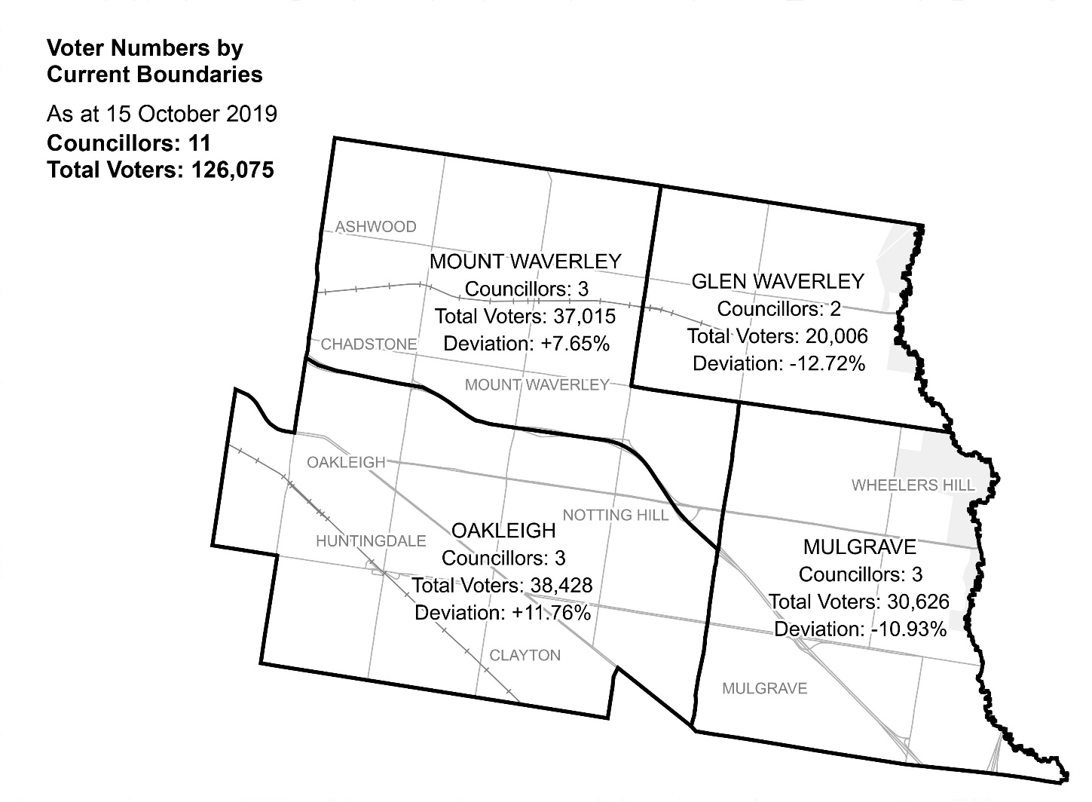  
Diagram 1: Monash City Council electoral structure and voter statistics

Current subdivision review

The current subdivision review of Monash City Council was required due to the voter-to-councillor ratio in Glen Waverley, Mulgrave and Oakleigh Wards being more than plus-or-minus 10% of the average number of voters per councillor. Consequently, ward boundaries had to be adjusted so that the enrolment in all wards would be within the 10% tolerance at the 2020 general election.

Table 1 shows the number of voters in each ward as at 15 October 2019, ranked by the percentage this deviates from the average number of voters per councillor for the whole local council.

|  |  |  |  |
| --- | --- | --- | --- |
| ***Table 1: Voter numbers per ward*** | | | |
| **Ward** | **Councillors** | **Voters** | **Deviation (%)** |
| Glen Waverley | 2 | 20,006 | -12.72 |
| Oakleigh | 3 | 38,428 | +11.76 |
| Mulgrave | 3 | 30,626 | -10.93 |
| Mount Waverley | 3 | 37,015 | +7.65% |
| **Total for council** | **11** | **126,075** |  |

Preliminary report

The VEC’s subdivision review of Monash City Council commenced with the release of a preliminary report on Wednesday 26 February 2020. The report contained proposed ward boundary changes based on analysis of enrolment information and internal research.

In the current review, Glen Waverley and Mulgrave Wards—at -12.72% and -10.93% respectively—had to be expanded to gain additional voters from neighbouring wards; at +11.76% Oakleigh Ward had to decrease in size and voter population to satisfy legislated requirements.

The VEC proposed extending Mulgrave Ward west into Oakleigh Ward so that the ward boundary would run north-west along a small section of Princes Hwy, then north on Blackburn Road and east on Wellington Road. The suggested change impacted 1,011 voters in Oakleigh Ward who would be in Mulgrave Ward, and united most of the suburb of Mulgrave within Mulgrave Ward. The change also added a small part of Clayton to Mulgrave Ward. The result brought the voter-to-councillor ratios of Mulgrave Ward and Oakleigh Ward to within the accepted 10% tolerance.

An alternative approach would have been to use Blackburn Road as the ward boundary separating Oakleigh and Mulgrave Wards. While this would have provided a more continuous ward boundary, it would have involved a greater level of disruption. A large number of voters in the Notting Hill area—including students and residents employed in education and training who are likely to connect with Monash University and surrounds in Oakleigh Ward—would be in Mulgrave Ward rather than Oakleigh Ward.

The VEC suggested an extension to Glen Waverley Ward, south to Monash Freeway taking in the block bounded by Springvale and Blackburn Roads. The change impacted 4,093 voters in Mount Waverley Ward who would be in Glen Waverley Ward.

Alternative approaches to the above changes were explored but were not considered appropriate as they would likely cause more disruption for voters and/or split communities of interest.

Table 2 details the number of voters in each ward as a result of the proposed ward boundary changes bringing all wards to within the 10% tolerance for the 2020 election, with a total of 5,104 voters (or 4.05% of total voters) to be allocated to different wards. The VEC considered that the changes generally reflected Monash City Council’s communities of interest, had minimal impact on voters and for the most part maintained the clear and easily identifiable ward boundaries currently in place.

|  |  |  |  |
| --- | --- | --- | --- |
| Table 2: Voter numbers per ward with proposed boundaries | | | |
| **Ward** | **Councillors** | **Voters** | **Deviation (%)** |
| Glen Waverley | 2 | 24,099 | +5.13 |
| Oakleigh | 3 | 37,439 | +8.88 |
| Mulgrave | 3 | 31,615 | -8.05 |
| Mount Waverley | 3 | 32,922 | -4.25 |
| **Total for council** | **11** | **126,075** |  |

Public response

Response submissions

The VEC accepted submissions responding to the preliminary report from Wednesday 26 February 2020 until 5.00 pm on Wednesday 25 March 2020. The VEC received two response submissions. A list of people who made a response submission can be found in Appendix 1.

Josh Fergeus, a current Councillor for Oakleigh Ward, supported the VEC’s proposed ward boundary changes. Councillor Fergeus suggested that the VEC had taken a sensible approach to reducing the size and voter numbers in Mount Waverley and Oakleigh Wards.

Councillor Fergeus also suggested that the proposed Oakleigh-Mulgrave Ward boundary adjustment, which would result in voters from Oakleigh Ward being in Mulgrave, was sound. Councillor Fergeus argued that the alternative approach, containing Notting Hill in Mulgrave Ward, would be inappropriate as the area relates more to Monash University and Clayton in Oakleigh Ward.

Councillor Fergeus suggested that increasing Glen Waverley Ward to encompass the block east of Blackburn Road was a logical proposal and that it would create a consistent ward boundary. Councillor Fergeus also argued that voters in this area connect with the activity centre and shops in Glen Waverley Ward.

Stuart James, the current Mayor and Councillor for Oakleigh Ward, commended the VEC’s approach. Councillor James also supported the retention of Notting Hill in Oakleigh Ward, as it related more to Oakleigh Ward than to Mulgrave Ward.

Councillor James was, however, particularly concerned about the greater number of voters in Oakleigh Ward compared with Mount Waverley Ward. In response, Councillor James proposed and mapped two alternatives to more evenly balance the number of voters per ward and to better reflect communities of interest.

The first proposal was to adjust the Oakleigh-Mount Waverley Ward boundary to follow Huntingdale Road, Ferntree Gully Road and the Monash Freeway. Councillor James estimated that this would affect 2,000 residents in Oakleigh Ward that would now be in Mount Waverley Ward. Councillor James argued that this would provide a more even distribution of voters between the two wards and that residents and voters in this area were more aligned with communities and services within Mount Waverley Ward.

Councillor James’s second proposal was to extend Mulgrave Ward to encompass voters bounded by Waverley Road, Blackburn Road, Ferntree Gully Road and Springvale Road; and then to extend Mount Waverley Ward to contain an area bounded by Blackburn Road, Ferntree Gully Road and Huntingdale Road. Councillor James suggested that these changes would provide a more even distribution of voters per ward and better reflect communities of interest.

Of the two proposals, Councillor James preferred the second option, but suggested that the first option would be less disruptive to voters.

Public hearing

The VEC conducted a public hearing for those wishing to speak about their response submission at 7.00 pm on Wednesday 1 April 2020. The hearing was conducted online using CISCO Webex.

Councillor Stuart James spoke in support of numerous alternative ward boundary adjustments different to those put forward by the VEC in the preliminary report.

Councillor James began by commending the VEC’s proposal to extend Mulgrave Ward to include a small area of land bounded by Dandenong Road, Blackburn Road and Wellington Road. Councillor James suggested there was some concern at Council that the VEC would simply use Blackburn Road as the entire western boundary of Mulgrave Ward. The VEC’s proposed ward boundary adjustment was supported as it kept Notting Hill intact within Oakleigh Ward where its connections are strongest.

Councillor James raised concerns about the greater number of voters contained in Oakleigh Ward compared with Mount Waverley Ward. Councillor James suggested that Oakleigh Ward covered a larger geographical area and would likely continue to undergo more rapid residential growth and increased rates of higher density living than Mount Waverley Ward. This could result in the number of voters per councillor in Oakleigh Ward being above 10% of the overall Council average in the short-term. Councillor James was also concerned to contain communities within the ward they relate to.

To address these concerns, Councillor James spoke in support of several ward boundary adjustments. As per his response submission, Councillor James proposed extending the Mount Waverley-Oakleigh Ward boundary between Huntingdale Road and the Monash Freeway south to Ferntree Gully Road. Councillor James argued: residents in this area related more to Mount Waverley Ward and were in fact already within the suburb of Mount Waverley; the demographic characteristics of residents and housing types in this area were also more aligned with the Mount Waverley Ward rather than Oakleigh Ward; and, despite the clear ward boundary provided by the Monash Freeway, there were important north-south road and transport links connecting the communities. Councillor James suggested that Ferntree Gully Road would be a more appropriate ward boundary, as it currently separates distinct communities of interest. Councillor James also argued that the same arguments for maintaining Notting Hill in Oakleigh Ward should be applied to contain this part of Mount Waverley in Mount Waverley Ward. Councillor James felt, however, that the area between Stephensons Road and Blackburn Road, which consists largely of commercial and industrial services, might have more connections with Clayton and its surrounds in Oakleigh Ward.

Councillor James also suggested uniting all of Chadstone in Mount Waverley Ward. The suburb is currently split between Oakleigh and Mount Waverley Wards by the Monash Freeway. It was argued that Chadstone had stronger connections with Mount Waverley Ward and therefore the Mount Waverley-Oakleigh Ward boundary should be extended south to Scotchmans Creek.

Councillor James proposed extending Mulgrave Ward west to follow small sections of the Monash Freeway and Ferntree Gully Road and then along Blackburn Road and Waverley Road. It was suggested that this would provide a more equitable distribution of voters for Mulgrave Ward.

In summary, Councillor James proposed ward boundary adjustments to allow a more even distribution of voters across wards and to better contain and represent communities of interest.

Findings and recommendation

The VEC’s findings

The VEC is required to bring all wards within Monash City Council to within plus-or-minus 10% of the average number of voters per councillor for the 2020 general election. As part of the subdivision review process, the VEC prefers recommending ward boundary adjustments that have a minimal impact on voters, balanced with ensuring that as far as possible communities of interest are represented in wards and clear ward boundaries are used.

The electoral structure of Monash City Council has remained relatively stable since 2005 when the current structure was introduced following a representation review. In the 2011 representation review the VEC recommended no change to the electoral structure or ward boundaries, as population and voter growth had been stable and even across all four wards and the electoral structure was providing fair and equitable representation.

Only recently have the City’s wards deviated beyond the accepted plus-or-minus 10%. This has been due mainly to growth and development in Clayton, which has elevated the number of voters per councillor in Oakleigh Ward to 11.76% above the Council average. At the same time, a relatively slower rate of growth in Mulgrave and Glen Waverley Wards has caused the voter-to-councillor ratio to fall below the Council average by more than 10%, at -10.93% and -12.72% respectively. As a result, the VEC is required to increase the size and number of voters in Mulgrave and Glen Waverley Wards and decrease the size and number of voters in Oakleigh Ward. The flow-on effects of these changes impact Mount Waverley Ward.

The VEC recommends extending the Mulgrave-Oakleigh Ward boundary west to follow Dandenong Road, Blackburn Road and Wellington Road. This change affects 1,011 voters in Oakleigh Ward who will now be in Mulgrave Ward. This is considered a minor change and is expected to involve a minimal level of disruption for voters currently in Oakleigh Ward. The area affected includes substantial residential developments, which helps balance the number of current and projected voters across both wards. Although enrolments for both wards are relatively close to the accepted plus-or-minus 10% deviation, voter projections indicate that the changes will remain viable for the 2020 general elections and beyond. Moreover, the change is preferred to other options for re-balancing Mulgrave and Oakleigh Wards, such as using a greater part of Blackburn Road as a ward boundary. If adopted, this change would divide Notting Hill and allocate voters in the Notting Hill area to Mulgrave Ward, where they appear to have less connections than they do with Oakleigh Ward.

To increase the size and voter numbers in Glen Waverley Ward, the VEC recommends extending the ward boundary to contain a greater part of the Glen Waverley suburb in Glen Waverley Ward. Under this recommendation Glen Waverley Ward is extended to include an area bounded by Springvale Road, Waverley Road, Blackburn Road and the Monash Freeway. This change affects 4,093 voters in Mount Waverley Ward that will now be in Glen Waverley Ward and ensures both wards are well within plus-or-minus 10% of the average number of voters per councillor. The VEC also considers that the ward boundary adjustments should reflect the connections between voters in the area and the Glen Waverley Ward, and provides clear and easily identifiable ward boundaries. The VEC considers alternative ward boundary adjustments, such as including a smaller section of the Glen Waverley suburb in Glen Waverley Ward or extending Glen Waverley Ward west of Blackburn Road, would split communities to a significant degree and rely on the use of less clear ward boundaries.

The VEC considers there to be sound reasons for extending the Mount Waverley-Oakleigh Ward boundary south to Ferntree Gully Road, as proposed by Councillor James; voters in the area may indeed relate more to Mount Waverley Ward than Oakleigh Ward, and the proposed ward boundary changes would provide a slightly more even distribution of voters between the two wards. However, the change affects a significantly large number of voters which is not necessary to bring all wards to within plus-or-minus 10% of the average number of voters per councillor. It is also not necessary to provide a more even distribution of voters per ward, particularly when balanced against a greater level of disruption for voters, especially given that the VEC’s recommendations already satisfy the 10% equality requirement. There is also a large section of the proposed area north of Notting Hill between Stephensons and Blackburn Roads, which is primarily commercial and industrial in nature, and likely relates more to Oakleigh Ward. Furthermore, the proposal to move the ward boundary south to Ferntree Gully Road would break the continuity of the Monash Freeway ward boundary, which has been in place since 2005 and is clear and familiar to voters.

Similar factors were considered in assessing the proposal to include all of Chadstone in Mount Waverley Ward, which possibly relates more to areas north of the Mount Waverley-Oakleigh Ward boundary. The proposal would impact voters unnecessarily and use less clear and familiar ward boundaries than that currently provided by the Monash Freeway.

A major concern for Councillor James and the ward boundary adjustments proposed was to better represent communities of interest. Although the VEC considered communities of interest in the decision not to extend Mulgrave Ward west to include a part of Notting Hill, this was because two viable options for bringing Mulgrave Ward to within the accepted 10% deviation were available. In determining the most appropriate option, the VEC considered which option would involve the least change to voters and where possible maintain communities of interest. Therefore, while the above changes proposed by Councillor James might better reflect communities of interest, they are not essential to bring all wards to within plus-or-minus 10% of the average number of voters per councillor and would be more appropriately addressed as part of a full representation review.

The other ward boundary change proposed by Councillor James, to extend Mulgrave Ward west into Mount Waverley Ward, was considered unnecessary by the VEC. This change would also undermine the extension of Glen Waverley Ward, which was essential for returning the voter-to-councillor ratio to within 10% of the overall Council average.

In summary the VEC recommends the ward boundary changes as put forward in its preliminary report. The VEC considers that these changes affect a minimal number of voters (5,104 or 4.05% of total voters), maintain for the most part the current ward boundaries, including the Monash Freeway, Blackburn Road and Springvale Road, and where possible reflect communities of interest.

|  |  |  |  |
| --- | --- | --- | --- |
| Table 3: Voter numbers per ward of recommended ward boundaries | | | |
| **Ward** | **Councillors** | **Voters** | **Deviation (%)** |
| Glen Waverley | 2 | 24,099 | +5.13 |
| Mount Waverley | 3 | 32,922 | -4.25 |
| Mulgrave | 3 | 31,615 | -8.05 |
| Oakleigh | 3 | 37,439 | +8.88 |
| **Total for council** | **11** | **126,075** |  |

The VEC’s recommendation

The Victorian Electoral Commission recommends adjustments to the boundaries of the following wards within Monash City Council:

* Glen Waverley Ward
* Mount Waverley Ward
* Mulgrave Ward
* Oakleigh Ward

This recommendation is submitted to the Minister for Local Government as required by the *Local Government Act 1989*.

Please see Appendix 2 for a detailed map of the recommended ward boundaries.

# Appendix 1: Public involvement

Response submissions

Response submissions were made by:

Fergeus, Josh (Councillor, Monash City Council)

James, Stuart (Mayor and Councillor, Monash City Council)

Public hearing

The following individuals spoke at the public hearing:

James, Stuart (Mayor and Councillor, Monash City Council)

# Appendix 2: Recommended ward boundaries map

The map is provided on the next page.

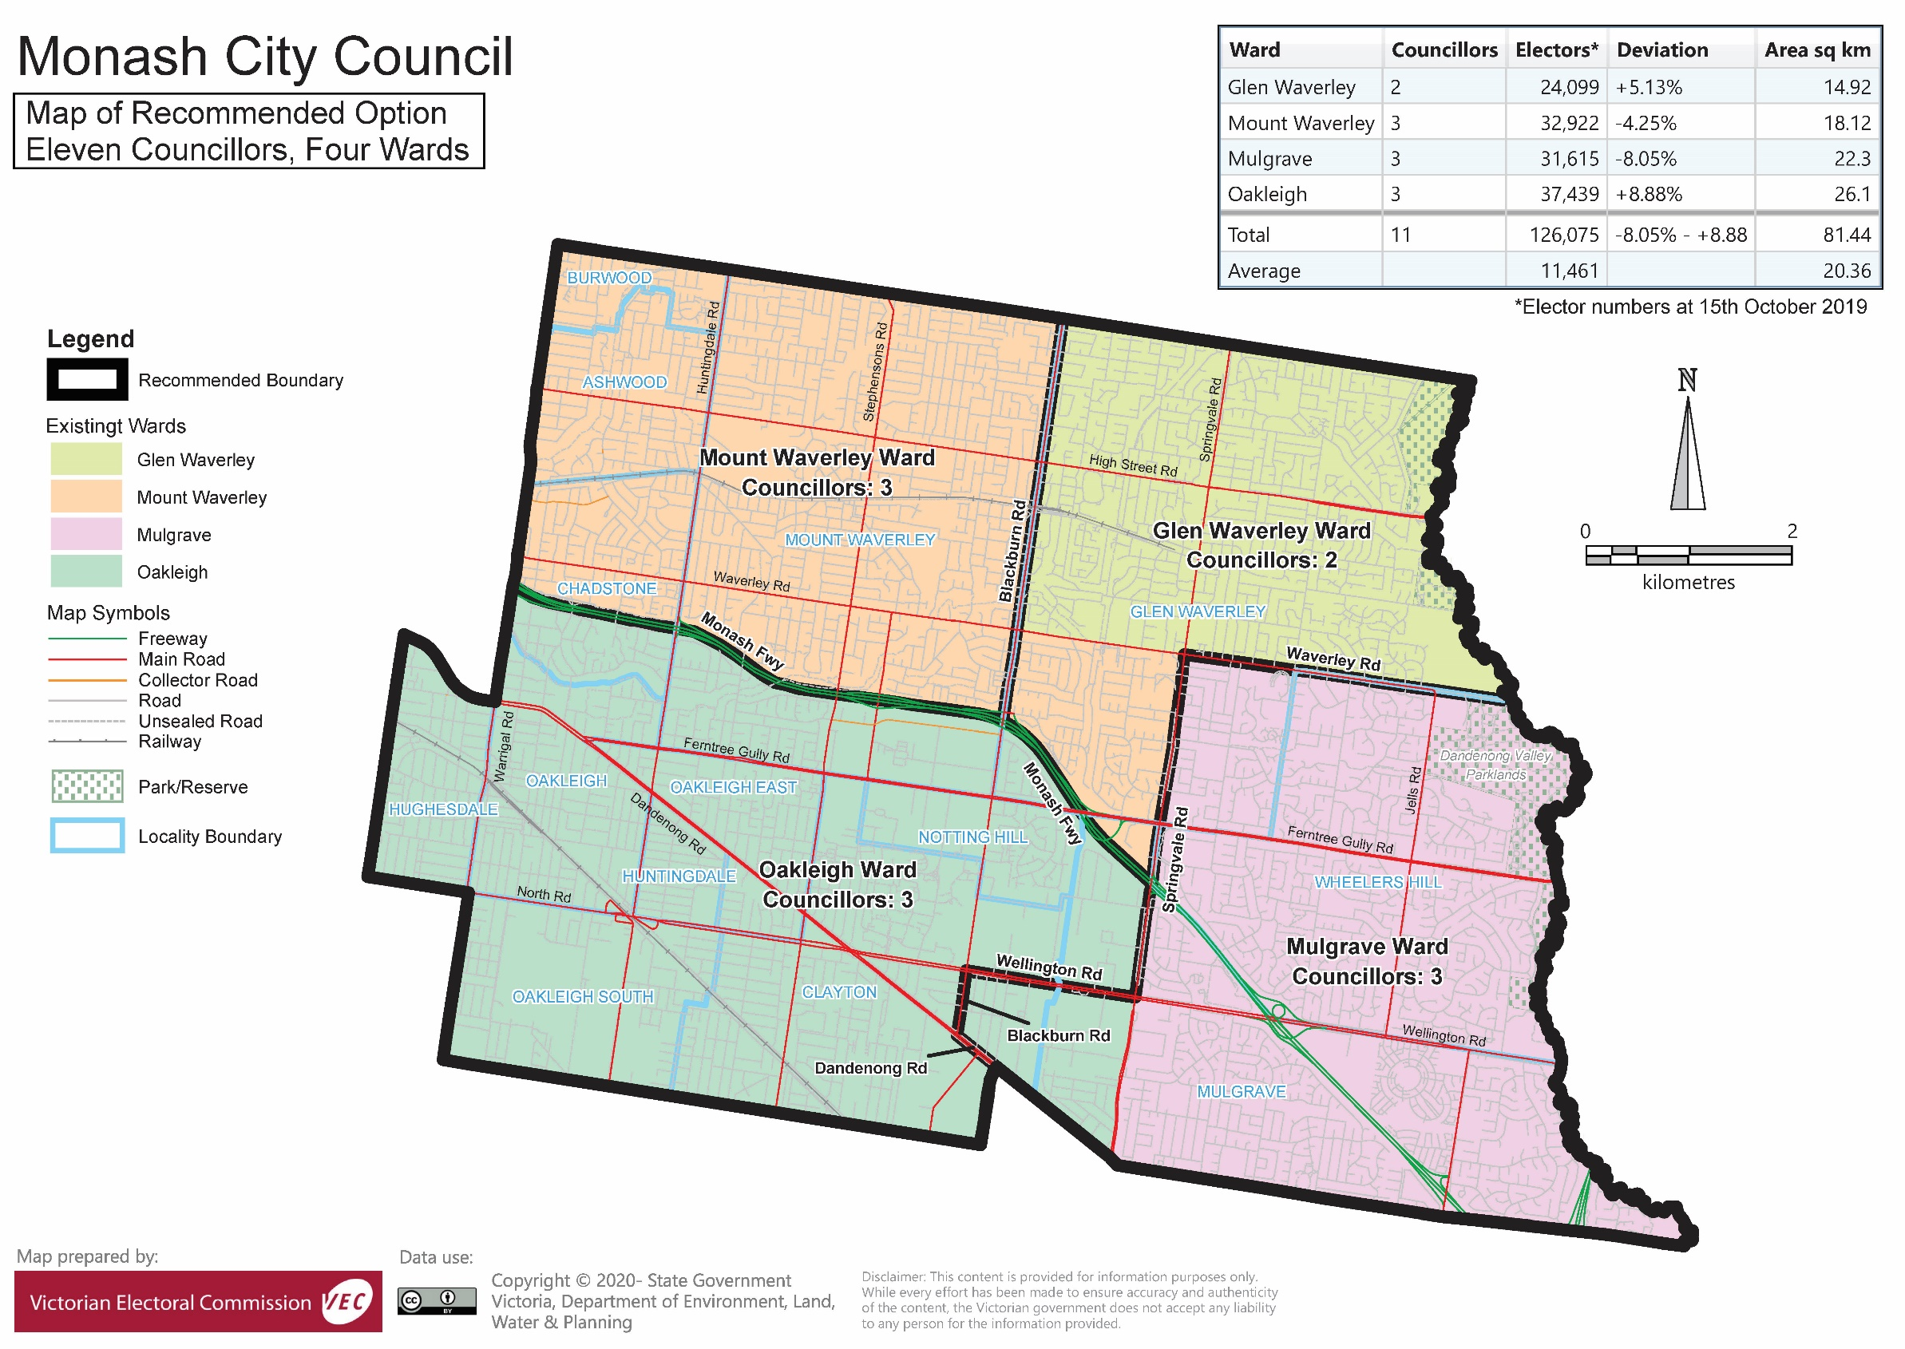

# Appendix 3: Public information program

Advertising

Public notices of the release of the preliminary report were placed in the following newspapers:

|  |  |
| --- | --- |
| **Newspaper** | **Date of publication** |
| *Herald Sun* | Saturday 22 February 2020 |
| *Monash Leader* | Tuesday 25 February 2020 |
| *The Age* | Wednesday 26 February 2020 |

Media releases

A media release was prepared and distributed to local media to promote the publication of the preliminary report on Friday 21 February 2020 A final media advisory was circulated on the publication date of this final report.

VEC website

The VEC website delivered up-to-date information to provide transparency and facilitate public participation during the review process. All public submissions were published on the website.

### Online submission tool

An online submission tool was developed and made available during the submission period of the review. The tool allowed people to make a submission from the VEC website.

Email and social media engagement

The VEC delivered an information email campaign targeted at known community groups and communities of interest in the local council area. This included a reminder email at each milestone of the subdivision review process.

The VEC also published sponsored social media advertising that was geo-targeted to users within the local council area. The total reach of these posts was 15,044.

Council communication resources

The VEC provided the Council with a communication pack that included information on the review in various formats. While the council is encouraged to distribute this information and raise awareness about the review, the VEC is an independent reviewer and all communications resources include reference and links to the VEC website and core materials.

This page has been left intentionally blank

This page has been left intentionally blank

This page has been left intentionally blank

|  |
| --- |
| **© State of Victoria**  (Victorian Electoral Commission) **April 2020** |
| This work, the Local Council Subdivision Review – Final Report Monash Shire Council 2020,  is licensed under a Creative Commons Attribution 4.0 licence (http://creativecommons.org/ licenses/ by/4.0/). You are free to re-use the work under that licence, on the condition that you credit the State of Victoria (Victorian Electoral Commission) as author, indicate if changes were made and comply with the other licence terms. The licence does not apply to any branding, including government logos. |
|  | |
| Level 11, 530 Collins Street  Melbourne Victoria 3000  T 131 832  info@vec.vic.gov.au  vec.vic.gov.au | |
|  | |



1. Section 219H of the *Local Government Act* *1989.*
2. Section 219L of the *Local Government Act* *1989.*
3. Section 219L of the *Local Government Act* *1989.*
4. .id is a consulting company specialising in population and demographic analysis and prediction information products in most jurisdictions in Australia and New Zealand.
5. .id, City of Monash: population forecast’, <https://forecast.id.com.au/monash>, accessed 30 January 2020.
6. Ibid.
7. Australian Bureau of Statistics, ‘2016 Quickstats: Monash (C)’, <https://quickstats.censusdata.abs.gov.au/census_services/getproduct/census/2016/quickstat/LGA24970?opendocument>, accessed 30 January 2020.
8. .id, City of Monash: community profile’, <https://profile.id.com.au/monash>, accessed 30 January 2020.
9. .id, City of Monash: economic profile’, <http://economy.id.com.au/monash>, accessed 30 January 2020.
10. .id, City of Monash: community profile’, <https://profile.id.com.au/monash>, accessed 30 January 2020.
11. Ibid.
12. .id, City of Monash: population forecast’, <https://forecast.id.com.au/monash>, accessed 30 January 2020.
13. .id, City of Monash: community profile’, <https://profile.id.com.au/monash>, accessed 30 January 2020.
14. Ibid.
15. Ibid.
16. Department of Environment, Land, Water and Planning (DELWP), *Victoria in Future 2019,* 2019, <https://www.planning.vic.gov.au/land-use-and-population-research/victoria-in-future> , accessed 30 January 2019.
17. .id, City of Monash: community profile’, <https://profile.id.com.au/monash>, accessed 30 January 2020.