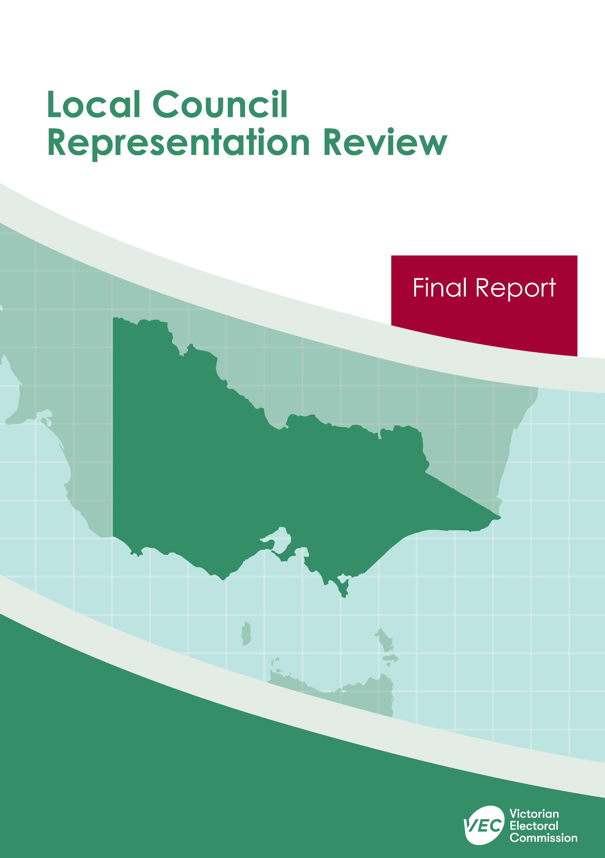



**Northern Grampians Shire Council**

**March 2020**

Contents

Recommendation 1

Executive summary 2

Background 4

Legislative basis 4

Public engagement 4

The VEC’s principles 5

Developing recommendations 6

Northern Grampians Shire Council representation review 9

Profile of Northern Grampians Shire Council 9

Current number of councillors and electoral structure 10

Preliminary submissions 11

Preliminary report 13

Public response 17

Response submissions 17

Public hearing 20

Findings and recommendation 22

The VEC’s findings 22

The VEC’s recommendation 25

Appendix 1: Public involvement 26

Appendix 2: Map 27

Appendix 3: Public information program 29

Recommendation

The Victorian Electoral Commission recommends that Northern Grampians Shire Council continue to consist of seven councillors elected from four wards with adjustments to the current ward boundaries (one three-councillor ward, one two-councillor ward and two single-councillor wards).

This recommendation is submitted to the Minister for Local Government as required by the *Local Government Act 1989*.

Please see Appendix 2 for a detailed map of this recommended structure.

Executive summary

The *Local Government Act 1989* (the Act) requires the Victorian Electoral Commission (VEC) to conduct an electoral representation review of each local council in Victoria before every third council general election.

The purpose of an electoral representation review is to recommend the number of councillors and the electoral structure that provides ‘fair and equitable representation for the persons who are entitled to vote at a general election of the Council.’[1] The matters considered by a review are:

* the number of councillors
* the electoral structure of the council (whether the council should be unsubdivided or divided into wards and, if subdivided, the details of the ward boundaries and the number of councillors per ward).

The VEC conducts all reviews based on three main principles:

1. taking a consistent, State-wide approach to the total number of councillors
2. if subdivided, ensuring the number of voters represented by each councillor is within plus-or-minus 10% of the average number of voters per councillor for that local council
3. ensuring communities of interest are as fairly represented as possible.

Current number of councillors and electoral structure

Northern Grampians Shire Council currently comprises seven councillors elected from four wards (one three-councillor ward, one two-councillor ward and two single-councillor wards). Prior to the representation review in 2007, Northern Grampians Shire Council was comprised of nine councillors elected from two wards (one six-councillor ward and one three-councillor ward).

Visit the VEC website at [vec.vic.gov.au](http://vec.vic.gov.au) for more information on the Northern Grampians Shire Council and to access copies of the 2007 representation review final report.

Preliminary submissions

Preliminary submissions opened at the commencement of the current review on Wednesday 30 October 2019. The VEC received seven submissions for the representation review of Northern Grampians Shire Council by the deadline of 5.00 pm on Wednesday 27 November 2019.

Preliminary report

A preliminary report was released on Wednesday 29 January 2020 with the following options for consideration:

* Option A (preferred option)  
  **Northern Grampians Shire Council consist of seven councillors elected from four wards with adjustments to the current ward boundaries (one three-councillor ward, one two-councillor ward and two single-councillor wards).**
* Option B (alternative option)  
  **Northern Grampians Shire Council consist of seven councillors elected from an unsubdivided electoral structure.**

Response submissions

The VEC received nine submissions responding to the preliminary report by the deadline of 5.00 pm on Wednesday 26 February 2020.

Public hearing

The VEC conducted a public hearing for those wishing to speak about their response submission at 6.00 pm on Wednesday 4 March 2020. Two people spoke at the public hearing.

Recommendation

**The Victorian Electoral Commission recommends that Northern Grampians Shire Council continue to consist of seven councillors elected from four wards with adjustments to the current ward boundaries (one three-councillor ward, one two-councillor ward and two single-councillor wards).**

This electoral structure was designated as Option A in the preliminary report. Please see Appendix 2 for a detailed map of this recommended structure.

Background

Legislative basis

The Act requires the VEC to conduct a representation review of each local council in Victoria before every third general council election, or earlier if gazetted by the Minister for Local Government.

The Act states that the purpose of a representation review is to recommend the number of councillors and the electoral structure that provides ‘fair and equitable representation for the persons who are entitled to vote at a general election of the Council.’[2]

The Act requires the VEC to consider:

* the number of councillors in a local council
* whether a local council should be unsubdivided or subdivided.

If a local council is subdivided, the VEC must ensure that the number of voters represented by each councillor is within plus-or-minus 10% of the average number of voters per councillor for that local council.[3] On this basis, the review must consider the:

* number of wards
* ward boundaries
* number of councillors to be elected for each ward.

Public engagement

### Public information program

The VEC conducted a public information program to inform the community of the representation review, including:

* public notices printed in local and State-wide papers
* public information sessions to outline the review process and respond to questions from the community
* media releases announcing the commencement of the review and the release of the preliminary report
* a submission guide to explain the review process and provide background information on the scope of the review
* an information email campaign targeted at known community groups and communities of interest in the local council area
* sponsored social media advertising geo-targeted to users within the local council   
  area
* ongoing information updates and publication of submissions on the VEC website.

More information on the VEC’s public information program for the representation review of Northern Grampians Shire Council can be found at Appendix 3.

### Public consultation

Public input was encouraged by the VEC via:

* preliminary submissions at the start of the review
* response submissions to the preliminary report
* a public hearing that provided an opportunity for people who had made a response submission to expand on their submission.

Public submissions are an important part of the review process but are not the only consideration. The VEC ensures its recommendations comply with the Act and are formed through careful consideration of public submissions, independent research, and analysis of all relevant factors.

The VEC’s principles

Three main principles underlie all the VEC’s work on representation reviews:

1. **Taking a consistent, State-wide approach to the total number of councillors.**

The VEC is guided by its comparisons of local councils of a similar size and category to the council under review. The VEC also considers any special circumstances that may warrant the local council having more or fewer councillors than similar local councils.

1. **If subdivided, ensuring the number of voters represented by each councillor is within plus-or-minus 10% of the average number of voters per councillor for that local council.**

This is the principle of ‘one vote, one value’, which is enshrined in the Act and is common across all three levels of government: local, state and federal. This means that every person’s vote counts equally.

1. **Ensuring communities of interest are as fairly represented as possible.**

Each local council contains a number of communities of interest. Where practicable, the electoral structure should be designed to ensure they are fairly represented, and that geographic communities of interest are not split by ward boundaries. This allows elected councillors to be more effective representatives of the people and interests in their particular local council or ward.

Developing recommendations

The VEC bases its recommendations for the number of councillors and electoral structure on the following information:

* internal research specifically relating to the local council under review, including data from the Australian Bureau of Statistics and .id[4]; voter statistics from the Victorian electoral roll; and other State and local government data sets
* small area forecasts provided by .id for relevant local council areas
* the VEC’s experience conducting previous electoral representation reviews of local councils and similar reviews for State elections
* the VEC’s expertise in mapping, demography and local government
* consideration of all input from the public in written submissions received during the review and via oral submissions at the public hearing
* advice from consultants with extensive experience in local government.

### Deciding on the number of councillors

The Act allows for a local council to have between five and 12 councillors but does not specify how to decide the appropriate number.[5] In considering the number of councillors for a local council, the VEC is guided by the Victorian Parliament’s intention for fairness and equity in the local representation of voters under the Act.

The starting point in deciding the appropriate number of councillors for a local council is comparing the local council under review to other local councils of a similar size and type (Principle 1). Generally, local councils that have a larger number of voters will have a higher number of councillors. Often large populations are more likely to be diverse, both in the nature and number of their communities of interest and the issues of representation.

However, the VEC also considers the particular circumstances of each local council which could justify fewer or more councillors, such as:

* the nature and complexity of services provided by the Council
* geographic size and topography
* population growth or decline
* the social diversity of the local council.

### Deciding the electoral structure

The Act allows for a local council ward structure to be unsubdivided—with all councillors elected ‘at-large’ by all voters—or subdivided into a number of wards.

If the local council is to be subdivided into wards, there are three options available:

1. single-councillor wards
2. multi-councillor wards
3. a combination of single-councillor and multi-councillor wards.

A subdivided electoral structure must be developed with internal ward boundaries that provide for a fair and equitable division of the local council.

The Act allows for wards with different numbers of councillors, as long as the number of voters represented by each councillor is within plus-or-minus 10% of the average number of voters per councillor for that local council (Principle 2). For example, a local council may have one   
three-councillor ward with 15,000 voters and two single-councillor wards each with 5,000 voters. In this case, the average number of voters per councillor would be 5,000.

Over time, population changes can lead to some wards in subdivided local councils having larger or smaller numbers of voters. As part of the review, the VEC corrects any imbalances and considers likely population changes to ensure ward boundaries provide equitable representation for as long as possible.

In determining the most appropriate electoral structure, the VEC considers the following matters:

* the VEC’s recommendation at the previous representation review and the reasons for that recommendation
* the longevity of the structure, with the aim of keeping voter numbers per councillor within the 10% tolerance for as long as possible (Principle 2)
* communities of interest, consisting of people who share a range of common concerns, such as geographic, economic or cultural associations (Principle 3)
* the number of candidates in previous elections, as outcomes from previous elections indicate that large numbers of candidates can lead to an increase in the number of informal (invalid) votes
* geographic factors, such as size and topography
* clear ward boundaries.

Northern Grampians Shire Council representation review

Profile of Northern Grampians Shire Council

The Northern Grampians Shire Council is in the Wimmera Southern Mallee Region of Victoria and is about 230 kilometres north-west of Melbourne. It covers an area of 5,918 square kilometres, including part of the Grampians Ranges. The Wimmera River traverses the Shire and the Avoca River forms part of its eastern boundary. Parts of the Shire face environmental risks, such as drought, flooding and bushfires.[6]

The Barengi Gadjin people and the Dja Dja Wurrung people are the traditional custodians of the land now known as Northern Grampians Shire Council.

The main transport corridor is the Western Highway, which links Horsham, Stawell and Nhill with Melbourne and Adelaide. The Sunraysia Highway runs north-west to south-east through St Arnaud and the Wimmera Highway provides an east-west link.

Most of the Shire’s population lives in the towns of Stawell and St Arnaud, both of which service the surrounding agricultural areas and provide retail and other commercial services. The Shire’s other towns include Great Western, Navarre, Stuart Mill, Marnoo, Glenorchy and Halls Gap.

Agriculture is the main land use and industry in the Shire and is currently the second largest employer behind health care and social assistance (15.9%).[7] Manufacturing is also an important industry, particularly in Stawell, the location for Victoria’s largest working gold mine and where meat-processing employs over 10% of the town’s working population.[8] Tourism is an industry of growing importance, particularly in Halls Gap, which sits at the gateway to the Grampians National Park (Gariwerd).

The Shire sits below state and regional averages on measures of relative social advantage/disadvantage, with notable levels of social disadvantage evident in Stawell and St Arnaud.[9] Across the Shire, median personal and household incomes are lower than the state and regional averages.[10] There are, however, high rates of home ownership across all parts of the Shire with about 45% of homes owned outright and 28% owned with a mortgage.[11] Renters account for around 22% of all households.[12]

Nearly 85% of residents are Australian-born.[13] Since 2006 the proportion of residents born overseas has increased slightly from 5.7% to 7.4%, whereas those born in Australia declined somewhat, from 88.7% to the current level of 84.3%.[14] At 17.7%, Halls Gap has a greater proportion of overseas-born residents than the Shire as a whole.[15]

Population ageing is occurring in the Shire, with the median age increasing from 42 to 48 since 2006[16], and there has been some decrease in the numbers of younger age groups.[17] Overall, the Shire underwent a small decline in population, decreasing from 11,911 in 2006 to 11,439 in 2016.[18] This trend is expected to continue with the population projected to be 10,575 by 2031.[19]

Current number of councillors and electoral structure

Northern Grampians Shire Council currently comprises seven councillors elected from four wards (one three-councillor ward, one two-councillor ward and two single-councillor wards). Prior to the representation review in 2007, Northern Grampians Shire Council was comprised of nine councillors elected from two wards (one six-councillor ward and one three-councillor ward).

Visit the VEC website at [vec.vic.gov.au](http://vec.vic.gov.au) for more information on the Northern Grampians Shire Council and to access copies of the 2007 representation review final report.

Preliminary submissions

At the close of submissions on Wednesday 27 November 2019, the VEC had received seven submissions for the representation review of Northern Grampians Shire Council. A list of people who made a preliminary submission can be found in Appendix 1.

### Number of councillors

Most submitters (four out of seven) suggested retaining seven councillors.

Adam Newman argued seven councillors was working well and that the current voter-to-councillor ratio compared well with similar local councils. Both Northern Grampians Shire Council and Peter Vanrenen submitted that the number of councillors should remain the same but did not specify why seven councillors was appropriate.

The Proportional Representation Society of Australia (Victoria-Tasmania) Inc. (the PRSA) preferred an odd number of councillors (either seven or nine depending on the electoral structure) to avoid stalemates in Council decision-making and to better uphold the principle that a majority view be represented by a majority of councillors.

One submitter, Chantelle Cook, argued there were too many councillors and council employees for the area covered by the Shire but did not specify a preferred number of councillors.

Two submitters did not comment on the appropriate number of councillors for the Shire.

### Electoral structure

Three submitters favoured an unsubdivided electoral structure (including the PRSA, which also proposed a multi-councillor ward structure) and three wanted to retain the current four-ward structure. One submitter did not comment on the most appropriate electoral structure but suggested the need to improve council services.

**Unsubdivided**

Alan Cooper submitted that an unsubdivided electoral structure would be fairer as it would reduce the chance of uncontested elections and enable voters to have a say on all candidates at election time.

The PRSA suggested an unsubdivided electoral structure to maximise the value of individual votes, reduce the chance of uncontested elections, require all candidates to be elected on the same quota of votes and better represent the Shire’s communities of interest.

Ms Cook favoured an unsubdivided electoral structure to improve services to the community and prevent favouritism in the employment of council employees, which she felt the current electoral structure had encouraged.

**Multi-councillor wards**

The PRSA proposed a multi-councillor ward structure of three three-councillor wards, if the number of councillors was increased to nine. It argued that this structure would provide parity between the different wards, enhance the percentage of effective votes when compared with other electoral structures and reduce the chance of uncontested elections.

**Mixed structure of single-councillor and multi-councillor wards**

Northern Grampians Shire Council argued the current subdivided electoral structure provided each distinct township and community of the Shire with a locally elected representative and effectively represented local issues. The Shire argued against the need for ward boundary adjustments, and further suggested:

* changes in the Local Government Bill 2019 would make any proposed ward boundary adjustments for voter equality in the 2024 elections obsolete
* the timeframe to make ward boundary changes resulting from the review in preparation for the 2020 elections would place unfair demands on a small rural council with limited resources.

Mr Newman referred to the distinct communities of Stawell and St Arnaud to suggest the current subdivided electoral structure best represented the Shire and its communities. To correct the voter-to-councillor ratio in South West Ward, Mr Newman proposed moving the ward boundary between South West and Central Wards to the west so that voters in the town of Great Western would be in Central Ward.

Mr Vanrenen argued for retention of the current subdivided electoral structure to ensure the representation of rural interests and provide local representation.

Preliminary report

A preliminary report was released on Wednesday 29 January 2020. The VEC considered public submissions and research findings when formulating the options presented in the preliminary report.

### Number of councillors

When considering the appropriate number of councillors for Northern Grampians Shire Council, the VEC assessed population and voter data, particularly in comparison with similar Victorian local councils, and other factors such as communities of interest and special circumstances.

The VEC determined that, with 1,579 voters per councillor, the voter-to-councillor ratio of Northern Grampians Shire Council compared well with similar country Victorian local councils with seven councillors. Although the Shire had undergone some decline in its population since the last review and would continue to do so in future years, the rate and impact of this change was considered minimal and did not warrant a decrease to the number of councillors.

The VEC also considered the special circumstances faced by the Shire, including environmental risks, population ageing and social disadvantage. It was determined that these factors did not warrant increasing the number of councillors and that seven councillors had served the Shire well to date.

For these reasons and given the low level of support in submissions for any change to the number of councillors the VEC determined seven councillors to be appropriate for fair and equitable representation for the voters of Northern Grampians Shire Council.

### Electoral structure

To determine the most appropriate electoral structure the VEC considered numerous factors, including changes in the number and distribution of voters since the last review, election outcomes and arguments presented in submissions.

In developing the preliminary options presented in this report, the VEC considered several other options, as summarised in the table below.

|  |  |  |
| --- | --- | --- |
| Overview of models considered | | |
| **Electoral structure** | **Option in preliminary report** | **Key Considerations** |
| Current structure (with adjustments) | Option A | * Projected elector population estimates indicate that this electoral structure will be viable until the next scheduled review in 2028 * Supported through submissions * Minimal change * Geographic communities of interest are clearly reflected in wards |
| 7 councillors unsubdivided | Option B | * Projected elector population estimates indicate that this electoral structure will be viable until the next scheduled review in 2028 * Supported through submissions * Addresses history of uncontested elections in single-councillor wards * The rural community of interest is not divided across wards |
| 3 x three-councillor wards |  | * Additional councillors are not required based on comparisons to similar councils |
| 7 single-councillor wards |  | * No support in submissions * Stawell would be split into three wards and St Arnaud would be split into two wards |

The VEC did not consider an electoral structure of three three-councillor wards to be appropriate, primarily because increasing the number of councillors to nine was not warranted.

A structure of seven single-councillor wards was not considered to be appropriate as it would entail dividing the main towns of St Arnaud and Stawell across different wards and received no support in submissions.

The VEC presented two viable seven-councillor electoral structure options for the Northern Grampians community to consider: the current electoral structure consisting of one three-councillor ward, one two-councillor ward and two single-councillor wards (with ward boundary adjustments); and an unsubdivided electoral structure.

**Option A: current electoral structure (with ward boundary adjustments)**

The VEC provided Option A as a minimal change option, with boundary adjustments to ensure that the voter-to-councillor ratio in all wards would be within plus-or-minus 10% of the Shire average over the long-term. One of these changes impacted 187 voters (1.7% of total votes) in the town of Great Western in South West Ward who would now be in Central Ward. This was considered a minor change; voters in Great Western would likely connect with towns along the Western Highway and would therefore be appropriately represented within either Central or South West Ward. A slight ward boundary improvement affecting six voters in Stawell Ward, making better use of identifiable roads surrounding the town and the railway line, was also proposed.

Aside from these changes, Option A retained the ward boundaries of the current electoral structure, all of which were considered to be familiar and easy to identify. Furthermore, the VEC considered that the proposed ward boundaries did not divide communities and maintained the two major towns of Stawell and St Arnaud within their respective wards.

The VEC determined the main advantage of Option A to be the provision of local representation in proportion to the distribution of the Shire’s population. It was also considered that the wards, although unequal in geographical size, corresponded with the Shire’s communities of interest, including the main towns of Stawell and St Arnaud, the tourism interests of Halls Gap and the country or farming interests located throughout much of the centre of the Shire.

The VEC also considered that voters within the Shire’s different communities valued the opportunity to elect candidates familiar with their local area and that the four-ward structure provided a good opportunity for voters to connect with candidates and elected councillors, and for voters to elect candidates with knowledge of local issues.

Uncontested wards and low numbers of candidates at elections were considered the main potential drawbacks of Option A and the current electoral structure. The VEC noted that in the past three elections (2008, 2012 and 2016) three-quarters of the wards (8 out of 12) were uncontested and that this appeared to limit voter choice at election time.

**Option B: an unsubdivided electoral structure**

The VEC considered the main advantage of Option B to be a probable reduction in the number of uncontested elections and a greater level of choice for voters at election time.

It was also considered that an unsubdivided electoral structure might foster a greater Shire-wide approach to social issues such as population ageing and environmental challenges relating to flooding, drought and bushfires. Candidates would be encouraged to appeal to voters from across the whole of the Shire. However, the VEC determined that under Option B candidates from less populated areas might encounter difficulties connecting with voters in other, more populated, parts of the Shire.

The VEC determined that Option B would avoid the situation of having wards of unequal size or requiring a different quota of votes for candidates to be elected. This would mean all candidates would require the same quota of votes to be elected.

A further advantage of Option B was that with no wards there would be no need to create internal ward boundaries or make adjustments to ensure the voter-to-councillor ratio remained within plus-or-minus 10% the average number of voters per councillors.

In addition to these benefits the VEC suggested that in Option B candidates with a reasonable level of support would likely be elected, thus providing a good chance that the Shire’s communities of interest would continue to elect candidates from their local area to represent them.

Overall, the VEC considered both options to have distinct advantages and that both would provide voters with fair and equitable representation.

### Options

After careful consideration, the VEC put forward the following options:

* Option A (preferred option)  
  **Northern Grampians Shire Council consist of seven councillors elected from four wards with adjustments to the current ward boundaries (one three-councillor ward, one two-councillor ward and two single-councillor wards).**
* Option B (alternative option)  
  **Northern Grampians Shire Council consist of seven councillors elected from an unsubdivided electoral structure.**

Public response

Response submissions

The VEC accepted submissions responding to the preliminary report from Wednesday 29 January 2020 until 5.00 pm on Wednesday 26 February 2020. The VEC received nine response submissions. A list of people who made a response submission can be found in Appendix 1. The table below indicates the level of support for each option.

|  |  |
| --- | --- |
| Preferences expressed in response submissions | |
| **Option A** | **Option B** |
| 6 | 3 |

### Number of councillors

Three submitters reiterated that seven councillors continued to be the most appropriate number of councillors for Northern Grampians Shire Council.

The PRSA supported seven councillors, as an odd number of councillors would help to avoid tied votes on the Council. Peter Hilbig suggested seven councillors was consistent with the population of similar rural councils. James Anderson submitted that the current number of councillors provided adequate representation for residents in each of the four wards and enabled a reasonable distribution of councillor workloads. In support of retaining the current electoral structure, Mr Anderson also argued that any increase in the number of councillors would need to be a multiple of seven, which would be more than the maximum number of councillors permitted under current legislation.

### Electoral structure

Six submitters favoured Option A, most of whom argued that it provided local representation and best represented the Shire’s geographic communities of interest, while three submitters supported Option B.

**Support for Option A**

Mr Hilbig argued that the four-ward structure in Option A reflected the interests of rural and urban areas and the economic influences associated with agriculture, tourism, industry, services and trade. Adam Newman similarly suggested the distinct interests of the Shire were best represented by the current four-ward structure, particularly the wards centred around the towns of St Arnaud and Stawell.

Northern Grampians Shire Council submitted that the current ward structure delivered local representation for each distinct township and community within the Shire and best upheld the principle of ‘one vote, one value’. Mr Anderson suggested the current subdivided electoral structure was appropriate to cover the vast geography of the Shire and best represented the Shire’s different communities.

Iris Hunter-Conlan argued Option A would guarantee representation for the residents and businesses of St Arnaud. Joan Fletcher argued that Option A would provide rural communities with representation and prevent a majority of councillors being from the main towns. Ms Fletcher considered such representation important in relation to the contribution farming communities made to the finances of the Shire, and further argued that an even distribution of councillors from across the Shire would help facilitate an equitable distribution of council services and infrastructure.

Many of the submitters in support of Option A argued strongly against Option B. For example, Northern Grampians Shire Council submitted that an unsubdivided electoral structure could lead to a concentration of councillors from the main population centres of the Shire and potentially leave smaller communities without a local representative. Ms Fletcher submitted that an unsubdivided electoral structure could lead to the dominance of one particular group or political party. Ms Hunter-Conlan argued that an unsubdivided electoral structure would disadvantage residents and businesses in   
St Arnaud.

Mr Anderson argued that an unsubdivided electoral structure was not appropriate for the large geographical area of the Shire or for the distinct localities and communities contained within it. Mr Anderson also submitted that under an unsubdivided electoral structure, residents in the main towns of St Arnaud and Stawell would have little knowledge of candidates and councillors from the alternate town. Mr Hilbig likewise suggested that councillors at one end of the Shire would find it difficult to relate to voters or residents at the other.

In favour of Option A, Mr Newman suggested that it was important for the Shire to have locally elected councillors that live in and understand their local area. Mr Hilbig submitted that the current ward structure enabled voters to identify with candidates that understood the social, geographical and economic issues of the local area.

Two submitters—Mr Anderson and Mr Hilbig—did not consider uncontested elections to be potential drawbacks of Option A. Mr Anderson submitted that uncontested elections were common in rural councils and pointed out that there had been only one   
by-election since 2008. Mr Hilbig suggested that it was important to consider pre-election processes, such as candidate nominations, not just voter choice at election time, to determine the input, options and choice that residents and voters exercised.

Two submitters commented on the ward boundaries proposed in Option A. Mr Newman suggested that the ward boundary change affecting voters in Great Western would not alter the character of the current wards; Mr Anderson submitted that the ward boundaries in Option A were appropriate but did not comment specifically on the impact of the proposed ward boundary changes. There were no submissions from Great Western.

**Support for Option B**

Chantelle Cook suggested that the current four-ward structure had led to a lack of community consultation around local issues and that councillors tended to focus on the area where they lived, which benefited the larger towns of Stawell and St Arnaud to the detriment of the smaller, more dispersed communities. Ms Cook argued that an unsubdivided electoral structure was the fairest option and would encourage a council-wide approach to matters, improve consultation, provide residents with a greater chance of having their voices heard and encourage new candidates with fresh ideas. Ms Cook also suggested that Option B would help prevent favouritism in the hiring of council employees.

The PRSA supported Option B as the fairest electoral structure of seven councillors as it would maximise effective votes, provide an odd number of councillors to avoid tied votes on the Council and reduce the chance of uncontested elections. It also argued that under Option B all councillors would have the same geographical area in common and would be motivated to understand the whole of the Shire.

The PRSA contended that the mix of single-councillor and multi-councillor wards in Option A would provide an inconsistent mix in the quota of votes to elect a councillor and would be unfair for those candidates requiring a higher quota of votes to be elected. It also argued against single-councillor wards, stalemate two-councillor wards and any electoral structure with an unequal number of councillors in each ward.

Paul Stephens submitted that Option B was the best option for the Shire but did not elaborate on why this was so.

Public hearing

The VEC conducted a public hearing for those wishing to speak about their response submission at 6.00 pm on Wednesday 4 March 2020 in the Council Chambers, Pleasant Creek Historic Precinct, 50-52 Longfield Street, Stawell. A list of people who spoke at the hearing can be found in Appendix 1.

Two people—Mr Jim Anderson and Ms Iris Hunter-Conlan—spoke at the public hearing and both argued in favour of Option A.

Mr Anderson argued seven councillors provided adequate representation and allowed for a fair distribution of councillor workloads. Mr Anderson also suggested Option A was fair and equitable as the seven councillors were evenly distributed across the four wards.

Mr Anderson did not believe an unsubdivided electoral structure was appropriate for a rural council like Northern Grampians Shire Council, due to its vast geographical area and distinct communities, including the urban areas of Stawell and St Arnaud. He suggested that councillors should have experience and empathy with their locality, which the current subdivided electoral structure enabled.

Mr Anderson argued that the current electoral structure had not prevented a Shire-wide approach to Council matters or encouraged parochialism.

Mr Anderson was not concerned about the number of uncontested elections in the previous three general elections and suggested that it was common for elections to be uncontested in rural councils. He believed there to be no correlation between contested elections and good governance and pointed out there had only been one by-election since the current electoral structure was introduced in 2007.

Mr Anderson argued that it would be unfair for the electoral structure of Northern Grampians Shire Council to be changed on the basis of reducing the chance of uncontested elections.

Mr Anderson was concerned that Option B could result in candidates and councillors from Stawell dominating elections. He argued that candidates should only need the support of voters in their local area or ward to be elected.

Mr Anderson did not comment on the ward boundary changes proposed in Option A and argued that, as he did not live in the area affected, it was not his business to comment.

Ms Hunter-Conlan spoke as an individual and also as a member of the St Arnaud Community Action Network (SCAN). Ms Hunter-Conlan outlined various reasons in favour of Option A:

* The four wards provide fair, equitable and quality representation and ensure residents in St Arnaud have a voice
* It is less likely candidates from Stawell dominate elections and/or disenfranchise voters in St Arnaud and the Shire’s smaller towns
* It is more likely candidates familiar with their local area and local communities will be elected
* Wards provide voters and residents with better access to councillors.

Ms Hunter-Conlan raised a number of points against Option B:

* Less guarantee that councillors would be committed to local issues
* Residents would be reluctant to approach a councillor not living in the local area
* Residents in St Arnaud would encounter difficulties travelling to Stawell to connect with a councillor at the same time as councillors from Stawell would have difficulties travelling to St Arnaud to address resident concerns.

It was also suggested that there was not enough publicity about the representation review process in St Arnaud, which made it difficult for community members to make a submission.

In summary, both speakers were concerned about local representation, especially maintaining representation for St Arnaud; both were concerned that under an unsubidivded electoral structure some communities would be left without representation.

Findings and recommendation

The VEC’s findings

The VEC considered a range of views expressed in submissions and conducted its own internal research to inform its final recommendations regarding the appropriate number of councillors and electoral structure for Northern Grampians Shire Council. The VEC also considered the Shire’s communities of interest when making these recommendations.

### Number of councillors

The VEC put forward two options in the preliminary report, both of which consisted of seven councillors. The VEC determined that seven councillors was the most appropriate number of councillors, as it was consistent with the voter-to-councillor ratio of similar country Victorian local councils and was supported by a large majority of submitters.

The VEC did not find sufficient evidence to justify decreasing or increasing the number of councillors. Although the Shire was projected to undergo a small rate of population decline in future years, the impact of population change was considered minimal and did not warrant decreasing the number of councillors. It was also determined that the special circumstances faced by the Shire did not justify an increase in councillor numbers and that, overall, seven councillors would continue to provide fair and equitable representation.

For these reasons and considering public support for retaining the current number of councillors, the VEC recommended seven councillors as appropriate for Northern Grampians Shire Council.

### Electoral structure

The VEC put forward two options in the preliminary report, both of which were considered to provide fair and equitable representation: Option A, the current four-ward structure with boundary adjustments; and Option B, an unsubdivided electoral structure.

Although there was equal support for the current electoral structure and an unsubdivided electoral structure in preliminary submissions, the majority of response submissions supported Option A.

On the basis of arguments presented in submissions and the VEC’s own research, it was determined the four wards in Option A reflected the Shire’s main geographical communities of interest, including the towns of St Arnaud and Stawell and the farming communities and Halls Gap, which also includes major tourism interests. Option A distributed councillors broadly in proportion to the size of these communities and in the previous three general elections had resulted in a good spread of councillors from most areas of the Shire. Due to the distribution of the Shire’s voting population, the VEC considered there to be a reasonable chance that Option B would similarly result in a good spread of councillors from across the Shire. However, it was reasoned that Option A provided greater assurances to the community and its representatives that all communities would continue to be represented.

According to submitters, the Shire’s communities of interest have specific needs and voters were found to value the opportunity to connect with candidates and councillors from their local area. By providing local representation in proportion to the distribution of population, the VEC considered Option A provided a good chance that voters would elect candidates responsive to local needs.

It was determined the current electoral structure would continue to balance the interests of St Arnaud and Stawell, the Shire’s two largest communities. The current electoral structure was developed during the 2007 representation review in response to the representational needs of Halls Gap and the tourism industry and also the Shire’s farming communities. The VEC considered that the single-councillor wards in Option A would continue to provide local representation for these communities.

In the previous representation review, it was reported that the two communities around St Arnaud and Stawell did not share the same interests. Further, it remains the case that the two towns are not directly linked by a major highway. The VEC found factors such as these sustained two distinct and separate communities. It was also considered that tensions between the interests of St Arnaud and Stawell observed in the previous review could resurface under Option B as candidates from the respective towns may be seen to be competing for the same limited vacancies.

Relatedly, the VEC found that many submitters feared candidates from Stawell would dominate elections under an unsubdivided electoral structure and leave voters in   
St Arnaud and other areas without a local representative. Although the number of voters in St Arnaud would likely support the election of one or two local candidates with a reasonable level of community support, the population is skewed towards the south-west of the Shire. Over half of the Shire’s population lives in Stawell, whereas about one-fifth lives in St Arnaud.[20] In elections a far greater number of candidates from Stawell have stood for election. While candidates do not have to live in the ward in which they are elected from, in the previous three general elections all councillors elected from Kara Kara Ward have lived in the local area. Therefore, the VEC reasoned that Option A would be more likely to continue to provide St Arnaud, its surrounds and smaller communities with local representation.

Nonetheless, the VEC considered an unsubdivided electoral structure to have numerous advantages. Option B would reduce the number of uncontested elections, provide voters with more choice at election time and potentially encourage more of a Shire-wide approach to council matters.

The VEC reasoned that an unsubdivided electoral structure had a greater potential to reduce the likelihood of uncontested elections. However, with historically low numbers of candidates overall in previous general elections, the VEC could not altogether rule out the possibility of uncontested elections occurring under Option B.

As an unsubdivided electoral structure would enable voters to choose from all candidates at election time, the VEC considered Option B would likely provide voters with a greater degree of choice. The VEC did determine, however, that voters at one end of the Shire may not relate to or connect with issues facing voters at the other end. As such, voter choice could still be restricted under Option B as voters could face difficulties making an informed choice about election issues and candidates outside of their local area.

Option B was considered for its potential to encourage a greater Shire-wide approach to council matters. The VEC assessed arguments suggesting that, under the current structure, councillors tend to concentrate on their local area or ward to the detriment of Shire-wide issues. It was determined that Option B would likely require councillors to be more responsive to all voters and all areas of the Shire. However, given the presence of two distinct and separate communities in St Arnaud and Stawell, an unsubdivided electoral structure would not necessarily enhance a Shire-wide approach. Nonetheless, the VEC noted that councillors are elected to represent the whole council area regardless of the electoral structure.

Finally, the VEC considered the proposed ward boundaries in Option A. Most of the current ward boundaries, which are generally familiar and easily identifiable, are retained in Option A. The boundary changes affecting voters in Great Western were considered minor as they impacted a small number of voters and the VEC considered that voters in this area would be effectively represented in either Central or South West Wards. The minor ward boundary changes to Stawell Ward were considered an improvement on the current structure.

Overall, the VEC found that on balance the advantages of Option A outweighed the potential benefits of an unsubdivided electoral structure and that the current four-ward structure would best represent the Shire’s communities of interest.

The VEC’s recommendation

**The Victorian Electoral Commission recommends that Northern Grampians Shire Council continue to consist of seven councillors elected from four wards with adjustments to the current ward boundaries (one three-councillor ward, one two-councillor ward and two single-councillor wards).**

This recommendation is submitted to the Minister for Local Government as required by the *Local Government Act 1989*. The model was designated as Option A in the VEC’s preliminary report for this review.

If this recommendation is accepted, any changes to the number of councillors and electoral structure will apply at the October 2020 general election.

Please see Appendix 2 for a detailed map of this recommended structure.

# Appendix 1: Public involvement

Preliminary submissions

Preliminary submissions were made by:

Cook, Chantelle

Cooper, Allan

Cox, Tracey

Newman, Adam

Northern Grampians Shire Council

Proportional Representation Society of Australia (Victoria-Tasmania) Inc.

Vanrenen, Peter

Response submissions

Response submissions were made by:

Anderson, James

Cook, Chantelle

Fletcher, Joan

Hilbig, Peter

Hunter-Conlan, Iris

Newman, Adam

Northern Grampians Shire Council

Proportional Representation Society of Australia (Victoria-Tasmania) Inc.

Stephens, Paul

Public hearing

The following individuals spoke at the public hearing:

Anderson, James

Hunter-Conlan, Iris

# Appendix 2: Map

The map is provided on the next page.

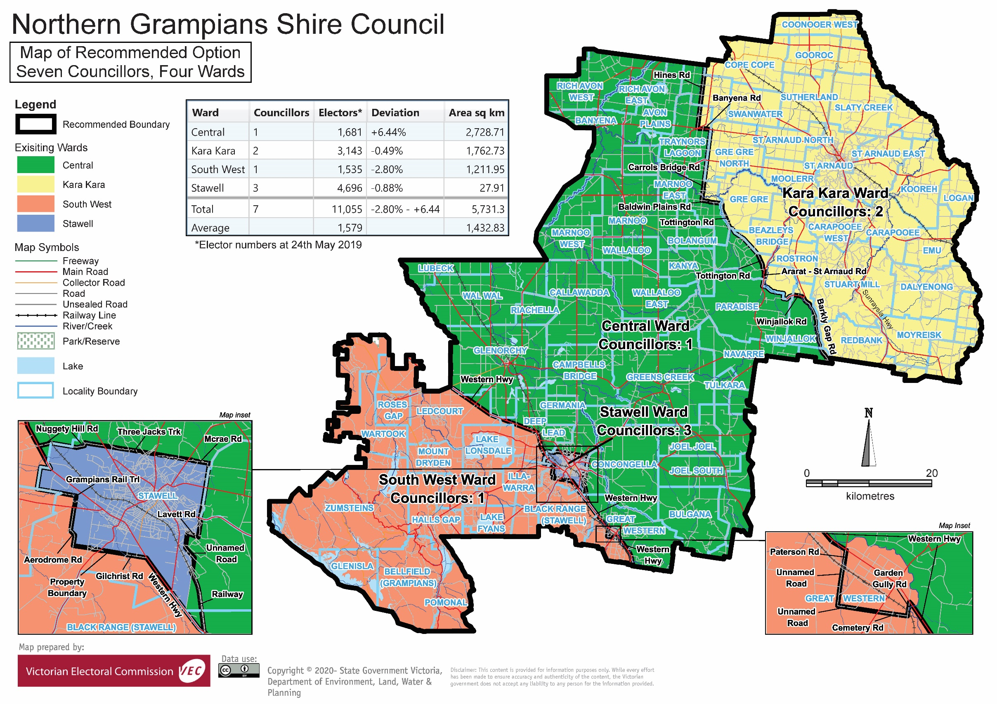

# Appendix 3: Public information program

Advertising

In accordance with the Act, public notices of the review and the release of the preliminary report were placed in the following newspapers:

|  |  |  |
| --- | --- | --- |
| **Newspaper** | **Notice of review** | **Notice of preliminary report** |
| *Herald Sun* | Thursday 24 October 2019 | Wednesday 29 January 2020 |
| *Stawell Times News* | Friday 18 October 2019 | Friday 24 January 2020 |
| *St Arnaud North Centre News* | Wednesday 23 October 2019 | Wednesday 29 January 2020 |
| *The Weekly Advertiser* | Wednesday 23 October 2019 | Wednesday 29 January 2020 |

Media releases

A media release was prepared and distributed to local media to promote the commencement of the review on Thursday 24 October 2019. A further release was distributed with the publication of the preliminary report on Friday 24 January. A final media advisory was circulated on the publication date of this final report.

Public information sessions

Public information sessions for people interested in the review process were held on:

* Tuesday 29 October 2019 in the Perry Room, St Arnaud Town Hall, 40 Napier Street, St Arnaud
* Wednesday 30 October 2019 in the Council Chambers, Pleasant Creek Historic Precinct, 50-52 Longfield Street, Stawell

Submissions guide

A submission guide was developed and made available on the VEC website, or in hardcopy on request, throughout the review timeline. The submission guide provided information about the review, the review timeline and how to make submissions to the review.

Online submission tool

An online submission tool was developed and made available during the submission periods of the review. The tool allowed people to make a submission from the VEC website. During the preliminary submission stage, users also had the opportunity to map out their preferred subdivisions through the online submission tool using Boundary Builder. Boundary Builder included real elector numbers so that users could see if their preferred structures and numbers of councillors met the plus-or-minus 10% rule.

VEC website

The VEC website delivered up-to-date information to provide transparency and facilitate public participation during the review process. All public submissions were published on the website.

Email and social media engagement

The VEC delivered an information email campaign targeted at known community groups and communities of interest in the local council area. This included a reminder email at each milestone of the representation review process.

The VEC also published sponsored social media advertising that was geo-targeted to users within the local council area. This included advertising at both the preliminary submission and response submission stages. The total reach of these posts was 2,951during the preliminary submission stage and 3,129 during the response submission stage.

Council communication resources

The VEC provided the Council with a communication pack that included information on the review in various formats. While the council is encouraged to distribute this information and raise awareness about the review, the VEC is an independent reviewer and all communications resources include reference and links to the VEC website and core materials.

|  |
| --- |
| **© State of Victoria**  (Victorian Electoral Commission) **March 2020** |
| This work, Local Council Representation Review – Final Report Northern Grampians Shire Council, is licensed under a Creative Commons Attribution 4.0 licence (http://creativecommons.org/ licenses/ by/4.0/). You are free to re-use the work under that licence, on the condition that you credit the State of Victoria (Victorian Electoral Commission) as author, indicate if changes were made and comply with the other licence terms. The licence does not apply to any branding, including government logos. |
|  | |
| Level 11, 530 Collins Street  Melbourne Victoria 3000  T 131 832  info@vec.vic.gov.au  vec.vic.gov.au | |
|  | |



1. Section 219D of the *Local Government Act* *1989.*
2. Section 219D of the *Local Government Act* *1989.*
3. Ibid.
4. .id is a consulting company specialising in population and demographic analysis and prediction information products in most jurisdictions in Australia and New Zealand.
5. Section 5B(1) of the *Local Government Act 1989.*
6. Department of Environment, Land, Water and Planning (DELWP), Planning Schemes Online, Northern Grampians Planning Scheme, <https://planning-schemes.delwp.vic.gov.au/schemes/northerngrampians>, accessed 19 November.
7. .id, ‘Northern Grampians Shire: community profile’, <https://profile.id.com.au/northern-grampians>, accessed 19 November 2019.
8. Australian Bureau of Statistics (ABS), ‘2016 Quickstats: Northern Grampians (S)’, <https://quickstats.censusdata.abs.gov.au/census_services/getproduct/census/2016/quickstat/LGA25810?opendocument>, accessed 19 November 2019.
9. .id, ‘Northern Grampians Shire: community profile’, <https://profile.id.com.au/northern-grampians>, accessed 19 November 2019.
10. ABS, ‘2016 Quickstats: Northern Grampians (S)’, <https://quickstats.censusdata.abs.gov.au/census_services/getproduct/census/2016/quickstat/LGA25810?opendocument>, accessed 19 November 2019.
11. Ibid.
12. Ibid.
13. Ibid.
14. ABS, *Census of population and housing: time series profile, Australia, 2016,* 2003.0, 2017.
15. ABS, *Census of population and housing: general community profile, Australia, 2016,* 2001.0, 2017.
16. ABS, *Census of population and housing: time series profile, Australia, 2016,* 2003.0, 2017.
17. id, ‘Northern Grampians Shire: community profile’, <https://profile.id.com.au/northern-grampians>, accessed 19 November 2019.
18. ABS, *Census of population and housing: time series profile, Australia, 2016,* 2003.0, 2017.
19. Department of Environment, Land, Water and Planning (DELWP), *Victoria in Future 2019,* 2019, <https://www.planning.vic.gov.au/land-use-and-population-research/victoria-in-future> , accessed 15 August 2019.
20. .id, ‘Northern Grampians Shire: community profile’, <https://profile.id.com.au/northern-grampians>, accessed 19 November 2019.