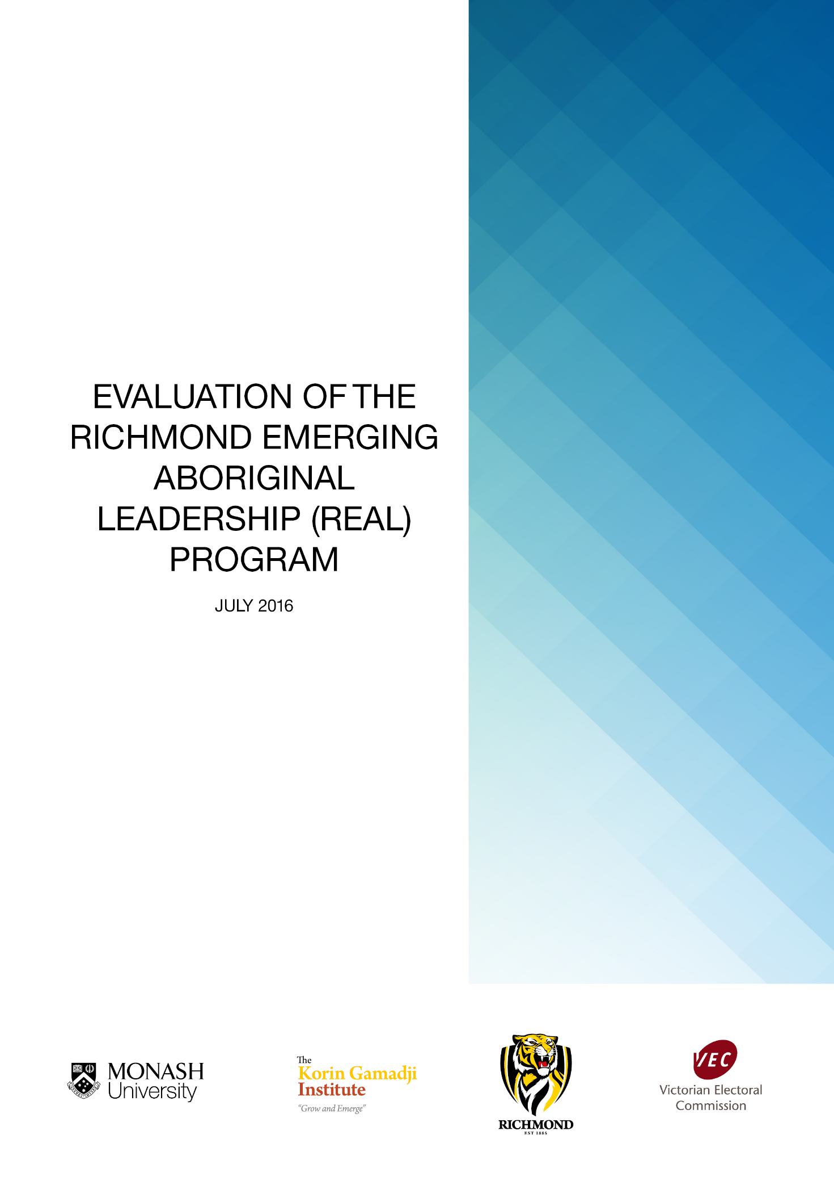

Table of Contents

Table of Contents 1
Executive Summary 3
The Evaluation Team 8
PART A: Background and Methodology 9
About the KGI REAL Program 9
Research Objectives and Methodology 10
The Interviews 11
The Survey 12
The Focus Groups 12
PART B: FINDINGS IN RELATION TO PROGRAM OBJECTIVES 16
1. Overall program effectiveness 17
2. What are the most effective elements of the program that achieve the stated objectives? 21
3. Does the age at which a participant first experiences the intensives have any impact? 25
4. What are the effective elements of the program between the two intensives? 27
5. Participants’ recognition of the connection between politics and their issues. 29
6. Understanding of and confidence in the electoral process. 35
7. Propensity to enrol and vote when of age. 41
8. Understanding about the importance of personal and community health, the incidence of key health issues, and the actions that can be taken to improve their personal health. 46
9. Sense of cultural identity, improved awareness of family connections, and understanding of Koorie culture. 50
10. Understanding of the various career and personal development pathways. 54
11. Participants are equipped with skills to become active citizens within their wider communities (leadership). 58
11.1 What leadership means to participants individually. 59
11.2 Program participants are more likely to be active participants in their community (which may include involvement in community events, clubs, school programs or leadership roles). 69
12. How they can demonstrate leadership across a range of settings, and identify current and past Aboriginal and Torres Strait Islander leaders. 72
SUMMARY OF FINDINGS 75
PART C: Recommendations 78
APPENDICES 84
References 85
Student Survey on the Effectiveness of the Korin Gamadji REAL Program 87
Staff Interview questions 101
Parent Interview Questions 102
Issues that Matter 103

Executive Summary
Late in 2015 the Victorian Electoral Commission (VEC) and the Tigers in Community Foundation Limited through the Korin Gamadji Institute (KGI) contracted the Monash University Faculty of Education to undertake evaluation of the Richmond Emerging Aboriginal Leadership (REAL) program. The purpose was to evaluate the effectiveness of the REAL program in assisting selected Aboriginal and Torres Strait Islander boys and girls between the ages of 14–17 to develop their confidence, self–belief and leadership attributes and to encourage them to become actively involved in their local and broader communities. The evaluation was conducted against defined objectives of the VEC and the KGI.
This report draws from interviews, surveys and focus groups from all relevant participants including a control group of Indigenous youth who had not participated in the REAL program. The report utilises an Indigenous "storytelling" methodology that seeks to highlight and honour the authentic voices of research participants.
The report is divided into three parts:
Part A provides an overview of the program and the methodology used in this evaluation.
Part B includes the findings of the evaluation of the effectiveness of the program in terms of the detailed objectives of the VEC and the KGI.
Part C provides a number of recommendations for the KGI REAL program in future.

Key findings based on the VEC sponsorship objectives and the KGI REAL program objectives
A number of key findings related to the strengths and successes of the program in relation to its key objectives are notable.
1. Overall program effectiveness
Participants rated highly the value of the program in providing socialising, networking and other opportunities for participants to connect. The development of leadership skills also rated highly.
The focus groups highlighted key psychological factors that enabled active participation such as self–belief, self–image, confidence, being courageous, pride in the culture, and passion. This is arguably one of the greatest strengths of the program.
2. What are the most effective elements of the program that achieve the stated objectives?
The REAL program intensives have overall provided a strong platform for Aboriginal youth to work on shaping their identity as Indigenous Australians, holding especially true for participants from metropolitan areas where access to cultural contexts are few and far between. For some of these young people, the various REAL program intensive activities conducted by the Indigenous presenters provide an opportunity for them to unpack questions about their own identity at a very close and personal level.
3. Does the age at which a participant first experiences the intensives have any impact?
The survey data suggests a high correlation between the age of starting and the degree of engagement in the program. The best starting age is 13 to 14 years, as 16 year olds may have already become too solidified in their views to respond to the program’s purposes. This is reflected in the data from the surveys. In each instance, a greater combined proportion of the younger group compared with the older group is either ‘highly confident’ or ‘confident’.
4. What are the effective elements of the program between the two intensives?
School was a key site at which elements of the program were operationalised between the intensives. Developing more confidence in making decisions at school, as well as about life in general, was found quite frequently amongst participants and their parents. A disconnect between the intensives was noted by staff and parents and the young people, suggesting that more continuity is needed between what goes on within, between and beyond the program intensives.
5. Participants’ recognition of the connection between politics and their issues.
A significant majority (75.7%) of REAL participants were ‘somewhat confident’ to ‘very confident’ in their ability to recognise the connection between politics and their own local and broader community issues. They were more confident that they have a good understanding of how society works in relation to laws and systems compared to the control group.
6. Understanding of and confidence in the electoral process.
REAL participants demonstrated much higher levels of understanding around the electoral and voting system processes and acknowledged that the REAL program activities provided by the VEC and others as important for developing this understanding within them. After the program REAL participants were ‘confident’ or ‘highly confident’ (42.4%) that they have an understanding of the electoral and voting system compared to 31.2% of non–REAL participants. When the ‘somewhat confident’ category is included, 78.8% of REAL participants had an understanding of the electoral and voting system compared to 56.2% of the control group.
7. Propensity to enrol and vote when of age.
After having been part of the REAL program, participants were far more confident that they would enrol to vote (82.0%) compared to the control group (62.4%). 81.8% were ‘confident’ or ‘very confident’ that they would vote in State and Federal elections, compared to 37.6% of the control group. This indicates a high degree of impact of the REAL program on participants compared to the control group.
8. Understanding about the importance of personal and community health, the incidence of key health issues, and the actions that can be taken improve their personal health.
At the end of their participation in the REAL program participants had a strong or very strong understanding about all the various health related issues in comparison to the control group.
9. Sense of cultural identity, improved awareness of family connections, and understanding of Koorie culture.
The REAL program had a powerful impact on participants’ sense of their own cultural identity (86.6%) in comparison to the control group (50.0%). Participants in the program had a stronger sense of Koorie culture (83.3%) when compared to the control group (43.8%). Participants in the program also had a stronger sense of connection to their family (73.3%) compared to the control group (62.4%).
REAL Staff and program participants confirmed the impact of the program on cultural identity. Parents reinforced the impact of the program on participants’ cultural identity and the resultant impact on their engagement in school and the wider community.
10. Understanding of the various career and personal development pathways.
Over 93.3% of REAL program participants ‘agreed’ or ‘strongly agreed’ after the program that they understood what was available to them for personal career pathways while 86.6% had an understanding about different career pathways. There is a significant difference compared with the responses of the control group (93.3% and 62.4% respectively). These responses very strongly confirm the impact of the program’s objectives.
11. Participants are equipped with skills to become active citizens within their wider communities (leadership).
The REAL program made the participants feel very confident that they will use their new knowledge to take action in their communities (87.0%), which is a significant indicator of the success of the program. They were twice as confident (75.7%) that they could take action on issues compared to the control group (43.7%). The REAL program has clearly had a powerful effect on the participants in relation to this objective.
94.0% of REAL program participants were ‘highly confident’ or ‘confident’ of their understanding of leadership after the program compared to 56.2% of the control group. 69.6% of REAL program participants were ‘highly confident’ or ‘confident’ that they have had an exposure to leadership after the program compared with 56.2% for the control group. Clearly the objectives of the program have been met.
Participants from the REAL program in the focus groups overwhelmingly nominated the “Local” as their main site of influence. The school was typically mentioned, as well as home, football and netball clubs and the CFA. Leadership skills developed during the program intensives were applied in areas such as playing sport.
A need for more attention to developing political literacy emerged during the focus groups. REAL Staff agreed also that not enough time was available for citizenship work (political literacy).
12. How they can demonstrate leadership across a range of settings, and identify current and past Aboriginal and Torres Strait Islander leaders.
The REAL program was successful in developing leadership attitudes, skills and practices. This evaluation shows a powerful impact on participants’ confidence of their understanding of leadership, and they were four times more likely to be active in the community through leadership than the control group. REAL program participants were significantly more confident of their understanding of leadership after the program (93.3% compared to 56.2% for the control group). In addition, they were significantly more confident that they had the leadership skills to become active citizens in their communities (78.8% compared to 62.5% for the control group).
A number of key recommendations and their rationales are proposed in Part C of this report. In summary they are:
- Further develop the transformational model of leadership.
- Develop a more explicit component focusing on practical opportunities to engage in civics and citizenship education, in particular the development of political knowledge and literacy.
- Develop and extend more explicit opportunities for activities to reinforce the program learnings during, between and after the intensives.
- Provide regional opportunities for participants.
- Ensure appropriate and consistency in the program through staffing and skills.
- Develop a more rigorous evaluation mechanism focused on continuous improvement.

The Evaluation Team
Authors
Lucas Walsh, Peter Anderson, David Zyngier, Venesser Fernandes and Hongzhi Zhang.
Project Manager
Jasmine Evans
Indigenous Advisory Group
Inala Cooper, Jason Brailey and Kristel Keleher
The Yulendj Indigenous Engagement Unit provides support services to Indigenous students and is attached to the Office of the Vice Chancellor at Monash University. The Wurundjeri Tribal Land Council has given approval to use the word Yulendj as the name of the Indigenous Engagement Unit. Yulendj comes from the Woiwurrung language and means 'sense, intelligence'.
Research Assistance
Crystal McKinnon, Misol Kim and Dr Hongzhi Zhang.
Acknowledgement
The evaluation team would like to acknowledge the support of the Victorian Electoral Commission, KGI REAL program and Richmond Football Club in the assistance of this evaluation. In particular the authors are extremely grateful to Michael Lacy and Luke Murray for their support in organising the interviews, surveys and focus groups.
The evaluation team would like to also thank Bronwyn Dethick in the Faculty of Education, Monash University for her support and Qualtrics expertise.
The authors are also grateful to the following schools and organisations for their generous support in providing resources and venues to conduct the focus groups: Judy Curson, Carolyn O’Reilly and Elisabeth Murdoch College; Victoria Van Schie and Mildura Senior College; John Patten from the Bunjilaka Aboriginal Cultural Centre; Alana Paszko from the Melbourne Museum; Donna Wright and Matthew Ondarchie from the City of Whittlesea; and Lisa Anderson and Eric Clarke from the Department of Education and Training.
And a final thanks to the young people and their parents who participated in this evaluation.

PART A: Background and Methodology

About the KGI REAL Program
The Richmond Emerging Aboriginal Leadership (REAL) Program recruits Aboriginal and Torres Strait Islander boys and girls between the ages of 14–17 with the aim of developing participants’ confidence, self–belief and leadership attributes and encouraging them to become actively involved in their local and broader communities. Participants’ teachers nominate participants on the basis of good school attendance and leadership potential.
Intensive sessions in camp format are run over four days during school holiday periods within the Victorian school year. Each participant has the opportunity to attend two intensives over consecutive years. The intensives provide information on issues such as leadership, active citizenship, political literacy, health and wellbeing, education and employment pathways in a fun environment. They also allow time for participants to develop skills in areas of interest such as sport, dance, art, music, multimedia etc., developing aspirations in personal and career pathways. In between the intensives, there are a number of additional interface activities.
The Young Men’s Christian Association Victoria (YMCA) is the organisation engaged by the KGI to work with them to deliver the program against KGI’s requirements. It is also responsible for conducting the intensives. YMCA volunteers are involved in delivery, together with Aboriginal presenters and partner organisations identified by the KGI (such as the VEC).

Research Objectives and Methodology
Objectives
The effectiveness of the REAL program was evaluated against the following sponsor program objectives:
VEC sponsorship objectives
- Participants’ recognition of the connection between politics and their issues
- An increased understanding of, and confidence in, the electoral process
- An increased propensity to enrol and vote when of age
- Participants are equipped with skills to become active citizens within their wider communities (leadership)
- What are the effective elements of the program at the interface between the two intensives?
KGI REAL program objectives
- Program participants are more likely to be active participants in their community (which may include involvement in community events, clubs, school programs or leadership roles)
- Greater understanding about the importance of personal and community health, the incidence of key health issues, and the actions that can be taken improve their personal health
- Participants have a stronger sense of cultural identity, improved awareness of family connections, and understanding of Koorie culture
- Participants have a greater understanding of the various career and personal development pathways
- Participants have considered what leadership means to them individually, how they can demonstrate leadership across a range of settings, and to identify current and past Aboriginal and Torres Strait Islander leaders.
When examining the effectiveness of the program against these objectives, a subset of questions were investigated:
- Does the age at which a participant first experiences the intensives have any impact?
- How does a control group of Aboriginal young people aged 14–17 who have not attended the intensives compare across the measures?
Methodology
The evaluation report draws from survey data, focus groups and interviews and utilises an Indigenous "storytelling" methodology that seeks to highlight and honour the authentic voices of research participants, as described below.
Ensuring Ethical Research
Prior to commencing the evaluative research, appropriate permission was sought from the Monash University Human Research Ethics Committee. The advice of our Indigenous Advisory Group (IAG) was essential to ensure that this evaluation was conducted with appropriate cultural awareness and sensitivity. The Monash project team consulted with the Yulendj Indigenous Advisory Group to ensure this.

The Interviews
KGI and VEC Staff
Altogether six phone semi-structured interviews, three with KGI and two with VEC staffers and one interview with a YMCA presenter were conducted. Each interviewee was sent the questions beforehand by email together with the appropriate consent and explanatory forms. Interviews lasted between 30 and 60 minutes. The interviews were transcribed and analysed using the following coding themes: Identity; Leadership; Community; Political Literacy; and finally Recommendations. The staff interview questions can be found in the Appendices. Other artefacts, such as past evaluations, email and social media communication, were provided by KGI and were also reviewed.
Indigenous Parents
As a part of the evaluation, eight parents were interviewed about their perceptions of the REAL program. Each interviewee was sent the questions by email beforehand together with the appropriate consent and explanatory forms. The interviews lasted between 30 and 60 minutes. They were transcribed and analysed using the same coding themes as above. Parent interview questions can be also found in the Appendices.
Indigenous Youth
Two groups of young Indigenous people aged 14–17 participated in the data collection via surveys and focus groups:
REAL Participant Group: 58 REAL Program current participants were sourced from a database provided by KGI. In order to participate these young people were nominated by a teacher or Koorie Education officer. In the words of one KGI staff interviewee, student participants “have to have had a reference from someone that has regular contact with them, a reference saying that they are one, attending school and two, have leadership potential ... It’s not a program that’s based on deficit. We’re not running a program that’s supporting the most disadvantaged Aboriginal kids in Victoria. We’re trying to deliver a program that’s supporting the kids with the most potential”.
Non-REAL Participant Group: A control group of 23 Aboriginal and Torres Strait Islander youth were sourced through a snowballing technique, where participants from Group 1 were asked to nominate and or invite friends and relatives of appropriate age and location to participate in the evaluation. In addition, participants were sourced through liaison with Koorie Education Co-ordinators and Koorie Education Support Officers in the Department of Education and Training and through direct liaison with selected schools.

The Survey
An online survey was developed for the two participant groups. Demographic and attitudinal data were collected in order to respond to the VEC–KGI REAL program objectives as detailed in the documentation provided by the VEC (pp.2–3). Survey data was collected about the background of young people and their participation as outlined in the discussion below. The survey combined quantitative (5 point) Likert scale questions, providing the opportunity for respondents to add open text responses justifying and or explaining their choices.
The 70 (54 REAL and 16 non–REAL) participants who completed the survey and provided contact details were eligible for vouchers and a draw prize. The full surveys can be found in the Appendices.

The Focus Groups
Focus group methodology is a well–recognised means of encouraging people, including young people, to describe their experiences in their own terms (Yin, 2003). Focus groups were used to foster synergistic or snowballing insights through the interactions of the group that were not possible within a one–to–one interview (Wilkinson & Birmingham, 2003). The methodology provided critical insights in fields such as youth participation that are characterised by varying or contradictory perspectives (Neuman, 2003). During this process, respondents were engaged in a culturally sensitive manner under the supervision of the Indigenous Advisory Group.
For the focus group discussions involving participants in the REAL program, semi–structured questions and themes were also explored that directly related to the participant’s experience of the REAL program:
- Are young people activated by the program?
- How is the program translating into school and other parts of their lives?
- To what extent are participants actively engaged in making change in their communities (e.g. writing to their local council?)
- To what extent are participants engaged as peer leaders? (They might be actual leaders of the program in future).
- To what extent do participants feel valued, a part of something, aware of their talents, and aiming for personal high performance?
Focus Groups were conducted with participants in the REAL program and a group who had not participated in the program. Participants from the REAL program included those just entering the program and those who are currently in it. The sampling intention here was the creation of two purposive, parallel critical cases (Flyvberg, 2006; Yin, 2003) to provide reinforcing or varying insights into the various forces that influence the experience of REAL Program participants. It sought to determine the cumulative effect of any interface activity participation on the REAL Program objectives. Where the survey data sought to capture key demographic information and other data related to participation, the focus group evaluation adopted a methodology seeking to explore young people’s perceptions and experience of power and participation by investigating different modes or ‘channels’ of influence and participation through interactive focus group sessions (Walsh and Black, in press).
Six focus groups were conducted for each of the participant groups during April, May and June of 2016. Focus groups were limited to between 8–10 participants. Focus groups were held in two regional centres (Mildura and Rowsley) as well as locations in Melbourne (including the KGI ME Bank Centre at Punt Road Oval and Museum Victoria).
The following four activities were conducted to generate discussion, research data and as a means of exploring the questions raised above.
Exercise 1: Issues that Matter
Participants were asked to identify the issues that are important to them. Using Mission Australia’s list of 15 issues of importance to young people (Mission Australia 2012) participants selected three of those they consider most important.
- Adolescence/youth
- Alcohol and drugs
- Bullying
- Crime, safety, violence
- The economy & financial matters
- Education
- Employment
- The environment
- Equity and discrimination
- Health
- Homelessness/housing
- LGBT issues
- Mental Health
- Politics and societal values
- Population issues
- Other: Women's interests political participation
- Other: Equal access to technology for communication and creative self–expression
- Other: family/community connection (cultural leadership)
If none of the listed issues were pertinent, the participants were invited to add in their own.
Exercise 2: Spheres of Influence
Participants were then asked to think about their experience as a young person of potential influence. They were asked to position where they thought they had influence at local, national and global levels (they could pick more than one sphere or overlap them):

Exercise 3: Perceived Influence
Two questions were then posited to all focus group participants to understand what enablers and barriers were perceived by them to impact on their capacity to influence and shape their worlds and potentially address key issues of concern:
- What are the barriers to young people influencing society; and
- What are the enablers to them influencing society?
Exercise 4: Engaged and Empowered
Drawing from the methodology of Arvanitakis (in Arvanitakis and Sidoti 2011), participants were then asked to explore and place themselves within the four possible combinations of engaged, empowered, disengaged and disempowered. The tables below were posted on A3 posters at each venue. Participants wrote their name on a post–it note and stuck it on where they saw themselves, related back to the issues of concern identified in Exercise 1.
‘Engaged’ suggests being interested and keen to be involved. ‘Disengaged’ suggests a disinterest in any particular issue. ‘Empowered’ suggests a feeling of being able to participate, influence and make change. ‘Disempowered’ suggests a lack of agency to participate, influence and make change.

PART B: FINDINGS IN RELATION TO PROGRAM OBJECTIVES
The following findings incorporate data from all aspects of the evaluation, including the survey (both quantitative and qualitative data), focus groups, parent and staff interviews and related artefacts collected (such as past evaluations). The findings are organised firstly in terms of responses to the overall program effectiveness and key strengths, and then in terms of the main objectives of the program. Related research questions are woven throughout the following discussion. Each section begins with top-line findings.
The following survey results highlight the most favoured and least favoured aspects of the program, according to its participants. Survey respondents rated highly the value of the program in providing socialising, networking and other opportunities for participants to connect. The development of leadership skills also rated highly. On the other hand, as Figure 1.2 suggests, a significant proportion felt that the program is too short. This view was affirmed by the focus groups.

1. Overall program effectiveness
KEY FINDING: Participants feel very confident that they will use their new knowledge to take action in their communities. They also want to remain connected to the program after its completion and would recommend it to their friends.
The following survey results highlight the most favoured and least favoured aspects of the program, according to its participants. Survey respondents rated highly the value of the program in providing socialising, networking and other opportunities for participants to connect. The development of leadership skills also rated highly. On the other hand, as Figure 1.2 suggests, a significant proportion felt that the program is too short. This view was affirmed by the focus groups.
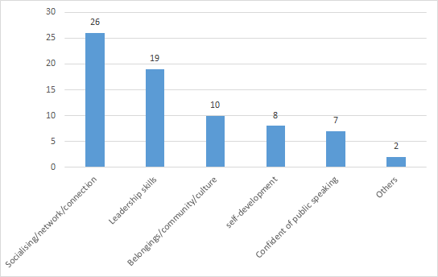
Figure 1.1: What I liked the most about the REAL Program intensives
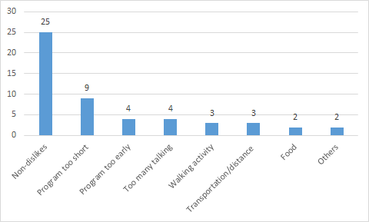
Figure 1.2: What I liked the least about the REAL Program intensive
The above two figures indicate the success of the program’s focus on creating connections to community and leadership and the fact that there were many who could not find anything to dislike about the program except that it was too short.
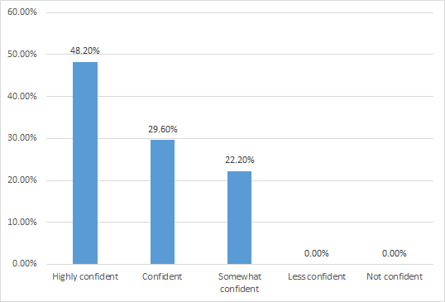
Figure 1.3: How confident am I that I will make connections back to the REAL program?
This figure shows a very strong desire of participants to reconnect with the REAL program. Some of the many positive comments in the survey responses provide insight into this desire:
I’ve always wanted to do something for the Aboriginal people so I think KGI will help me do that
I’ll always be part of the KGI team, they’re my family and I’ll do whatever I can to be part of it
It’s very inclusive and continue to offer me opportunities after completing my alumni camp
Because they have taught me to be a better person
I really enjoy doing the programs and I want to give back to the KGI for the programs
Already I have made connections back to KGI, being given the opportunity to be involved in the Laguntas netball is just the start and I highly doubt that will be the last connection as KGI has been such an amazing opportunity for me in the first place
It taught me to be a better leader and it built up my confidence so it would be good to go back again and show the younger ones how to become a leader
It made me feel worthy, made me feel like I could make a difference. [Survey Responses]
Focus group participants affirmed a strong desire to stay connected to the program and peer networks developed as a part of it.
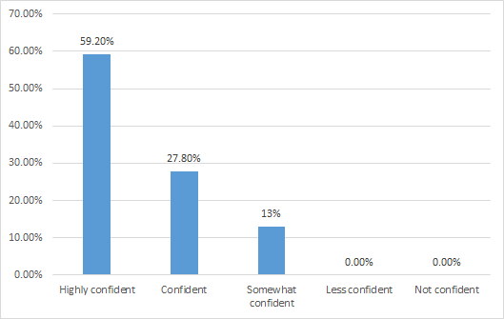
Figure 1.4: How confident am I that I will use my knowledge gained through this program by taking action in my community?
The REAL Program has made all participants ‘confident’ that they will use their new knowledge to take action in their communities. 59.2% of participants felt ‘highly confident’, 27.8% felt ‘confident’ and ‘13.0% felt ‘somewhat confident’. The combined responses of the two largest groups (87.0%) strongly confirm the success of the program.
A sample of the many positive comments in the survey responses is given below:
The KGI program gave us heaps of options of how we could help out the community and I’m highly confident that the things I’ve learnt in KGI will help the community I’m in
I have been noticed in my community to be stepping up to take charge and lead which I can say came from the REAL program
At school I’ve already used my leadership knowledge that I have gotten from the REAL program
I’ve been given more roles and opportunities in my local community since doing KGI
Without the REAL program I wouldn’t have had the knowledge or confidence about leadership and taking action in my community. So far since these programs, I have experienced and done things that I would not have done before if I hadn’t gone on these camps. [Survey Responses]

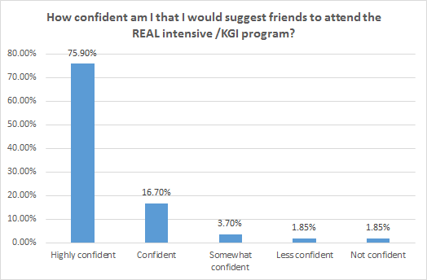
Figure 1.5: How confident am I that I would suggest friends to attend the REAL intensive program?
92.6% of participants would recommend the REAL Program to their friends. In fact many commented that they had already recommended the program to their friends and family members too. Survey respondents comments included:
You gain a lot from the program
It was a great experience for young people to learn about their culture and leadership
The program engages Indigenous youth to become greater people in their communities
It is a life changing experience. [Survey Responses]

2. What are the most effective elements of the program that achieve the stated objectives?
KEY FINDING: The program develops individual and collective identity, confidence and connectedness to community.
I think the biggest way it benefits is that too often Aboriginal and Torres Strait Islander people from across Victoria, stay within community, so especially young people, they go to school in their community but the KGI Real program gives them a space to come together from all different tribes and clans but also different communities. [KGI Staff Interview]
Based on data from surveys and responses from focus groups, parents and staff interviews the REAL program intensives have overall provided a strong platform for Aboriginal youth to work on shaping their identity as Indigenous Australians, holding especially true for participants from metropolitan areas where access to cultural contexts are few and far between. For some of these young people, the various REAL program activities conducted by the Indigenous presenters provide an opportunity for them to unpack questions about their own identity at a very close and personal level: Who they are at a personal level and then at a community level? Where do they belong? What is their identity and role as young Indigenous Australians? Parents also highlighted the ways that the program strengthened identity.
Anecdotal feedback from the focus groups suggests that the experiences that they gain through the time spent at the REAL program intensives allow them to have an opportunity to look at themselves closely and gain an understanding of some of their strengths and weaknesses. Having this experience shared with other young people of a similar background further helps them in unpacking some of their inner conflicts, questions and possibilities. This appears to be in part why they developed a strong emotional contract with the REAL program. Interestingly, this is also affirmed in the interviews with KGI–VEC staff and through the voices of the parents of these young people. The program intensives provides both metropolitan as well as country Indigenous youth with an opportunity to connect with other Koori young people and make a connection with their Indigenous culture.
Another parent described how this program provided an opportunity for Aboriginal kids to get a better grounding and understanding of who they are and how they can shape their identity. In fact, for some of the parents, this was the reason their children were being encouraged to attend the program. In their words, “I felt it was a great opportunity for them to focus on themselves as young Indigenous people (emphasis added). And so I felt them being around young Aboriginal people the same ages as themselves and doing some specific leadership, tailored specifically for Aboriginal youth was a great opportunity for them.”
The REAL program appeared to be very timely for a number of Aboriginal young people who need a positive voice in the identity-shaping years of their life. As one parent described it, the REAL program intensives provided her daughter an opportunity to become a more confident and positive young person. The program has provided these young people with an avenue to shape and develop their identity and also demonstrate who they are to others. According to the parents the young people love going away on the program intensives and being with their peers.
The literature affirms that specific planned experiences which provide them with opportunities to explore their individual culture and community are vital in the process of their youth development (Freeman, 2014). The focus group and parent interviews suggest that, at and through the program intensives, young people develop a strong bond with their cultural identity and in their community of young Aboriginal people, while the specific activities that focussed on analysing their life greatly assisted in them making better choices for themselves. This in effect can be seen as the shaping of a collective identity between the participants of the program.
Participants and their parents (as well as KGI and VEC staff) both value this aspect of the program and its effectiveness can be seen through the growing maturity and confidence found within participants over their years of being a part of the program. This confidence is discussed further below.
The power of being able to be amongst their own Aboriginal young people and unpacking their own identity was also voiced by another participant, “Mum, it’s fantastic. It’s really good being away for that period of time, getting to know other Aboriginal people, and knowing that they have issues too with identity and how to express themselves as Aboriginal kids, especially when other kids ask you who you are and they might not believe you, so needing to know how to respond without being angry is really important.” This quote suggests quite powerfully how the REAL Program offers these Indigenous youth with a valuable opportunity of being able to interact with others while understanding personal issues around self, self–concept and their own identity. In line with their Aboriginal culture, this experience provides significant opportunities to understand who they are and how they connect within their community. This in effect is a core essential in developing young people as future leaders.
The focus groups also reported greater connection to the local community through the activities. This is consistent with parents’ views, who reported the importance of: community; Aboriginal community; and giving back to the community, such as through getting involved in co–ops. Related benefits noted in the focus groups included the development of resilience in relation to racism and a greater recognition and affirmation of cultural identity.
Other key themes emerged during the focus groups as to the benefits of the program activities, as suggested above, including how the REAL program builds confidence, particularly in relation to public speaking and developing “a strong voice”. [Focus Group Participant] As one female from a regional focus group suggested: “I reckon that’s a really big support because a lot of us, as I’ve noticed on our camps, we come here really shy and just in our shell but as the camps go on we slowly break out of that shell and we gain leadership knowledge and confidence...” [Focus Group Participant] Another female participant said “When I first went on camp I had no confidence, I would hate speaking in front of everyone and then when I left the camp I had confidence” [Focus Group Participant] “and I’m really good at speaking in class.” [Focus Group Participant]
This confidence, in turn, flowed through to helping participants overcoming the challenges of cultural stereotyping. Several participants highlighted how this confidence was developed through overcoming perceptions that they were somehow less or not Indigenous because of the (lighter) colour of their skin or their surname. [Focus Group Participants] One female noted how “It’s kind of hard. Yeah, you know, so it was kind of hard to be like, be proud, because you always got that discrimination. Even you find, ’You’re not black, you’re white, look at you.’ And stuff like that. So they’ve gone, like KGI, because I do lots of cultural stuff it makes you more proud and confident.” [Focus Group Participant] They felt supported and encouraged by the program.
The importance of acceptance is a theme that emerged from the focus groups. Participants in the focus groups highlighted how the program developed a strong sense of community shared by participants, who mutually supported each other: “the good thing about it too is you’ve got other people that are in the same boat as you.” [Focus Group Participant]. Participants from previous years echoed this. According to one Facebook review on the KGI Facebook page from 31 May 2014:
KGI has seriously changed my life for the better. It's given me the most amazing role models and given me purpose back in my life. It's a place where everyone whether they’re youth or leaders believe in each other and it's a guarantee that you create deadly memories and friends for life. You don't need to wear masks or be a person you’re not you’re accepted for who you are flaws and all. Everyone should get behind KGI and embrace their spirit. You are filled with so much pride and develop a new respect for our culture. Thank you KGI [Facebook Post]
One male participant highlighted how “You barely know anyone [when] you go there, but they [are] just there for the same reason as you so together you help each other.” [Focus Group Participant] Being with “… people exactly like you, doing the same thing… you help each other get out of your shell.” [Focus Group Participant] A female participant from the regional focus group recalled how “…in a school environment I feel anxious and stuff, it just—like at my school for instance I’m the only Indigenous person in that year level, ... and it’s like we’re four of us, but when you’re at these camps everyone else is like [you], your confidence builds because you know you’re not one of those Indigenous people that are just [not good enough] and you feel more confident and stuff like that. Yeah it just, you can feel it, you’re more confident.” [Focus Group Participant]
By “meeting other people” [Focus Group Participant] and “getting out of your comfort zone… like other people that you don’t know, meeting other people and stuff” [Focus Group Participant], the program helped to develop a sense of family, which was seen to be important “Because they’re the people you feel most comfortable around” [Focus Group Participant], and “and that have your back.” [Focus Group Participant]
Visible connections were evident between the program and the value of “Being involved in the community… Where there’s like events going on to go and help out.” [Focus Group Participant] This suggests an attitude emerging from the program that could translate into greater community engagement: “Yeah, say if your health service chucked on a function or something, just go and help out and set up.” [Focus Group Participant]
Courage was another attribute to emerge as a result of the program. [Focus Group Participant] Resilience was a key theme to emerge during the focus groups. One female participant summarised it as the will to “keep trying”. [Focus Group Participant] Another female participant felt that: “From KGI you kind of get this strength instilled in you so that when you’re unleashed back into society you find that again and you can stand up for yourself and be like ‘No, that’s not right.’ or ‘Yes, that is but there’s also this.’” [Focus Group Participant] Another focus group member expanded on this:
I think also the general conversations you have with peers who are on the programs you talk about your experiences at school if you’ve dealt with something like that and it helps you gain that strength to actually say ‘They went through the same thing and obviously it’s not the right thing to be happening’, and you build up that strength to be ‘No, that’s wrong’ because we don’t want it to happen to the next person. That general talk with your peers actually helps you go back to your school and deal with the problems. [Focus Group Participant]
Connection to peers is a powerful outcome of the various program activities. This is evident both in the focus groups and in the evaluation from the REAL program intensive Phase 1 (April 2016), which asked: “During the program what session made the biggest impression on you and why?” One participant responded that “The session we had last night because I didn’t realise how many friends I made and been for [me] and it really touched me.” [2016 Evaluation]

3. Does the age at which a participant first experiences the intensives have any impact?
KEY FINDING: The best age to start the program is 13 to 14 years of age.
KGI staff report that the best starting age is 13 to 14 years, as 16 year olds may have already become too solidified in their views to respond to the program’s purposes. This is reflected in the following data from the surveys. In each instance, a greater combined proportion of the younger group compared with the older group is either ‘highly confident’ or ‘confident’.
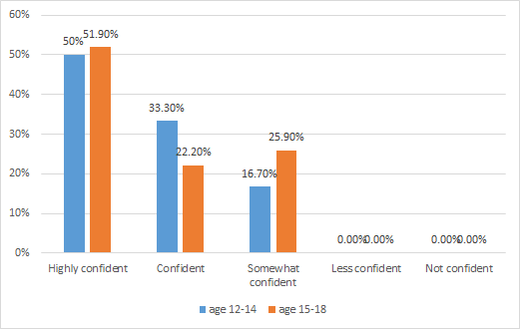
Figure 3.1: Age of starting REAL intensives and confidence that I will make connections back to the REAL program

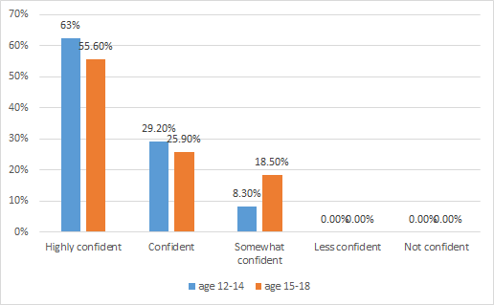
Figure 3.2: Age of starting REAL intensives and confidence that I will use my knowledge gained through this program by taking action in my community
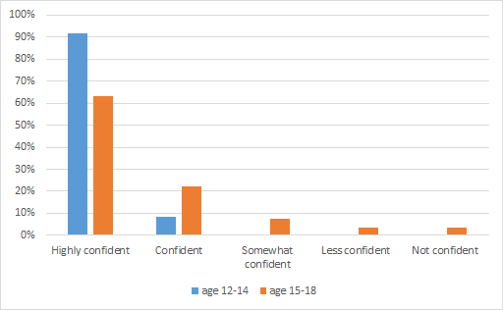
4.5%
4.5%
8%
21%
9%
62%
91%
Figure 3.3: Age of starting REAL intensives and confidence that I would suggest friends to attend the REAL intensive/KGI program
Both age groups clearly are either ‘highly confident’ or ‘confident’ that they would recommend the program to their peers. However, the younger group (99%) were more confident overall than the older group (83%).

4. What are the effective elements of the program between the two intensives?
KEY FINDING: Learning from the program is utilised at school and in the community, particularly through peer leadership.
Confidence as leaders built in the program through its planned activities extends to life beyond the program intensives. It was found that “when you come home from those camps you just really feel an internal confidence boost within yourself and, yeah I think that’s what I really enjoy about those camps too.” [Focus Group Participant] Participants added that:
I feel like that really explains and it’s really true to itself because it’s like you grow, in five days you grow a lot and you really do emerge and stuff, and when you come back I know myself I’m a totally different person to when I went. Now I’m still like that different person because you just grow and you get all this new knowledge and confidence, and you really grow and just, yeah become the better person that you can be. [Focus Group Participant]
And like now I will actually run into it, I’ll actually try and get the rest of the group to actually contribute and stuff. [Focus Group Participant]
School was a key site at which elements of the program were operationalised at the interface between the intensives. Developing more confidence in making decisions at school, as well as about life in general, was found quite frequently amongst participants and their parents. As one parent noted:
I think with school, it’s helped him make some decisions. Rather than asking me or his dad, ‘What should I do?’ he has actually come forward to say, ‘I want to do this, but I don’t want to do that,’ and he’s given good reasons for that. [Parent Voice]
Peer leadership in school and the community emerged as a theme amongst the focus groups. Leadership skills developed during the program intensives were applied in areas such as playing sport, “On the field and all that, playing sport, practice yelling out, do it loud and all that...” [Focus Group Participant]
One young female participant said: “it’s good to pass on that knowledge to the younger people and stuff like that, and you can bring it back to the community and speak up about certain issues that are happening.” [Focus Group Participant] Another female participant in another regional focus group highlighted how:
The KGI actually helped me because especially being in Year 12 you actually need it because our school, this year we’re trying to get more of the Year 12 to run assemblies and whatnot, so it’s actually brought more confidence in me, I will actually get up and do it without being real shy... Because when I was first on a KGI camp I didn’t talk to no one… [Focus Group Participant]
It should be noted, however, that interviews with VEC staff pointed to an apparent disconnect between the program intensives in relation to developing active citizenship that could be addressed in future programs as discussed in our recommendations:
When you’re talking about active citizenships really, you want it to be a bit more of a community development model where you’re in contact and you’re doing ongoing work with them. The KGI team could broker some ongoing relationships between our Indigenous officers and the kids locally, so when they finish a camp, and particularly between the first camp and the second camp. …. That was part of our original plan but it never actually kind of got off the ground, where we actually do some engagement with those kids in between the camps and work on some local issues with them or get them to be advocates in their community around political literacy and some civics and citizenship. [VEC Staff Interview].

5. Participants’ recognition of the connection between politics and their issues.
KEY FINDING: The program’s core areas of health and wellbeing, cultural identity and career pathways emerged as key areas of concern to participants. Participants reported being more engaged and empowered as a result of the program. 75.7% of REAL participants were ‘somewhat confident’ to ‘highly confident’ of their ability to recognise the connection between politics and their own local and broader community issues. This connection was largely perceived to be at the local level. Education and cultural identity were seen to be major enablers of active participation. REAL participants indicated much higher levels of understanding around the electoral and voting system processes and acknowledge the program for developing this understanding.
The starting point of the focus group discussions with REAL participants was to seek out what issues are important to them (see Appendices for responses). These issues were in alignment with the program’s focus on cultural identity, health and wellbeing and, to a lesser extent, career pathways. Issues rating highly as a concern included: alcohol and drugs, crime, safety, violence, education, equity and discrimination, health, including mental health. The identification of good health and wellbeing and education as bases for employment – all core areas of the program – rated most highly. For example, about 40.0% of focus group participants chose alcohol and drugs as their first issue of concern. 15.0% chose education as the first priority.
Focus group participants were asked about their experiences of the program and how the program shaped their thinking about leadership and connection between politics and the issues that they identified in Exercise 1. The program appeared to bolster participants’ orientation towards influence at the local level. Some participants indicated how the REAL program is beneficial in developing a local orientation to shaping community and society:
... after KGI I decided to join the Careers Council so ever since then they’ve been getting me to sit on panels to discuss Aboriginal issues and I think that not only engaged and empowered me but it gave me the opportunity to engage and empower others. [Focus Group Participant]
In one group, which included participants who were advanced in the program as well as newcomers, the majority (eight) indicated that they had become more engaged and empowered to participate and influence change as a result of the program. Some reported feeling engaged and empowered at the national level, attributing their engagement to the REAL program. For example, one female participant said that:
I guess for me with a national level I do feel engaged and empowered just because with KGI I’ve been given other opportunities as well as KGI. So last year I did Youth Parliament so that’s laws, national policy level. I felt like I could really make a change on behalf of Aboriginal people as well. [Focus Group Participant]
The program “gave me a platform to speak so I wasn’t just empowering myself, it was giving me the opportunity to inform them about experiences and the kind of got them to engage in further actions to stop like the stigma in education, in culture, all that kind of stuff.” [Focus Group Participant] Another female participant echoed this experience:
I think KGI’s given me the determination to look more deeply into things like at school I do legal studies and we’ve looked at the 1967 referendum and Koowarta versus Bjelke–Petersen in 1982 and it’s made me realise there’s still more work that needs to be done at a national level even though it happened in the past. I still feel like I’ve got the determination one day to change things on a national level sort of thing. [Focus Group Participant]
Another female added: “my first KGI was in year eight and I think I was the youngest in my group. It was like the third KGI camp. I was probably engaged but disempowered. I think I was 14 and I think KGI has given me the courage and the confidence to be more determined and as a ripple effect has led me to become more empowered.” [Focus Group Participant]
During focus group discussions, cultural identity as a basis for confidence and resilience also emerged as a powerful basis for active participation. Amongst the enablers to influence society identified in the focus groups included psychological factors such as self–belief, self–image, confidence, being courageous, pride in the culture, and passion. This is arguably one of the greatest strengths of the program.
With regard to the program’s emphasis on active participation, there was a feeling of agency amongst some REAL focus group participants to exert influence: “You have to go big to try and – I reckon in like the national scale they listen to kids more than the local.” [Focus Group Participant]

The following survey responses outline some key findings beyond the focus group discussions.
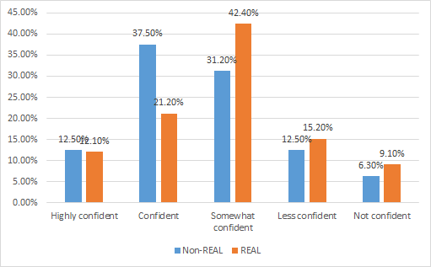
Figure 5.1: How confident am I that I can recognise the connection between politics and my own local and broader community issues (REAL and non–REAL participants)?
Discounting the ‘somewhat confident’ category, the non–REAL respondents appear to have more confidence in their ability to recognise the connection between politics and their own local and broader community issues (50.0%) compared to REAL participants (33.3%). However this may be due to actual reservations in the ability of the REAL participants after their exposure to more knowledge and experience. When the ‘somewhat confident’ to ‘highly confident’ responses of REAL participants 75.7% of REAL participants are able to recognise the connection between politics and their own local and broader community issues which is similar when compared to 81.2% of the control group.
REAL participants who chose ‘highly confident’ or ‘confident’ in the survey commented about this issue:
I know the right way to go about solving an issue in the community
I still believe I have a fair way to go to understand the connection between politics and community. But I do know that politics control finding and community action
I learnt how every community connects
I've learned how to understand what they're talking about
We learnt how to vote
The politicians have the power to improve or ruin communities through their decisions but ultimately it is the communities that choose our leaders. I tend to be in a lot of discussions regarding issues in politics about our communities but also trying to help raise awareness to others for the sake of our youth voice not being heard enough. [Survey Responses]
As suggested above, in the REAL focus groups, the main site for active participation was at the local level. Enablers that help to actively participate in and influence REAL participants’ worlds were identified. The local community is a key enabler of participation and influence. This includes school, social groups, youth parliament, and “community events so they can actually get out the word in front of everybody… For example, bullying and suicide around here is bad, around Sunraysia, so if they had someone come in and say [hold a community event] about that issue and then actually show you how many people have actually committed suicide from bullying…” [Focus Group Participant]
There were differences amongst focus group participants as to whether coming from a small local community is either an enabler or inhibitor to influence. One regional focus group participant suggested “because there’s such a small community they wouldn’t necessarily have a lot of, I don’t know, things that could contribute…” [Focus Group Participant] In another regional focus group, on the other hand, influence was seen to be more likely because of the size of the community in which they live: “Because we have a small community and people would listen to us” “and we have forums and stuff like conferences and that.” [Focus Group Participant]
There was some agreement that making change best starts at the local level as a basis for influencing the national through connecting with others as a foundation for collective action.
Education was seen to be another key enabler of their ability to participate in and influence society. [Focus Group Participant] In particular, lack of educational attainment was identified as a barrier to accessing political leadership roles: “well if say someone dropped out in Year 7 and they wanted to make a difference and try to become, like into say prime minister area, they wouldn’t allow him because he never completed Year 12, he’ll stuff the country. If someone did complete Year 12 they have more of a chance trying to get up there.” [Focus Group Participant] It was added that “No one’s going to listen to a person that dropped out… they’ll just look down at you, like well you shouldn’t be here you’re not in our league because you never finished school.” [Focus Group Participant] Educational programs were identified as playing an important role, such as the REAL Program, leadership programs and events, camps, conferences, training and forums. As a corollary of educational attainment, employment emerged as an enabler to participation in society and influencing change.
The survey data yielded the following additional comparative insights across age groups.
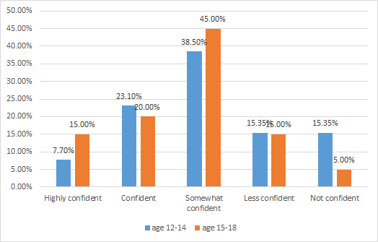
Figure 5.2 Age of starting REAL intensives and confidence that I can recognise the connection between politics and my own local and broader community issues
From Figure 5.2, and discounting the ‘somewhat confident’ category, the older group was slightly more ‘confident’ than the younger group (35.0% compared to 30.8%). In this instance it does not seem that age of participants was particularly relevant.
Nevertheless, being Aboriginal was seen by some members of the focus groups to be a barrier to active participation. One male participant from a regional focus group highlighted how “being Aboriginal… like it’s harder to get a voice out there and stuff because you’re Aboriginal but then if you put it another way, if you’re Aboriginal then you get your Aboriginal community to come and help you and you get a bigger voice, more people helping you and stuff. But at the start being Aboriginal be a hard barrier because there’s not many Aboriginals that try and have a voice and stuff, and the ones that do don’t really get that far.” [Focus Group Participant] Another female participant from the program acknowledged that “the white person would be a lot more easier for them to get notice and do stuff…” [Focus Group Participant] and that “because being an Indigenous person it’s harder to get into the higher places [of government] than what white people would.” [Focus Group Participant]
Being shy and having low confidence, shame, being nervous, being tired, and fear (“being scared”) were cited as other barriers to participation and influence. One female focus group participant said it “comes down to that internal barrier, too, being fearful, like you have fear of embracing issues because fear of discrimination against you because Aboriginal you could feel that or it could be fear of not getting heard, you’re not getting across … it could be just internal fear of discrimination against you as well, it could be that… I’m just saying just probably fear in general [of the young person].”
Some participants felt as though they had no influence at all. A female participant from the regional REAL focus groups highlighted that “As an individual,” it was hard for some to see how they could influence change.” This suggests a potential area of work for the program moving forward.
Some comments from VEC staff suggested that there was insufficient time to address the VEC’s goals in relation to fostering active participation. This was particularly the case in finding time for young people to be able to identify important issues act on them so that they have confidence in using the political process.
Focus group responses in the non–program participants were similar again to the REAL focus groups, in that the majority felt that they could influence locally, with some nationally. As with REAL participants, one young man felt that democratic freedoms were potential enablers, in that “We're allowed to have an opinion. Like where we live in the country lets us have the opinion… In other countries, you say something against the leader and you get put in prison or something like that.” [Focus Group Participant]
As with the REAL focus groups, specific outlets to express their views were seen to be important enablers: “Even though they might not listen, we still get the places to go to, like a council or something where we can still give our opinion and something like that. Even though they might not listen, that's still there.” [Focus Group Participant] Elders were another important enabler: “Like if you maybe go to them and get them to go around to the other adults and stuff and get them to talk to them about what your opinion is”. [Focus Group Participant]
Importantly, some saw themselves as potential enablers and becoming mentors to young people, through “talking to younger kids for the future” [Focus Group Participant]. When asked if this particular young man was afforded opportunities to do this, he replied: “Not really.” [Focus Group Participant]. Probed further, it was suggested that school provides some, but limited opportunities to be leaders. [Focus Group Participant] The REAL program could benefit these young people.

6. Understanding of and confidence in the electoral process.
KEY FINDING: 42.4% of REAL participants after the program are ‘confident’ or ‘highly confident’ that they have an understanding of the electoral and voting system compared to 31.2% of non–REAL participants. When the ‘somewhat confident’ category is included, 78.8% of REAL participants have an understanding of the electoral and voting system compared to 56.2% of the control group.

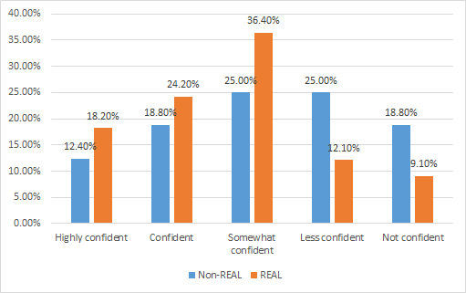
Figure 6.1: How confident am I that I have an understanding of the electoral and voting system (REAL and non–REAL participants)?
Figure 6.1 indicates that 42.4% of REAL participants after the program are ‘confident’ or ‘highly confident’ that they have an understanding of the electoral and voting system compared to 31.2% of non–REAL participants. When the ‘somewhat confident’ category is included, 78.8% of REAL participants have an understanding of the electoral and voting system compared to 56.2% of the control group. This clearly confirms that the sessions conducted by the VEC have been effective.
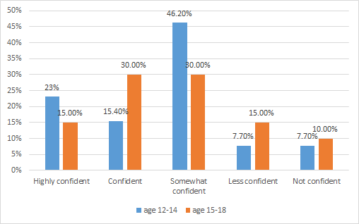
Figure 6.2: Age of starting REAL intensives and confidence that I have an understanding of the electoral and voting system
The starting age of participants in the program again shows little difference. 38.4% of the younger age group were ‘confident’ or ‘very confident’ that they have an understanding of the electoral and voting system compared to 45.0% of the older group. When the ‘somewhat confident’ category is included the results for younger age group are higher at 84.6% compared to 75.0%.
REAL participants who chose ‘highly confident’ or ‘confident’ commented about this issue:
I've gained an understanding from the VEC sessions of what they actually mean
The camp has taught me a lot about politics and the importance of voting as an aboriginal person
We went to the parliament house and learnt how it works
There was a session [in] the REAL program and several sessions in school
Doing the activities that we did on the program, the connection that was made, made it easier for me and others to understand
I have enough knowledge to be able to vote. [Survey Responses]
As indicated in this section, REAL participants demonstrate much higher levels of understanding around the electoral and voting system processes and acknowledge that the REAL program activities provided by the VEC and others for developing this understanding within them. Some participants even go further and have become involved actively within the election process.
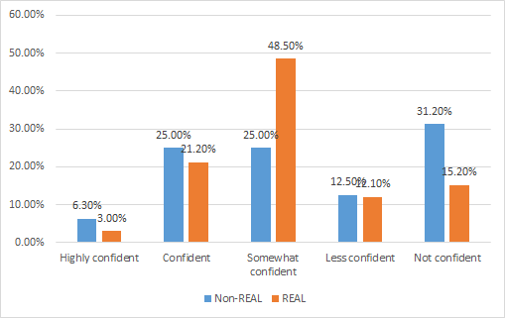
Figure 6.3: How confident am I that I believe that the electoral and voting system processes are fair? (REAL and non–REAL participants)
As indicated in Figure 6.3, only 24.2% of REAL participants were ‘very confident’ or ‘confident’ that they believed that the electoral and voting system process is fair compared to 31.3% of non–REAL participants. However, when the ‘somewhat confident’ category is included, 72.7% of REAL participants believe the process is fair compared to only 56.3% of the control group. Taking into consideration the age of some of these participants, it would be reasonable to say that there is a developing understanding around the electoral and voting system processes and a visible mental shift demonstrated in their understanding of the fairness of these democratic processes.
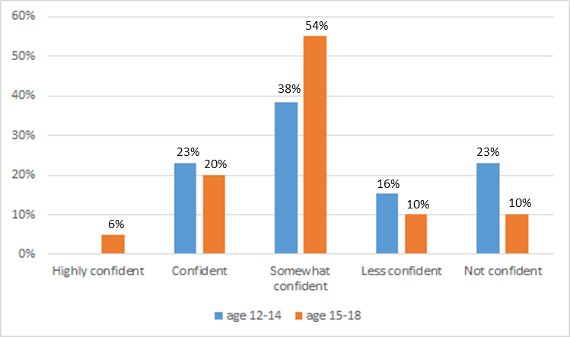
Figure 6.4 Age of starting REAL intensives and confidence that I believe that the electoral and voting system process are fair
Figure 6.4 indicates that 26.0% of the older group are highly confident or confident that the electoral and voting system process is fair compared to only 23.0% of the younger group. This is a statistically minor difference suggesting that older participants closer to the voting age had greater confidence in fairness in the electoral system and had a better understanding of how it actually works. However, when this figure is combined with ‘somewhat confident’ the older group have an overwhelming confidence (80.0%) that the electoral system is fair compared to 61.0% for the younger group. This is to be expected. These attitudes reflect findings from other relevant research conducted by the Lowy Institute that have found that young people in general are sceptical about democracy and especially the electoral system (Oliver, 2015).
REAL participants who chose ‘highly confident’ or ‘confident’ commented about this issue:
Aboriginal people didn't get to vote so that was unfair but now it is good other than some of our elders think that we don't have to vote … It's fair because the public can have their say, but it may not be because they may not be able to voice their opinions as well as others and their thoughts may be misinterpreted … I believe that the system is just and fair for all people it's just a matter of chance as to whether the person you elect gets voted in. Many years ago the system was decidedly unjust and unfair but now there's freedom of choice … It's as fair as I believe it can get. [Survey Responses]
Overall, it is quite clear that the REAL program provides participants with direct opportunities to engage in understanding the democratic processes such as voting and electoral systems and the role of the Aboriginal young person within these processes.
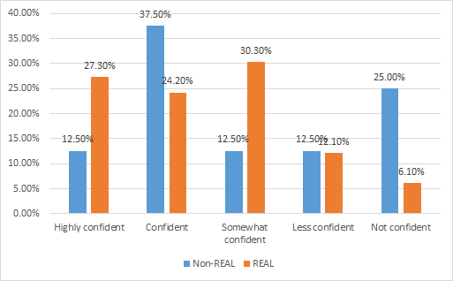
Figure 6.5: How confident am I that I will influence family members to vote? (REAL and non–REAL participants)
Figure 6.5 indicates that the 51.5% of the REAL participants were ‘highly confident’ or ‘confident’ they could influence family members to vote compared to 50.0% of the control group. When the ‘somewhat confident’ category is included over 81.8% of REAL participants believed that could influence family members to vote compared to 62.5% of the control group.
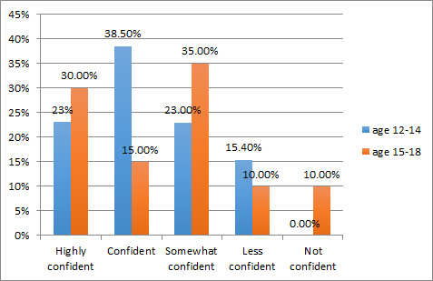
Figure 6.6: Age of starting REAL intensives and confidence that I will influence family members to vote (REAL participants)?
The age of the REAL participants seemed to have a great impact with 61.5% of the younger group being ‘highly confident’ or ‘confident’ that they could influence family members to vote compared to only 45.0% of the older group. However, when the ‘somewhat confident’ category is included, the figures are very similar (84.5% for the younger and 80.0% for the older group).
As indicated above in this section, there is a relationship between the starting age for the REAL intensives and the level of influence that these young people have on their family members in activating them to also participate in the voting process. The evidence suggests that further deliberations are required within the different stakeholders to identify why this influence seems to reduce in the older as compared to younger groups.
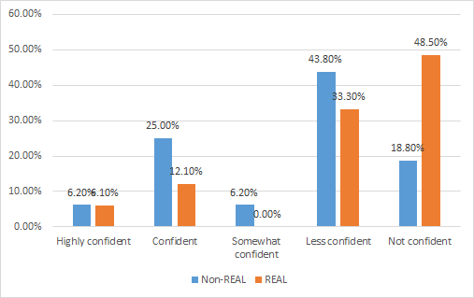
Figure 6.7: How confident am I that I might work in a voting centre? (REAL and non–REAL participants)
It appears that very few of the REAL or control group had any confidence that they might work in a voting centre. There was little difference in age group responses. Looking at the written answers given by respondents, it appears there may have been a misunderstanding about the intention of the question – many made comments that indicated they believed this was to be a full time work option. In any future use of this question it needs to be made clearer that the question refers to volunteering to work in an electoral centre.
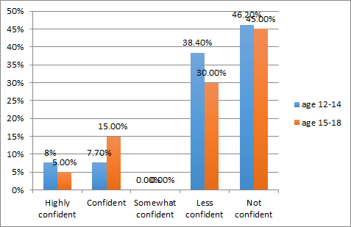
Figure 6.8: Age of starting REAL intensives and confidence that I might work in a voting centre?
Again, as mentioned above, it appears there may have been a misunderstanding about the intention of this question. Many respondents made comments that indicated they believed this was to be a full time option. If volunteering or working at a Voting Centre is an objective of the VEC, then more thought might be needed about how this can be encouraged in the REAL program. For example, a visit to a voting centre could be arranged during an election—whether it is for a local, state or Federal election or even a local community election.

7. Propensity to enrol and vote when of age.
KEY FINDING: REAL participants were much more confident than the control group that they would enrol to vote. The starting age of the program did not seem to have much impact on the REAL participants’ likelihood that they would enrol to vote. But after participating in the REAL program, 81.8% were ‘highly confident’ or ‘confident’ that they would vote in State and Federal elections compared to 37.6% of the control group.
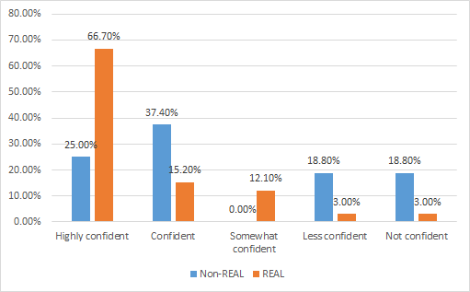
Figure 7.1: How confident am I that I will enrol to vote when I am old enough? (REAL and non–REAL participants)
After having been part of the KGI program, 81.9% of REAL participants were ‘highly confident’ or ‘confident’ that they would enrol to vote compared to 62.4% of the control group. When the ‘somewhat confident’ category was included the percentage for the REAL group jumped up to 94.0% - a clear demonstration of the positive influence of the REAL program on participants’ intention to enrol to vote.
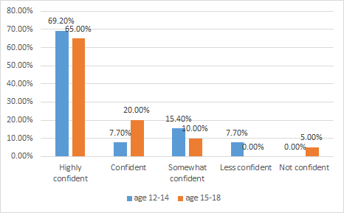
Figure 7.2: Age of starting REAL intensives and confidence that I will enrol to vote when I am old enough
The starting age of the program did not seem to have much impact on the REAL participants’ likelihood that they would enrol to vote.
REAL participants who chose ‘highly confident’ or ‘confident’ commented about this issue in the survey:
I believe as a young, Indigenous woman, our community needs to vote and that it is crucial for our voices to be heard. We do not want to elect someone who does not value aboriginal culture, tradition and ways. Voting is a must amongst us Aboriginal and Torres Strait Islanders
I'd highly recommend voting as a young person
I want to be able to have my say
I want my say to who takes the spot of prime minister of Australia and to look after my community
I know how to and what happens if you don't. [Survey Responses]
One young survey respondent explained that they would NOT enrol to vote “because it's a waste of time.”
The focus groups with more experienced program participants appeared to demonstrate higher levels of engagement in politics. Those who had been in the program for three to four years demonstrated higher levels of confidence, interest and feelings of engagement. One female participant stated that the program has “given us more confidence to just take it, just go for the opportunities, have a say. So I reckon before this I would’ve been engaged but I wouldn’t be doing anything about it but now we’re actually ... still engaged now but more empowered than we ever were. That was the first thing I remember realising when I did this camp. Two years ago, that’s when I started actually. So it’s really straightforward. As soon as you do it you change your life and you can’t really reverse it at all. That’s the best part.” [Focus Group Participant]
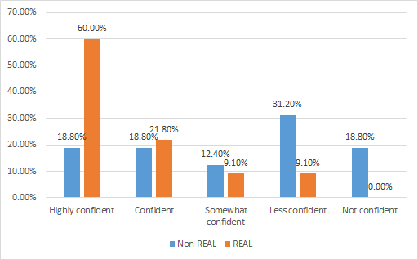
Figure 7.3: How confident am I that I will vote in State and Federal elections when I am old enough? (REAL and non–REAL participants)
After participating in the REAL program 81.8% were ‘highly confident’ or ‘confident’ that they would vote in State and Federal elections compared to 37.6% of the control group. As with the intention to enrol to vote, this confirms a high degree of impact of the REAL program on participants compared to the control group.
REAL participants who chose ‘highly confident’ or ‘confident’ commented about this issue:
I understand my role as a strong Aboriginal woman in an unjust society, who must do all she can to ensure that the future generations live in a safe, beautiful and sustainable environment enriched in cultural knowledge. And that my vote contributes to what our future may look like. As well as the privilege of voting is something I should use to my advantage, due to not being able to vote in past. [Survey Responses]
At the time of the evaluation the Prime Minister had signalled the possibility of triggering a double dissolution of parliament to bring on a federal election. Participants were asked how they felt about Australian politicians and if they would vote (hypothetically for those ineligible). Responses were mixed, but tended to be negative.
One male focus group participant suggested that politicians are:
All criminals. They all take our money. Do the same thing, throw us under the gutter. They have no respect for Aboriginal people. They want us to have a constitution put us in a constitution. We need a treaty, that’s what we need. We need a treaty. Been trying to voice it for years now. They won’t give it to us. There was a big debate about was this country settled, was it settled. It wasn’t settled it was invaded, this country was invaded. We didn’t give them land, we didn’t have an agreement. They killed us off. They tried to kill us off, we’re still here and we’ll be here for ... years. We need a treaty... [but those in power are] a bunch of jokers so got no time for them. [Focus Group Participant]
It was added that “Really we don’t get to actually choose who runs our country. It’s just we choose a party but they’ll choose a person so you don’t really get that much say I reckon. Unless you’re actually in one of those parties or that person, don’t have much say.” [Focus Group Participant] Another female respondent added that “We need new party.” When prompted as to what that party would look like, she suggested that it could be made up of “Youth and maybe some Indigenous youth as well because we’re the future so I think it should be youth–driven and I think there should be young Indigenous people as part of that party.” [Focus Group Participant]
One comment was particularly insightful (and hopeful): “... I’m pretty sure Turnbull wants to call a double dissolution which means everyone is going to be re–elected in both the house of reps and the senate so hopefully that’s an opportunity for more Aboriginal politicians to get involved and start changing the law a bit more regarding Indigenous affairs to make it more just.” [Focus Group Participant]
REAL participants’ attitudes to voting and politicians in general was characterised by ambivalence featuring degrees of engagement and disengagement. For example, in one focus group, the following range of opinions were offered:
Because it probably might change the community to make it … better. [Focus Group Participant]
Every vote counts, that’s why you have all of Australia voting to see who they want put into it and that’s what it means by as, ‘come vote local’ because as an individual you can influence others which they would influence others in a continuous form, so that’s how you get up to that point. So by having one person vote and then other people voting it comes together… [Focus Group Participant]
Examples of more disengaged views included:
I don’t reckon mine would matter.
They’re going to do whatever they want to do anyway regardless of who we vote for or what we vote on…
I’d rather pay the fines, actually. [Focus Group Participants]
As with REAL participants, the propensity to enrol and vote amongst the control group was characterised by a degree of ambivalence in relation to their disposition to vote. This ambivalence featured degrees of engagement and disengagement. For example, when asked if they would vote in the 2016 election, the following range of opinions were offered:
I would vote because I'll then feel like that I was involved – so that I would feel like I was a part of it. [Focus Group Participant]
But in contrast to the KGI REAL focus group participants, disengagement from politicians and politicians was more pronounced:
No... there's never been an Aboriginal Prime Minister, it's always been a white guy.
It's more that I don't feel empowered, so that makes me not really interested. Like I don't feel like I can do anything, so I don’t take an interest in it. In a way.
Politicians. No interest in that at all.
I wouldn't… Doesn't really faze me, the outcome.
I just wouldn't care. [Focus Group Participants]
Barriers to influence and participation included perceived ageism, in that no adults appeared prepared to listen. Other barriers to focus group participants not participating in the program included a lack of experience and ability to figure how best to exert influence, which as one male participant suggested, was about “not having a plan of attack”, lacking self–confidence and “trusting yourself” was raised. [Focus Group Participants] As with REAL participants, resilience emerged as a theme that was important to participation. Confidence could be built, it was suggested, “if you try something and you fail it, then you go back and try it harder and then you might succeed at it.”
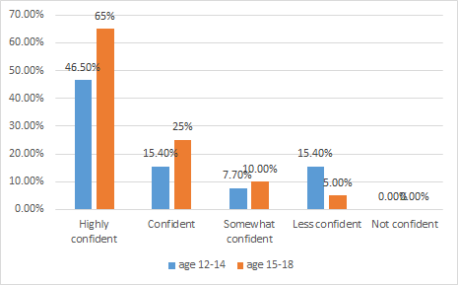
Figure 7.4: Age of starting REAL intensives and confidence that I will vote in State and Federal elections when I am old enough
There was significant difference again between the starting age of the REAL participants on their confidence that they would vote in State and Federal elections. The younger group is 61.9% ‘highly confident’ or ‘confident’ that they will vote while the older group was 90% ‘highly confident’ or ‘confident’.
The focus group findings suggest that the REAL program may be playing a role in improving the propensity to vote. Nevertheless, the evidence from both the control and KGI REAL focus groups suggests a need to develop a more explicit approach to the development of civics and citizenship education within the program.

8. Understanding about the importance of personal and community health, the incidence of key health issues, and the actions that can be taken to improve their personal health.
KEY FINDING: The importance of personal and community health was rated highly by both REAL participants and the control group. But at the end of their participation in the REAL program, participants had a strong or very strong understanding about all the various health related issues.
Our expectation is “don’t do what’s expected of Aboriginal kids”. So that's around dropping out of school, girls being pregnant, being addicted to drugs or alcohol, breaking into houses. [KGI Staff Interview]
Mental health emerged as a common and important issue throughout the focus groups. With regards to health in general, one female participant highlighted the ways that the KGI REAL program focused: “on it a lot like taking care of yourself, how to access facilities to maintain your health. Just generally taking care of yourself is a big factor that we look at with KGI.” [Focus Group Participant]
There were some geographic differences as to specific health and wellbeing issues. For example, in regional areas, parents expressed concern about young people falling back into bad behaviours such as drugs. Alcohol and drugs were raised as being “very common” in the regional communities in which the focus groups lived. Poor lifestyle choices were also a particular subject of discussion in one regional group, and the effects of peer pressure, poor dietary choice “You go to McDonald’s every night.” [Focus Group Participant] and “partying hard”.
Mental health, in particular, emerged as a key issue in the regional focus groups, as it “pretty much sums up what actually goes on around here… like around Mildura and around the area.” [Focus Group Participant]
Bullying was highlighted as another big issue of concern. As one regional focus group participant suggested: “Bullying can happen in your local community and where you live and stuff.” [Focus Group Participant] One young woman from regional Victoria concurred that it is “a big issue now, like personally and just general. And then that can affect mental health and that’s a big thing as well.” [Focus Group Participant] When probed further, this issue was of concern because “it’s very common in our society and there’s actually a lot of people committing suicide over bullying and stuff like that too. I reckon bullying’s very important to try and stop.” [Focus Group Participant]
The non–REAL participants shared similar concerns to those of participant groups. There was not a huge divergence in views expressed across all of the focus group exercises, although non–REAL participants appeared to demonstrate lesser self–confidence and slightly higher levels of disengagement from politics and a feeling of capacity to influence. Consistent with REAL participants, for Exercise 1, issues of concern included alcohol and drugs, crime, safety, violence, and education. Mental health was another shared issue of concern for non–REAL participants. Alcohol and drugs rated highly (number one in one group) [Focus Group Participant], which included “smoking and stuff...” [Focus Group Participant] This was seen to be a local issue “because I know there's drugs in my town” [Focus Group Participant], but also national in significance, “Because it's just a big matter around Australia.” [Focus Group Participant] Education was also highly rated, with particular concern about dropping out of school. [Focus Group Participant] Closely related to this was employment. As one young male said, “It's like if you don't get an education, it then flows on to employment.” [Focus Group Participant]
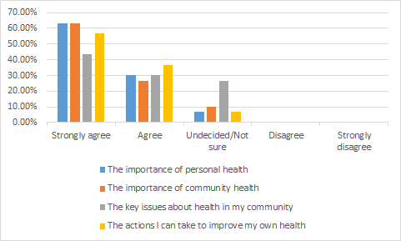
Figure 8.1: I have an understanding of: (REAL Participants)
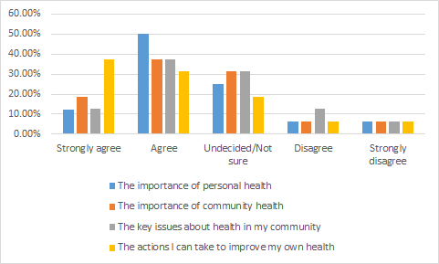
Figure 8.2: I have an understanding of: (non–REAL participants)
When comparing the above two figures, it is very evident that at the end of their participation in the REAL program participants have a strong or very strong understanding about health related issues compared to the control group. In the following figures, the findings shown in Figures 8.1 and 8.2 are presented separately for the four health related questions (Figures 8.3-8.6) and compared with the control group.
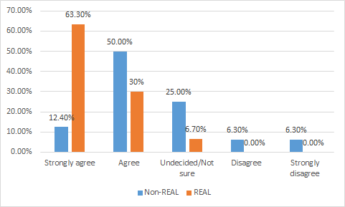
Figure 8.3: I have an understanding of the importance of personal health. (REAL and non–REAL participants)
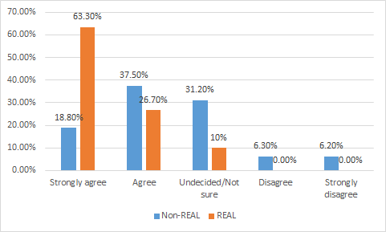
Figure 8.4: I have an understanding of the importance of community health. (REAL and non–REAL participants)
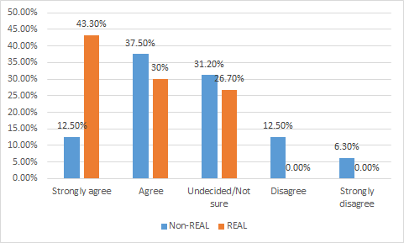
Figure 8.5: I have an understanding of the key issues about health in my community. (REAL and non–REAL participants)
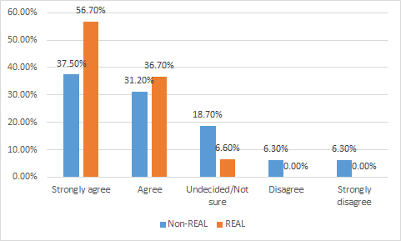
Figure 8.6: I have an understanding of actions I can take to improve my own health. (REAL and non–REAL participants)
When comparing Figures 8.4-8.6 it is evident that at the end of their participation in the REAL program, participants have a greatly improved (strong or very strong understanding) about all four identified health related issues compared to the control group.

9. Sense of cultural identity, improved awareness of family connections, and understanding of Koorie culture.
KEY FINDING: The program has a powerful effect on the development of cultural identity, awareness of family connections and understanding of Koorie culture.
We get a lot of kids that don't know a lot about their Aboriginality or are unsure who their mob is. So it’s obviously connecting kids with culture and reaffirming who they are. We have a lot of kids that come from communities where there’s not a large Aboriginal population. They might be the only kid in the whole school. So often they might not identify. So that’s been something we're really proud of and the kids say that in the evaluations, that they love that sense of culture. [KGI Staff Interview]
Within the focus groups, participants in the REAL program predominantly said that they as Aboriginal students tended to make up a minority of the school population. Two participants, for example, had around ten Aboriginal students in their school. They were keenly aware of their “minority” status within school.
There was consensus in one group that Aboriginal young people are characterised according to negative cultural stereotypes. Standing up to these was seen to require resilience and strength. Resilience was characterised by one male participant as “Someone who bounces back from bad problems or something bad that's happened” [Focus Group Participant] and another female as “Never give up” [Focus Group Participant]. Following on from earlier in this discussion, developing a strong sense of identity was seen to be important. It was characterised as: “knowing who you are” [Focus Group Participant], knowing your culture, background, and the “tribe that you're from” [Focus Group Participant], as well as “being involved” [Focus Group Participant] and “getting treated like everyone else”. [Focus Group Participant]
Within the focus groups, there was consensus amongst participants about the important role of developing cultural identity. One female highlighted how “we talk about how we need more awareness about Aboriginal culture and how we can get it out to the broader community rather than just celebrating it in our own community.” [Focus Group Participant] This happened “pretty straight away. It might grow stronger, it might change in slightly different ways over that time but usually from the instant first camp or something like that straight away engaged, empowered and then as we get older we’re more wise and we’re just growing on it.” [Focus Group Participant] KGI staff also highlighted the development of cultural identity during the program:
I hear time and time again is, “I didn’t feel Aboriginal before I came to the KGI,” or “The KGI helped me to” – whether it inspires them to go and seek more information to try and find out who they are, but I think it’s all about cultural pride. [KGI Staff Interview]
Similarly, VEC staff also identified the substantial contribution to culture and identity through the program:
The most profound thing for me was seeing the kids who wouldn’t have necessarily identified as Aboriginal before, seeing them come on to the camp with a bunch of other Indigenous kids and actually reconnect with their culture and start getting some of that cultural awareness. So I think the cultural identification is probably one of the biggest things. [VEC Staff Interview]
The role of parents both as key influencers and their connection to the program and culture played an important role for some of the participants. One participant highlighted the influence of her mother: “Growing up I’ve always had a strong sense of culture and going through KGI has kind of strengthened it even more with her up my backside as well... We come from a strong line of Aboriginal women.” [Focus Group Participant] She recognised the opportunities available to young people in contrast to their parents or grandparents: “They had limited opportunities back in that time and so I need to take advantage of what there is offered now.” Connecting parents to the program emerged as an important source of strength to participants. This is reflected in previous correspondence with KGI about the program. In one (undated) correspondence with KGI, a carer of one of the participants expressed her gratitude in the following way:
I would like to sincerely thank you and all those involved in the REAL Program for giving [Participant’s name] the opportunity to participate in the program. He hasn’t stopped talking about it and how fabulous it was. As [Participant’s name]’s non–indigenous grandmother and carer since he was little, I am always really appreciative to find avenues for him to embrace his Indigenous heritage which I am happy to say he is soaking up like a sponge and we are learning from him as well. [KGI Correspondence]
The role of parents in encouraging their children to attend the REAL program is significant. A number of parents observed that this program has gone a long way in helping their children develop a stronger and more cognizant understanding of cultural identity. Some of the parents noted the difference the program has made in making their children aware of family connections and gaining a deeper understanding of their Koorie culture. Some parents were of the opinion that this program provided a much needed necessity for Koori youth having an opportunity to understand the bigger picture, in terms of their giving back to the Aboriginal community through a better understanding of their own culture and the role that others before them had played in getting them to have this opportunity. On the whole, parents were highly positive on the achievement of program objectives in this area.
A corollary of this was the importance of the program in developing other social support networks. For example, one female participant said that:
On a personal development, when I started at KGI, I think everyone’s in the same boat you’re like that shy lost kid really. I know for me I just had no cultural connection whatsoever. My grandmother is stolen generation so we don’t get anything from her and then just over the years from KGI that continuous support and then eventually becoming a peer leader. Just that ongoing support and then the final result it’s just really good. [Focus Group Participant]
The powerful effect of the program on the development of cultural identity and improved awareness of family connections and understanding of Koorie culture is highlighted in the survey data below.
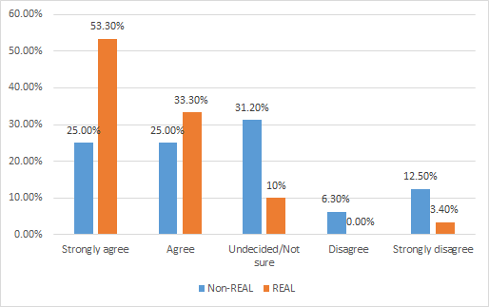
Figure 9.1: I have a strong sense of my own cultural identity. (REAL and non–REAL participants)
Those respondents who had participated in the REAL program had a much stronger sense of their own cultural identity (86.6%) compared to the control group (50.0%). Clearly participation in the REAL intensives had a powerful impact on respondents.
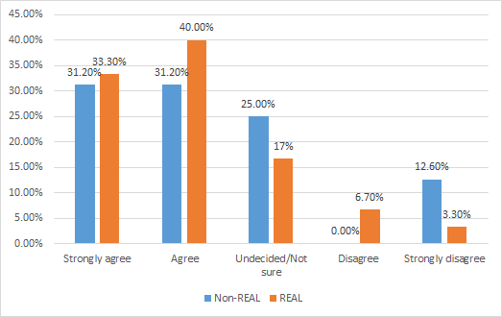
Figure 9.2: I have a strong sense of my connections to family. (REAL and non–REAL participants)
Figure 9.2 indicates that the participants in the REAL program had a stronger sense of connection to their family (73.3%) compared to the control group (62.4%). The intended outcome of the program was therefore met.
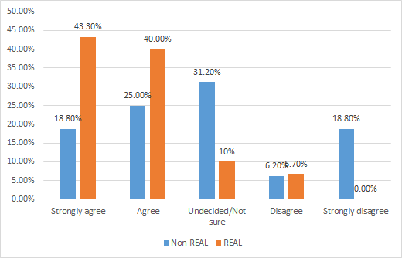
Figure 9.3: I have a strong sense of Koorie culture. (REAL and non–REAL participants)
Figure 9.3 indicates that the participants in the REAL program had a much stronger sense of Koorie culture (83.3%) compared to the control group (43.8%). Clearly participation in the REAL intensives had a powerful impact on respondents. This intended outcome of the program was therefore met.

10. Understanding of the various career and personal development pathways.
KEY FINDING: An overwhelming majority of REAL program participants (93.3%) agreed or strongly agreed after the program that they understood what was available to them for personal career pathways, while 86.6% had an understanding about different career pathways.
Focus groups conducted with participants raised education and employment as a key issue of concern. [Focus Group Participant] As one regional young male participant suggested: “You need education to have a good life, get a good job” [Focus Group Participant] and “because you need it through life.” [Focus Group Participant]
Notably, in one regional focus group the attainment of sufficient education was something some participants perceived to be a struggle to achieve. One young female highlighted that “not completing [school] as a barrier to influence [society], when you don’t complete school it’s more challenging to get where you want to go without having that education behind you.” [Focus Group Participant] From a social perspective, being Indigenous was closely associated with the challenges (and benefits) arising from lack of educational attainment:
And then adding on to, like being Indigenous … people say, ’You’re Indigenous and you completed Year 12, and you didn’t drop out.’ That’s like a, wow they don’t generally think Indigenous people can do that, it’s just the stereotype that they’ll drop out, try and get on the dole and stuff, get on the dole and live off that. But if they see look, ’You completed Year 12, you’re Koori.’ That’s just like two bonuses, they find it, ’Wow, you’re actually trying to do something for yourself.’ [Focus Group Participant]
Education was seen to be important not only for individual mobility [Focus Group Participant], but for the agency it affords to assist others: “So you can get a job and then you can help other people, it’s not just for yourself it’s to help other people... Because you can teach other people.” [Focus Group Participant]
Throughout discussions with focus groups, education and employment were closely linked. With education, one female suggested: “And you have more knowledge... and know what to do and succeed in life....” [Focus Group Participant] Education as a basis for employment was identified as an enabler to influence and actively participate in the community: “It gets you to places that you would never think you would get there by having that education, and like certificate behind you… It depends what you want to do though, if you want to get into banking or something having that education will help you get there...” [Focus Group Participant]
The REAL program provided participants with many career pathways to consider, as one parent enthusiastically discussed in relation to her daughter’s career pathway, “I think she’s looking at community development and all that kind of stuff. I’m thinking excellent, because that’s where you’ll have a voice as well. But yeah, she’s getting excited about that. But yeah, she often goes off and reads a lot of stuff on her own.” One participant highlighted how the REAL program provides valuable work experience: “So like when we went to the Crown and we made coffees, like that sort of helps you, if you want to work in a café you have that little bit of knowledge about making coffees.” [Focus Group Participant]
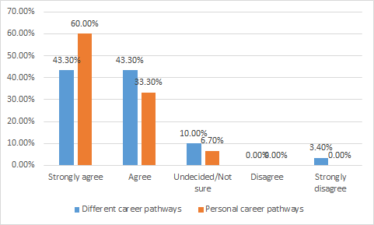
Figure 10.1: I have an understanding of what is available to me through career pathways (REAL participants)
Over 93.3% of REAL program participants agreed or strongly agreed after the program that they understood what was available to them for personal career pathways while 86.6% had an understanding about different career pathways.
While many focus group participants from the REAL program identified education as important in Exercise 1, university was seen as just one pathway. [Focus Group Participant] When asked about what kinds of jobs they were seeking, two young men from the regional focus groups nominated builder [Focus Group Participant] and carpenter. [Focus Group Participant] Nursing and counsellor were also offered in other focus groups. It became apparent that while jobs were seen by some to be scarce, others suggested one could get a job if one wanted to.
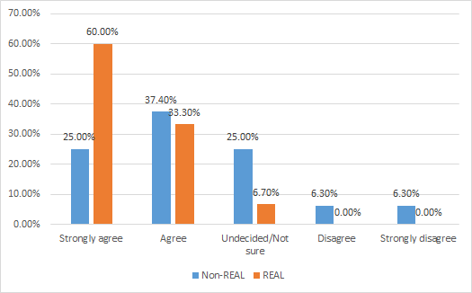
Figure 10.2: I have an understanding of what is available to me through different career pathways (REAL and non–REAL participants)
When compared to the non–REAL participants (Figure 10.2), there is a significant difference between the responses 93.3% and 62.4% respectively. These responses strongly confirm the program’s objectives in this matter have been met.
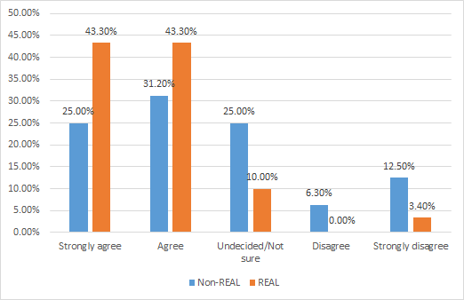
Figure 10.3: I have an understanding of what is available to me through personal development pathways (REAL and non–REAL participants)
Similarly, when compared to the non–REAL participants (Figure 10.3), there is a significant difference between the responses 86.6% and 56.2% respectively. Again, these responses strongly confirm the program’s objectives in this matter have been met.
One final observation is that the program has had some tangible effects on education outcomes. A case study from the Korin Gamadji Institute and Victorian Electoral Commission biennial report (July 1–December 31 2015) highlights one example in which the:
[Participant] started as shy and reserved young woman and has emerged as a confident and ambitious person evident by her receiving the Wannik and La Trobe Uni Vice–Chancellor’s Award. [Participant] has worked on her literacy and numeracy and has been accepted into a Bachelor of Nursing at Australian Catholic University. [Participant] was overwhelmed with her offer for University as this was an unrealistic option before she engaged with KGI. [2015 Case Study]

11. Participants are equipped with skills to become active citizens within their wider communities (leadership).
KEY FINDING: Focus group findings suggest that the local was the main site in which they felt they could actively participate. REAL program participants are almost twice as likely to participate in a variety of community activities as a result of the KGI program than the control group. This is clearly a powerful result of the overall enhancement by citizenship related elements of the program. For example, KGI participants were twice as confident (75.7%) that they could take action on issues, compared to the control group (43.7%).
We had one camp a couple of years ago, the kids left, 45 minutes later, one of the parents rings. I'm like oh what have they left behind. Their father pulled up in Kalkallo out on the Hume Highway, because they couldn’t stop crying, because firstly their son didn’t shut up for the 45 minute drive out of there and he never talks. And he just couldn’t believe the way he’d done that, little things like public speaking... [KGI Staff Interview]
A major theme running throughout the focus groups was the way that the REAL program boosted self–confidence. A KGI staffer commented about this:
I think it has an impact on the kids’ confidence and self–identity. If you can improve that then I think that the kids go back into the community with more confidence around sharing their voice and sharing their thoughts and opinions on different issues, and even – and considering different issues. [KGI Staff Interview]
At the start of the program, participants characterised themselves as feeling “shy” and “scared” [Focus Group Participant] The program was seen to be highly beneficial in addressing these feelings. According to one experienced male participant:
I just think at an individual level it’s actually given us opportunities whether it’s with school or just whatever it is whether we have a say or not it’s given us that more opportunity, more say, it’s just shown us a little bit more confidence to just stand up and do it, take it. So that’s really helped out a lot through this program for me and other people I’ve seen anyway. [Focus Group Participant]
One male participant from a regional focus group highlighted how the program “builds your confidence up, since I got back home from it I do feel a lot more confident and I’ll try new things, I’m just more engaged. Also it is very welcoming, you feel like you have a place that you can feel safe and that you know you’re around people that you can get along with.” [Focus Group Participant] A female discussant from the same group added: “It’s a good bridge.” [Focus Group Participant] This self-confidence, as will be discussed below is a vital basis for leadership.

11.1 What leadership means to participants individually.
When asked what leadership meant to them, a number of characteristics were offered by focus group participants, such as: someone who has the strength to stand up for their beliefs; who is honest and respectful; someone you can look up to, who listens to you and understands you; and someone who is confident at public speaking. The program enabled, as one young man suggested, “just having a voice and actually just not being shy, shame.” There was consensus that overcoming shame was an important benefit of the program.
One of the parents described quite poignantly how the program had helped develop her daughter’s leadership skills especially her confidence in herself. In her words, “She certainly has developed a lot more confidence in herself. She’s a lot more confident in ‘I can do anything, the world really is my oyster, Mum, you know, you keep telling me that but now I know it’... she’s developed a whole lot of skills and she’s identified things within her that she now knows that she can do anything, the choice is hers. And I think that comes from the REAL program, just saying to the kids that ‘look, you don’t have to be perfect, just do your best’, yeah, and I think each time they do that, they gain a little bit more confidence.”
A KGI staffer commented that once participants do the leadership session and are given the tools to establish for themselves why they were nominated, that’s the lightbulb moment where you see them saying, “You know what? I am a leader and I do deserve to be here.”
Following on from the discussion above, school was nominated by many during the focus groups as a key site in which young people could influence change and practice leadership. Aside from teachers and staff at school, influencing peers through leadership was a potentially powerful theme to emerge during discussions with REAL participants. As one regional female participant suggested: “You can help them, show them the right path or if they’re doing something wrong you can help them, like say no you can’t do that.” [Focus Group Participant] A male colleague added: “So starting off small.” [Focus Group Participant] The female participant agreed: “Yeah. Something small but it could help a long way.” [Focus Group Participant]
Finishing school was seen to be important and that their new leadership skills were applied to be more successful at school. Two members of one group had completed school, for example, but the focus group agreed that they were exceptional—the “First black fellas for … a long time.” [Focus Group Participant] Importantly, they attributed this to the leadership skills developed during the program.
The following data from the surveys provides further insight into the understanding and practice of leadership.

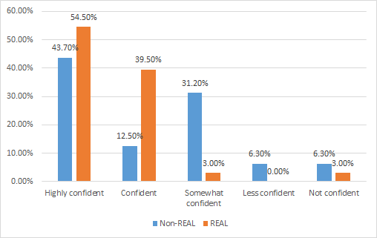
Figure 11.1: How confident do I feel that I have an understanding of leadership? (REAL and non–REAL Participants)
94.0% of REAL program participants were ‘highly confident’ or ‘confident’ of their understanding of leadership after the program compared to 56.2% of the control group. Clearly the objectives of the program have been met.
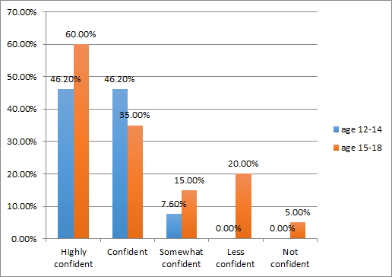
Figure 11.2: Age of starting REAL intensives and confidence that I have an understanding of leadership
There was no significant difference between the age groups starting the program and their understanding of leadership. KGI survey respondents commented about their understandings of leadership:
I think leadership comes in many forms and I believe a leader isn't someone who just has the spotlight on them ... A leader is someone who learns, takes opportunities, supports others around them etc. and does their best in everything they do and is constantly developing and listening to others … I have a strong understanding in leadership, I believe that taking control of your own life is more important than others taking control of yours for you … [KGI Participant]
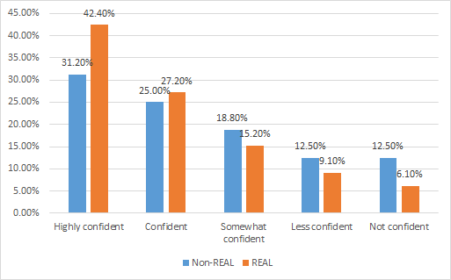
Figure 11.3: How confident do I feel that I have an exposure to leadership? (REAL and non–REAL Participants)
69.6% of REAL program participants were ‘highly confident’ or ‘confident’ that they have had an exposure to leadership after the program compared with 56.2% for the control group. Clearly the objectives of the program have been met.
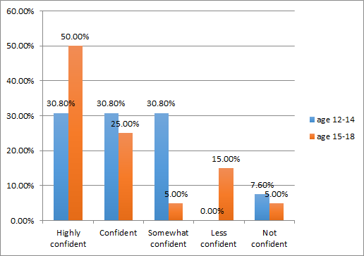
Figure 11.4: Age of starting REAL intensives and confident do I feel that I have an exposure to leadership
The older group were either ‘highly confident’ or ‘confident’ that they had exposure to leadership (75.0% compared to 61.6%).
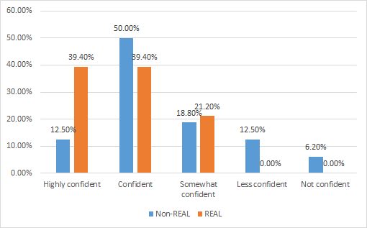
Figure 11.5: How confident am I that I am equipped with leadership skills to become an active citizen within my local and broader communities? (REAL and non–REAL participants)
78.8% of REAL program participants were ‘highly confident’ or ‘confident’ that they had the leadership skills to become active citizens in their communities compared to 62.5% of the control group. Clearly the objectives of the program have been met.
Following on from discussion earlier in this report, while some focus group participants suggested a capacity to influence their wider communities at the national level, most participants nominated the “local” as the main site of influence. These included sporting clubs, school, home, work, community volunteering work, the local council and/or health service. Some focus group participants perceived that they have a national influence through using Facebook and other media, the CFA, national strikes, politics and the Koori Youth Summit.
Other REAL focus group participants hoped to have a bigger influence in the future: “I believe I have influenced my local community so far. However I hope one day to influence people at a national level regarding social and political issues”; and “I feel like I can make a difference on a local level but national and global [levels] not right now.” Very few focus group participants thought that they have a global influence. One participant did not know how to influence globally. Such views reflect commonly held views among all Australian youth. Connection to global issues such as the environment could be an area of exploration in future.
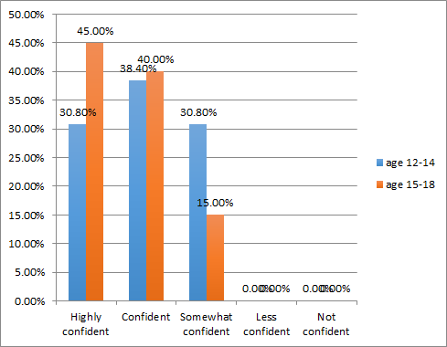
Figure 11.6: Age of starting REAL intensives and confidence that I am equipped with leadership skills to become an active citizen within my local and broader communities
85.0% of the older group were ‘highly confident’ or ‘confident’ they were ready to become active citizens compared with 69.2% of the younger group. Many of the older group had participated in a number of intensives already and this is finding is understandable as with age comes more maturity and confidence in becoming an active citizen.
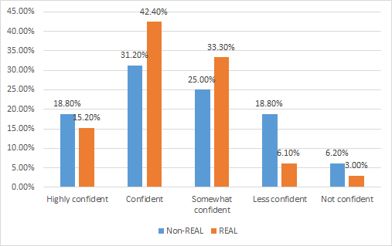
Figure 11.7 How confident am I that I can identify important issues that need to be solved in my local and national community? (REAL and non–REAL participants)
57.6% of REAL program participants were ‘highly confident’ or ‘confident’ they can identify important issues that need to be solved in their local and national community compared with 50.0% of the control group. This may indicate that more emphasis on this area may be needed in future intensives.
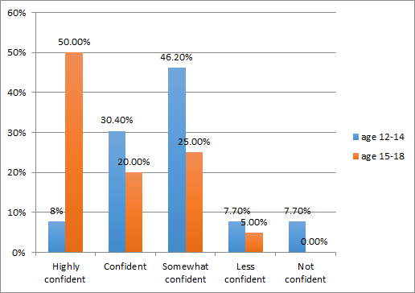
Figure 11.8: Age of starting REAL intensives and confidence that I can identify important issues that need to be solved in my local and national community?
70.0% of the older group compared with 38.4% of the younger group were ‘highly confident’ or ‘confident’ they could identify important issues that need to be solved in their communities. Many of the older group had participated in a number of intensives already and this is understandable as with age comes more maturity, knowledge and confidence.
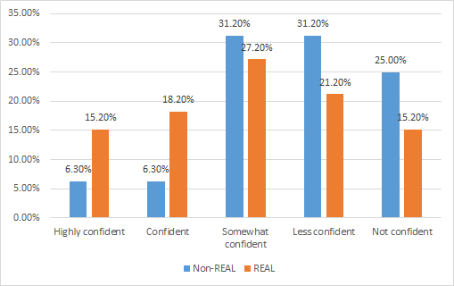
Figure 11.9: How confident am I to use the democratic process? (REAL and non–REAL participants)
The responses to this question clearly show that more emphasis needs to be put into this objective in the program as only 33.4% of REAL program participants were ‘highly confident’; or ‘confident’ of being able to use the democratic process (compared to only 12.6% for the control group). While this is a significant difference this may indicate that more emphasis on this area may be needed in future intensives. However, this finding tends to reflect what we know of the views of Australian youth generally about this matter, and is not just an issue for the Indigenous community. Recent research on Australian young people's views about democracy suggests that they are more suspicious of, ambivalent towards, and feel distant from the formal democratic system (e.g. see Oliver, 2014; 2015). As the REAL program's objective is to develop young Indigenous people to be more active citizens, more consideration of this aim is warranted. In our recommendations below, we outline how activities between intensives could enhance the young people's understanding of and confidence in the democratic system and their ability to get involved.
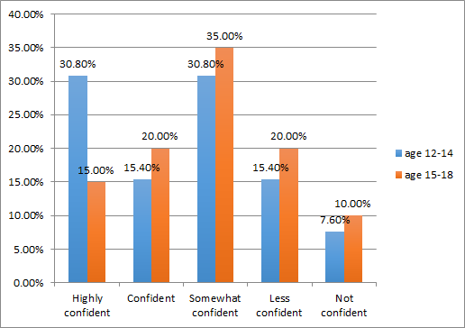
Figure 11.10: Age of starting REAL intensives and confidence that I use the democratic process
Interestingly, 46.2% of the younger participants were either ‘highly confident’ or ‘confident’ in their ability to use the democratic process compared with 35.0% for the older group.
Some of those who believed they could use the democratic process stated that:
I have had plenty of education and feel I know what to do. I've just never actually voted
I was taught at school [and] I am confident in using this process, it is the process I have used my entire life.
Some others who expressed lack of confidence indicated a lack of knowledge of the democratic process itself:
Not sure really what that means
What's a democratic system?
Don't know anything about it
I don't know anything about democracy I have no idea what it is
Not confident because I don’t know what democratic is.
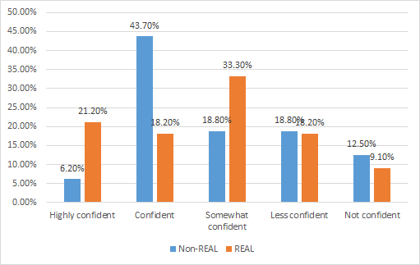
Figure 11.11: How confident am I in understanding how the leadership team in my community addresses issues? (REAL and non–REAL participants)
REAL program participants were less ‘highly confident’ or ‘confident’ that they understood how the leadership team in their community addresses issues compared to the control group (39.4% compared with 49.9%). If the ‘somewhat confident’ category is included the findings are almost identical (72.7% for the REAL group, 68.7% for the control group). Again this is a finding that deserves more deliberation and investigation. This may indicate that more emphasis on this area may be needed in future intensives.
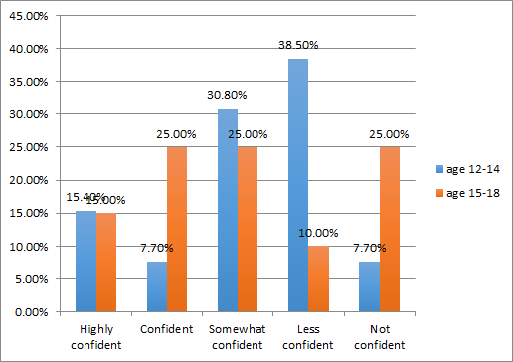
Figure 11.12: Age of starting REAL intensives and confidence that I understand how the leadership team in my community addresses issues
40.0% of the older group compared to 23.1% of the younger group were ‘highly confident’ or ‘confident’ they understood how the leadership team in their community addresses issues compared. This reinforces the report’s conclusion that the older group were more confident about the identified issues generally
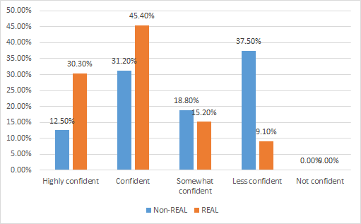
Figure 11.13: How confident am I that I can take action on issues where needed? (REAL and non–REAL participants)
75.7% of REAL participants compared to 43.7% of the control group were ‘highly confident’ or ‘confident’ confident they could take action on issues. The REAL program clearly has had a powerful effect on the participants in relation to this objective.
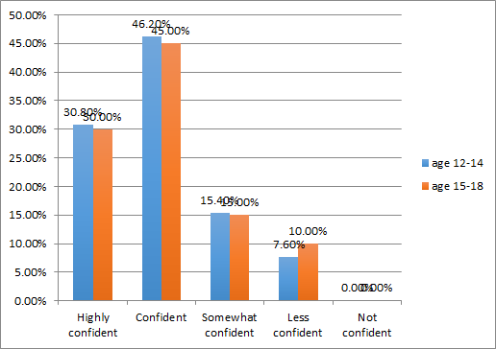
Figure 11.14: Age of starting REAL intensives and confidence that I can take action on issues where needed
There was no difference apparent in the starting age of the participants in relation to this issue.
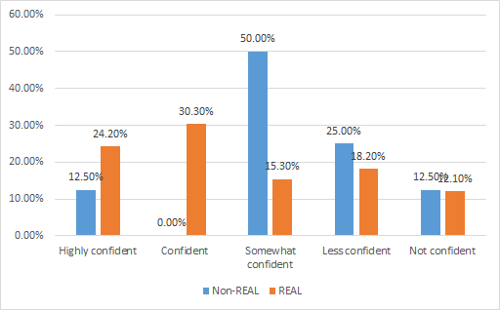
Figure 11.15: How confident am I that I have a good understanding of how society works in relation to laws and systems, particularly in groups like my Student Representative Council, [Koorie Youth Council] KYC or Co–op? (REAL and non–REAL participants)
54.5% of REAL participants compared with only 12.5% of participants in the control group were ‘highly confident’ or ‘confident’ they had a good understanding of how society works in relation to laws and systems, particularly in groups like my Student Representative Council, KYC or Co–op. Clearly the program has met its objectives in regard to this issue.
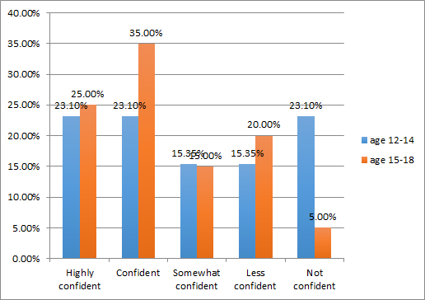
Figure 11.16: Age of starting REAL intensives and confidence that I have a good understanding of how society works in relation to laws and systems, particularly in groups like my Student Representative Council, KYC or Co–op.
Participants who were ‘highly confident’ or ‘confident’ commented that:
Being a part of the KYC I have a better understanding of how it works and how laws and systems are enforced, implemented or monitored
The Real/KGI program has given me a better understanding on how society and all these systems work
Especially after attending the KYC Summit
I've learnt over time what the no–nos are not good to do if you wanna look good in the community … I understand the legal system/the rules etc., very well, I've been taught how the processes work, and how it comes to be a rule/law
Many of my peers are part of these programs, and they inform me and keep me updated on current issues. [Survey Responses]
60.0% of the older group compared with 46.2% of the younger group were ‘highly confident’ or ‘confident’. This might be expected as with age comes more experience and confidence working with such groups. Younger groups coming into secondary school from the more sheltered and “nurturing” primary environment often suffer from transition issues that impact on their confidence.

11.2 Program participants are more likely to be active participants in their community (which may include involvement in community events, clubs, school programs or leadership roles).
In responding to Exercise 4, more than 50.0% of focus group participants from the KGI REAL program believed that they were both engaged and empowered. About 30.0% of focus group participants believed that they were engaged but disempowered. 16.0% perceived that they were empowered but disengaged. Interestingly none think that they are disempowered and disengaged at the same time. On the other hand, in the non–REAL participants’ focus group, three out of four (75.0%) participants believed that they are disempowered and disengaged. Only one perceived that he or she is empowered but disengaged. This is a significant finding and evidence of the efficacy of the program in meeting its objectives.
As suggested above, participants from the REAL program in the focus groups overwhelmingly nominated the “Local” as their main site of influence. The school was typically mentioned, as well as home, football and netball clubs and the CFA. In football and netball clubs, participants felt they could influence their worlds through “Coach, helping”, in leadership roles such as being captain, umpires and other leadership groups [Focus Group Participant]
These findings affirm feedback in the REAL Program Phase 2 participant survey/evaluation from April, 2016, which asked participants about their involvement in other programs, project or events as a result of their connections with KGI during the previous 12 months. Examples included:
Doing the Acknowledgement [of country] in front of the whole school
Put myself out there more to learn more about myself and do more dance
I’m more active in the community [2016 Evaluation]
One parent described how her son’s experience through the REAL program has activated his willingness to actively participate and lead at the community level. In her words, “When he first did the program, he was nominated by his Aboriginal organisation. And since then they’ve taken him on board to do some leadership activities, so he’s been able to run some of the school holiday programs with the younger ones, and he gets along really well with little kids, so that’s a bonus, I think.”
The overall findings of the evaluation suggest the program could more directly interface with schools through the provision of various activities and cultural information between the intensives.
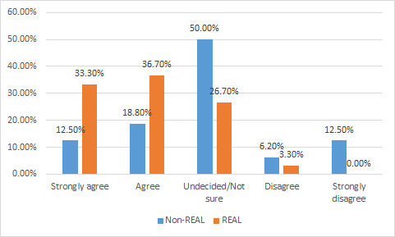
Figure 11.2.1: I am likely to be active in my community through community events. (REAL and non–REAL participants)

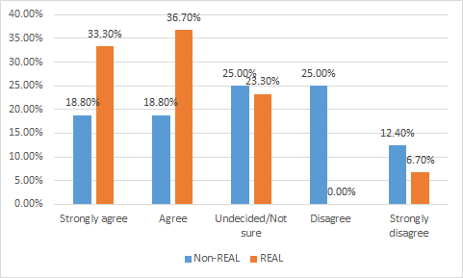
Figure 11.2.2: I am likely to be active in my community through clubs

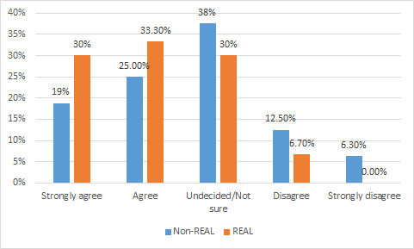
Figure 11.2.3: I am likely to be active in my community through after school programs. (REAL and non–REAL participants)

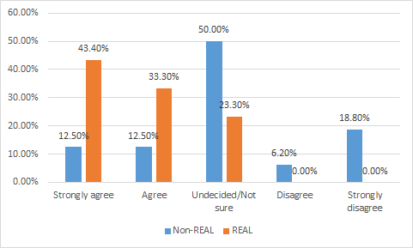
Figure 11.2.4: I am likely to be active in my community through leadership roles (REAL and non–REAL participants)
Figures 11.2.1 to 11.2.4 indicate that REAL program participants generally are twice as likely to participate in a variety of community activities as a result of the KGI program compared to the control group. This is a powerful and encouraging result of the enhancement provided by citizenship related elements of the program.

12. How they can demonstrate leadership across a range of settings, and identify current and past Aboriginal and Torres Strait Islander leaders.
KEY FINDING: The program provides an opportunity for most participants to develop themselves and transform into leaders. It is highly successful in developing the self–efficacy of these young people and in inspiring them to engage in the functions of leadership.
As indicated in the survey data above, most participants come out of the REAL program feeling quite confident of their understanding of their leadership abilities. In Figure 12.1, 93.3% of REAL participants ‘strongly agreed’ or ‘agreed’ that they had a personal understanding about what leadership meant to them individually.
The REAL program also prompts more active participation in their communities. In the words of one of the parents, her son has been actively involved in making changes within his community, “I think as far as leadership goes, he likes to take on any program that he can. In terms of his Aboriginal culture, he has actually taken that up with the TAFE that he’s doing his hospitality course through, so he’s talked about, ‘Well, should we be flying the Aboriginal flag?’ you know, that sort of stuff, and he said it at his school, too, so they’re important things. So he now has the confidence to do that.”
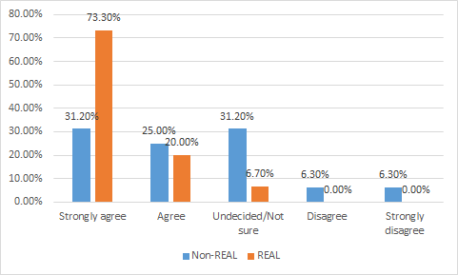
Figure 12.1: I understand what leadership means to me individually. (REAL and non–REAL participants)
In Figure 12.1, this was further demonstrated by 93.3% of the REAL participants who reported that they understand how to take up leadership activities, indicating growth in their self-confidence compared to 56.2% for the control group.
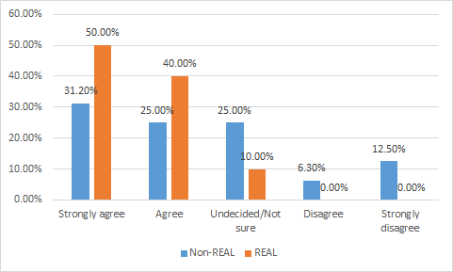
Figure 12.2: I understand how I can act as a leader in various situations and places (REAL and non–REAL participants)
Figure 12.2 provides strong evidence that the majority of the REAL participants (90.0%) have developed improved cultural understanding especially in terms of the roles played by Indigenous leaders both past and present and their contribution to the Aboriginal community and society in general compared to the control group.
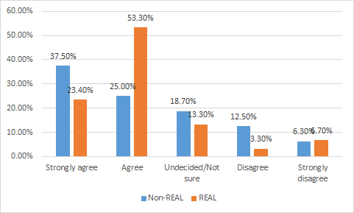
Figure 12.3: I understand more about past and present Indigenous leaders. (REAL and non–REAL participants)
In summary, the findings in this section evidence the clear benefits the REAL program provides for the majority of REAL participants, in particular the opportunity for growth of self and the potential stimulus to become leaders. The program’s success in developing self–efficacy amongst young Aboriginal people and in inspiring them to engage in leadership tasks is clearly evidenced by the findings of this evaluation.
Of course, participants are selected for the program on the basis of their showing leadership potential. This view was reflected in a number of comments from different KGI staff:
It’s generally because they’re doing really well at school, they’re standing out as someone who has outstanding leadership, or it’s someone who is seen to have a potential of great leadership if they’re empowered to do so. [KGI Staff Interview]
That being said, the majority of participants indicated the profound effect that the REAL program had had on their capability to contribute as leaders. On the basis of the findings, their leadership capability is strengthened by the program’s fostering participants’ recognition and celebration of their individual and collective identity, their understanding of their health and wellbeing and career pathways, and their active participation in their local communities. Overall, the present evaluation found that the REAL program largely has been successful in meeting its stated objectives.

SUMMARY OF FINDINGS
A number of key findings related to the strengths and successes of the program in relation to its key objectives are notable.
1. Overall program effectiveness
Participants rated highly the value of the program in providing socialising, networking and other opportunities for participants to connect. The development of leadership skills also rated highly.
The focus groups highlighted key psychological factors that enabled active participation such as self–belief, self–image, confidence, being courageous, pride in the culture, and passion. This is arguably one of the greatest strengths of the program.
2. What are the most effective elements of the program that achieve the stated objectives?
The REAL program intensives have overall provided a strong platform for Aboriginal youth to work on shaping their identity as Indigenous Australians, holding especially true for participants from metropolitan areas where access to cultural contexts are few and far between. For some of these young people, the various REAL program activities conducted by the Indigenous presenters provide an opportunity for them to unpack questions about their own identity at a very close and personal level.
3. Does the age at which a participant first experiences the intensives have any impact?
The best starting age is 13 to 14 years, as 16 year olds may have already become too solidified in their views to respond to the program’s purposes. This is reflected in the data from the surveys. In each instance, a greater combined proportion of the younger group compared with the older group is either “highly confident” or “confident”.
4. What are the effective elements of the program between the two intensives?
School was a key site at which elements of the program were operationalised between the intensives. Developing more confidence in making decisions at school, as well as about life in general, was found quite frequently amongst participants and their parents.
5. Participants’ recognition of the connection between politics and their issues.
A significant majority (75.7%) of REAL participants were ‘somewhat confident’ to ‘very confident’ in their ability to recognise the connection between politics and their own local and broader community issues. They were more confident that they have a good understanding of how society works in relation to laws and systems compared to the control group.

6. Understanding of and confidence in the electoral process.
REAL participants demonstrated much higher levels of understanding around the electoral and voting system processes and acknowledged the REAL program activities provided by the VEC and others as important for developing this understanding within them. After the program REAL participants were ‘confident’ or ‘highly confident’ (42.4%) that they have an understanding of the electoral and voting system compared to 31.2% of non–REAL participants. However, when the ‘somewhat confident’ category is included, 78.8% of REAL participants had an understanding of the electoral and voting system compared to 56.2% of the control group.
7. Propensity to enrol and vote when of age.
After having been part of the REAL program, participants were far more confident that they would enrol to vote (81.9%) compared to the control group (62.4%). 81.8% were ‘confident’ or ‘very confident’ that they would vote in State and Federal elections, compared to 37.6% of the control group. This indicates a high degree of impact of the REAL program on participants compared to the control group.
8. Understanding about the importance of personal and community health, the incidence of key health issues, and the actions that can be taken improve their personal health.
At the end of their participation in the REAL program participants had a strong or very strong understanding about all the various health related issues in comparison to the control group.
9. Sense of cultural identity, improved awareness of family connections, and understanding of Koorie culture.
The REAL program had a powerful impact on participants’ sense of their own cultural identity (86.6%) in comparison to the control group (50.0%). Participants in the program had a stronger sense of Koorie culture (83.3%) when compared to the control group (43.8%). Participants in the program also had a stronger sense of connection to their family (73.3%) compared to the control group (62.4%). Clearly, participation in the REAL intensives had a powerful impact on respondents.
10. Understanding of the various career and personal development pathways.
Over 93.3% of REAL program participants agreed or strongly agreed after the program that they understood what was available to them for personal career pathways while 86.6% had an understanding about different career pathways.
11. Participants are equipped with skills to become active citizens within their wider communities (leadership).
The REAL program made the participants feel very confident that they will use their new knowledge to take action in their communities (87.0%), which is a significant indicator of the success of the program. They were twice as confident (75.7%) that they could take action on issues compared to the control group (43.7%). The REAL program has clearly had a powerful effect on the participants in relation to this objective.
94.0% of REAL program participants were ‘highly confident’ or ‘confident’ of their understanding of leadership after the program compared to 56.2% of the control group. Clearly the objectives of the program have been met.
69.6% of REAL program participants were ‘highly confident’ or ‘confident’ that they have had an exposure to leadership after the program compared with 56.2% for the control group. Clearly the objectives of the program have been met.
Participants from the REAL program in the focus groups overwhelmingly nominated the “Local” as their main site of influence. The school was typically mentioned, as well as home, football and netball clubs and the CFA. Leadership skills developed during the program intensives were applied in areas such as playing sport
12. How they can demonstrate leadership across a range of settings, and identify current and past Aboriginal and Torres Strait Islander leaders.
The REAL program was successful in developing leadership attitudes, skills and practices. This evaluation shows a powerful impact participants’ confidence of their understanding of leadership, and they were four times more likely to be active in the community through leadership than the control group.

PART C: Recommendations
Throughout the focus groups, the overall experience of the REAL program was seen to be positive. When asked what they would like to see or get out of the program, common themes included public speaking and boosting confidence and learning to be proud. The following recommendations seek to build on the strengths of the current model, with some suggestions as to where and how it could be extended and potentially improved. They are divided into overarching and specific programmatic recommendations.
Overarching Recommendations
1. Further develop the transformational model of leadership.
The survey data suggests a high correlation between the age of starting and the degree of engagement in the program. REAL participants were more confident that they have a good understanding of how society works in relation to laws and systems. Of those who participated in the program, the older cohort demonstrated a better understanding than the younger group.
The relationship of this to the development of citizenship and leadership is not clear. However, REAL participants were four times more likely to be active in the community through leadership than the control group. A similar trend is found in their likelihood to be active through community events and after school programs, though to a lesser extent. But arguably, developing a model of transformational leadership could improve the efficacy of the program. Transformational leadership is a leadership approach that causes change in individuals and social systems where the focus is at creating valuable and positive change in the followers, in this case the REAL participants, with the end goal of developing these followers into young Indigenous leaders. Bass (1990) strongly suggests that “Transformational leadership can be learned.” Burns (1978) suggests that this transforming leadership process allows leaders and followers to help each other to advance to higher levels of morale and motivation. As the research suggests, this then creates significant change in the life of people, communities and organisations that they are a part of, as it redesigns perceptions and values, and changes expectations and aspirations of these followers - in this case, young Indigenous people. Transformational leadership focuses on enhancing the motivation, morale and performance of followers through a variety of mechanisms and strategies. These include:
- Connecting the followers’ sense of identity and self and developing their collective identity as a group and in line with the purpose of the REAL program;
- Being a role model (through stakeholders from the KGI, VEC, YMCA, Richmond Football Club) for these followers that inspires them to transform into that next generation of young Aboriginal leaders;
- Challenging followers to be innovative and creative and to demonstrate higher levels of performance, in this case, in their engagement and influence within school and within their communities;
- Demonstrating genuine concern for the needs and feelings of followers where they begin working at improving themselves through their best efforts; and,
- Influencing and challenging these followers to take greater ownership for their work, and in understanding the strengths and weaknesses of their peers whether those be peers at school, in their social groups, sport clubs, within their Aboriginal community or in the larger community that they live in.
As seen through the evidence collected from this evaluation, the REAL program has a number of components that work towards developing these capabilities within the participants and towards activating their sense of identity as potential Aboriginal youth leaders and to some extent as active citizens of Australia. In the case of the REAL program, the strength of this transforming process was found through emphasis given to the cultural leadership element that was emphasized within various elements of the program. The program could be further strengthened by benchmarking its delivery according to Aboriginal indicators, values and standards. A rights–based approach could be used that builds on the current structure of the program. The inclusion of more Indigenous presenters and volunteers was mentioned in a number of KGI staff interviews to further strengthen the current offering of the program and to embed a strong transformational leadership approach through a rights–based framework (see United Nations 2008).
2. Develop a more explicit component focusing on practical opportunities to engage in civics and citizenship education, in particular the development of political knowledge and political literacy.
But the problem is we don’t know what those kids have done – whether any of those kids went off and contacted their local council or followed up any of these ideas, which is a fundamental issue with the program [VEC Staff Interview]
While staff affirmed the impact of the program on cultural identity, it was suggested that there was not enough time available for the development of citizenship (particularly in the development of political literacy). A need for more attention to developing political literacy also became evident during the focus groups. The evidence from the focus groups, combined with suggestions from KGI staff, suggests that more could be done to develop civics and citizenship education within the program, while maintaining an Indigenous perspective when discussing voting and electoral issues, and to track the degree to which participants actively participate after completing the program. While this is often conducted in implied ways, the development of knowledge of Australia’s political system and parties, as well as political literacy more generally, could be taught and tracked more explicitly.
However, as one VEC staffer rightly warns:
[While] there should be more electoral literacy if we’re too overt about it, then the kids will turn off so when we don’t get that balance right, then the kids turn off, so, if there’s too much electoral literacy and it’s just straight up this is how politics works, the kids will turn off. If it’s too much wishy washy stuff about leadership and active citizenship that actually doesn’t get followed up on, then we lose the electoral component and the political literacy and electoral literacy. [VEC Staff Interview]
Specific Programmatic Recommendations
3. Develop and extend more explicit opportunities for activities to reinforce the program learnings during, between and after the intensives.
Parents reinforced the impact of the program on participants’ cultural identity, and the resultant impact on their engagement in school and the wider community. But parents and focus group participants expressed interest in extending the program after it is finished. This is affirmed by the survey data, which indicated that program is too short in duration.
There also appears to be a disconnect between the intensives. It is recommended that more continuity is needed between what goes on within, between and beyond the program intensives.
In seeing the strong influence that the program has in meeting the needs of these Aboriginal young people in developing self–identity and collective–identity, systems need to be put in place that support these young people in further identity development in the ‘in–between’ times of the program as well as post REAL programs. In other words: “what sustainable systems can be developed to sustain these networks of connectedness ‘between the program intensives’ as well as ‘after the program intensives’”?
From the parents’ perspectives, especially those in regional Victoria, there could be more interaction of the kids with program intensive leaders or alternatively with another regionally appointed representative, so that when they feel they are slipping back into old patterns, they have someone whom they trust that they can discuss these issues with.
Reinforcing activities between the intensives could be developed at the school/community level. Methodologies and frameworks already exist to provide practical exercises that can be incorporated into school–based activities that can potentially connect young people to local, national and global issues. ruMAD (Are You Making a Difference?) is one example as a potential framework in which this might take place. The ruMAD methodology is one example that has shown success (Bell et al. 2004). Using this framework, participants could be set a task between the intensives to practically reinforce that which is learnt during the program. This program developed in 2001 by teachers is freely available online supporting equity and excellence in students to be successful learners, confident and creative individuals and active and informed citizens. The ruMAD process starts with young people identifying shared and important values as a group, and community issues that are inconsistent or in conflict with those shared values. They then explore possibilities for action through various levels of involvement in social change projects, and lead the planning and implementation of their chosen projects. This could target specific areas of need, such as improve understanding of the various career development pathways. Local business, non–government organisation and local government could participate in locally based programs that complement and build on the REAL approach.
4. Provide regional opportunities for participants.
While there was overwhelming support for the value of the intensives, some participants in the regional focus group suggested that it would be beneficial for the program to come to them. This was mainly expressed for practical reasons related to the length of travel to Melbourne.
Trainers could be sent to regions, who could be made up of program alumni who could return to the local community to assist in the delivery of the program. Several participants who had turned 18 expressed a desire to continue to have involvement in the program (although one male suggested the age limit was “fair enough, though, because you’re an adult so that’s meant for the younger…” [Focus Group Participant]). Two participants recommended: “I think if they did a program … like the YMCA…Can mentor us and then we can become one of those and run those leadership camps.” [Focus Group Participant] A colleague added “One of the boys that are actually in the next group he did that, he just went down and … was a leader with the YMCA, he actually took a group of kids down with him from here.” [Focus Group Participant]
5. Ensure appropriate and consistency in the program through staffing and skills.
It was noted that YMCA has changed facilitators. Ensuring low or non–attrition of staff is valuable to maintaining and building “corporate memory”, as well as consistency for program participants.
As suggested above, Indigenous leaders should drive the program - especially in the VEC component. A VEC staffer highlighted this issue as follows:
[We need someone] who has skills in history, skills in Aboriginal and Torres Strait Islander culture and knowledge of and, as an educator, would be able to review the program and make suggestions. [VEC Staff Interview]
A disconnect was also noted in staff interviews between YMCA and VEC: more could be done to develop common goals and practices between them, as well as more regular reporting of activities between them. As a VEC staffer commented:
I think it would be good if there was more of a conversation around what are the overall themes running through the camp, how can we reinforce those themes. Considering that the VEC is such a major contributor to the camp and … I think it needs to go beyond just the 180 minutes we have with the kids. [VEC Staff Interview]
A number of KGI staff mentioned the potential employment of more Indigenous presenters and volunteers as part of the program through the development of a peer leadership program for graduates. One KGI staffer noted:
We could set up an academy, that once they finish, once they come through to a program into our academy. We, bring 30 kids in for a week, get them trained up in compliance, child protection and all that stuff, they learn all the games. We give them facilitation skills, potentially they can do the VEC sessions – what’s better than an 18 year old that’s been through the program, that’s just had their first vote in July, do a VEC session. [KGI Staff Interview]
6. Develop an evaluation mechanism focused on continuous improvement.
Staff suggested that internal evaluations have not been as effective as they could have been. A more rigorous approach is recommended. Freeman (2014) discusses the importance of Indigenous youth leadership development programs being based on evidence, so that changes and improvements being made to the program are directly beneficial for the participants.
As a KGI staffer reported:
We do a feedback form or a feedback survey that asks the kids a few questions about what they’ve learnt and what they’ve enjoyed the most, and what has impacted them the most, and if they now understand the electoral procedure more, if they’d be more inclined to encourage their family to vote. I think it probably has 10, 15 questions that range across quite a few things. [KGI Staff Interview]
Following on from this, a more rigorous evaluation framework could be developed and used pre–and post–intensives that seeks to elicit more explicit feedback against the stated goals of the program. Comments from the VEC staffers reinforced this need:
We only ever received I think one evaluation report or a report on the camp from KGI—I don’t think we’ve done the evaluation particularly well. [VEC Staff Interview]
By developing strong continuous improvement frameworks based on quality assurance and quality enhancement systems integrated within its programs, an organisation can transform itself into a strategically–oriented learning organisation. In such organisations, quality assurance systems ensure that the quality of a system is developed and maintained through the policies, processes and actions (Fernandes, 2016). These are benchmarked through set goals, key processes and a strong quality policy in place that ensures the implementation and evaluation processes of the organisation are being maintained at an above satisfactory level. Quality enhancement systems, focus on the improvement of educational quality brought about through cycles of continuous improvement and innovation which becomes the culture of the educational organisation. In other words, the organisation uses evidence to evaluate itself through the use of self–assessment tasks on its programs offered, this then leads to continuous improvement tasks in the form of future projects or program enhancements, as in the case of the REAL program. Fernandes (2013) also suggests that the combination of both these tasks: self–assessment tasks and continuous improvement tasks, working interdependently and consecutively in a continuous improvement system leads to a quality–enhanced educational organisation.
In short, waiting for the end of the program is really too late to elicit real–time feedback that will assist the aim of continuous improvement. The following strategies could closely align with the program’s goals of fostering voice, active participation, empowerment and personal responsibility.
- Digital documentation: Having a dedicated recorder for each session selected from among the participants who could use a smartphone to capture video responses at the end of each program or session.
- Online constant feedback: During and at the end of each session participants could be asked to give instant feedback through their own smartphones using a twitter hashtag or programs such as GoSoapBox.
- Formal evaluation: There should be a more formal evaluation at the end of each day of the intensives using an individual online feedback process potentially hosted on roving iPads.
- Self-run focus groups: At the end of each day of the intensive participants should lead their own focus group evaluations.
- Self-run focus groups: At the end of each intensive participants should lead their own focus group evaluations.

APPENDICES
These appendices include:
References
The survey
Staff interview questions
Parent interview questions
Issues that Matter: Findings

References
Arvanitakis, J., & Sidoti, E. (2011). ‘The politics of change: where to for young people and politics’. In L. Walsh & R. Black, In Their Own Hands: Can young people change Australia? (pp. 11-20). Melbourne: ACER Press.
Australian Bureau of Statistics (ABS) (2011). Aboriginal and/or Torres Strait Islander Students. Retrieved from: http://www.abs.gov.au/ausstats/abs@.nsf/Lookup/4221.0main+features402011
Bell, C., Shrimpton, B., Hurworth, R., & St Leger, P. (2004). Making A Difference In Schools And The Community: Evaluation of the ruMAD? (Are You Making a Difference?) Program in Victorian Schools. Centre for Program Evaluation The University of Melbourne.
Bass, B. (1990). From transactional to transformational leadership: Learning to share the vision. Organizational Dynamics, Vol. 18, No. 3, pp. 19–31.
Bell, C., Shrimpton, B., Hurworth, R., & St Leger, P. (2004). Making a Difference in Schools and the Community: Evaluation of the ruMAD? (Are You Making a Difference?) Program in Victorian Schools. Centre for Program Evaluation The University of Melbourne.
Burns, J.M. (1978) Leadership. New York: Harper & Row.
Fernandes, V. (2013) The Effectiveness of Total Quality Management as a School Improvement Process. (Doctoral dissertation). Monash University Theses Collection, Melbourne, Australia. Retrieved from http://arrow.monash.edu.au/hdl/1959.1/871750
Fernandes, V. (2016). Reframing Continuous School Improvement in Australian Schools. In A. Normore, L. Long, & M. Javidi (Eds.) Handbook of Research on Effective Communication, Leadership, and Conflict Resolution (pp. 98–124). Hershey, PA: Information Science Reference. doi:10.4018/978–1–4666–9970–0.ch006
Flyvberg, B. (2006). ‘Five misunderstandings about case–study research’. Qualitative Inquiry, Vol. 12, No. 2, pp. 219–245
Mission Australia (2012). Survey of Australian Youth. Sydney: Mission Australia.
Neuman, W. L. (2003). Basics of Social Research: Qualitative and Quantitative Approaches (Fifth ed.). Boston and London: Allyn and Bacon.
Oliver, A. (2014). The Lowy Institute Poll 2014. Accessed 15 June 2015.
Oliver, A. (2015). The Lowy Institute Poll 2015. Accessed 15 June 2015.
United Nations. (2008). Declaration on the Rights of Indigenous Peoples. Accessed on 10 May 2016.
Walsh, L. & Black, R. (forthcoming). Rethinking Citizenship After Entitlement. London: Bloomsbury.
Yin, R. K. (2003). Case study research: Design and methods (Third ed.). London: SAGE Publications.

Student Survey on the Effectiveness of the Korin Gamadji REAL Program
PURPOSE OF THIS SURVEY On behalf of the Richmond Emerging Aboriginal Leaders (REAL) Program and the Victorian Electoral Commission we wish to gain an understanding of Indigenous young people's understanding of your community participation and leadership. All your answers are confidential - no one will know your answers. At the end of the survey you will be able to enter your contact details in another place to receive a gift for your participation and also to go into a draw for one of two $50 vouchers.

1 My age is:

2 I am:
- Male (1)
- Female (2)

3 The town/suburb I live in is:

4 I am already registered to vote:
- Yes (1)
- No (2)

A Have I previously attended any of the Richmond Emerging Aboriginal Leadership (REAL) Program intensives?
- Yes (1)
- No (2)
If No Is Selected, Then Skip To End of Block

B I first came to the Richmond Emerging Aboriginal Leadership (REAL) Program intensives when my age was:

C The number of REAL Program intensives I have attended so far are:

D The number of REAL Program intensives I have completed so far are:

E What I liked the most about the Richmond Emerging Aboriginal Leadership (REAL) Program intensives was:

F What I liked the least about the Richmond Emerging Aboriginal Leadership (REAL) Program intensives was:

G Choose the option that fits your response and explain your answer in the box below.
 | Highly confident (1) | Confident (2) | Somewhat confident (3) | Less confident (4) | Not Confident (5)
How confident am I that I will make connections back to the REAL /KGI program? (1)

H Explain your answer

I Choose the option that fits your response and please explain your answer in the box below.
 | Highly confident (1) | Confident (2) | Somewhat confident (3) | Less confident (4) | Not Confident (5)
How confident am I that I will use my knowledge gained through this program by taking action in my community? (1)

J Explain your answer

K Choose the option that fits your response and explain your answer in the box below
 | Highly confident (1) | Confident (2) | Somewhat confident (3) | Less confident (4) | Not Confident (5)
How confident am I that I would suggest friends to attend the REAL intensive /KGI program? (1)

L Explain your answer

Q1a Choose the option that fits your response and then please explain your answer in the text-box.
 | Highly confident (1) | Confident (2) | Somewhat confident (3) | Less confident (4) | Not Confident (5)
How confident am I that I can recognise the connection between politics and my own local and broader community issues? (1)

Q1b Explain your answer

Q2a Choose the option that fits your response and explain your answer in the text-box.
 | Highly confident (1) | Confident (2) | Somewhat confident (3) | Less confident (4) | Not Confident (5)
How confident am I that I have an understanding of the electoral and voting system? (1)

Q2b Explain your answer

Q3a Choose the option that fits your response and explain your answer in the text-box.
 | Highly confident (1) | Confident (2) | Somewhat confident (3) | Less confident (4) | Not Confident (5)
How confident am I that I believe that the electoral and voting system process are fair? (1)

Q3b Explain your answer

Q4a Choose the option that fits your response and explain your answer in the text-box.
 | Highly confident (1) | Confident (2) | Somewhat confident (3) | Less confident (4) | Not Confident (5)
How confident am I that I will enrol to vote when I am old enough? (1)

Q4b Explain your answer

Q5a Choose the option that fits your response and explain your answer in the text-box.
 | Highly confident (1) | Confident (2) | Somewhat confident (3) | Less confident (4) | Not Confident (5)
How confident am I that I will vote in State and Federal elections when I am old enough? (1)

Q5b Explain your answer

Q6a Choose the option that fits your response and explain your answer in the text-box.
 | Highly confident (1) | Confident (2) | Somewhat confident (3) | Less confident (4) | Not Confident (5)
How confident am I that I am equipped with leadership skills to become an active citizen within my local and broader communities? (1)

Q6b Explain your answer

Q7a Choose the option that fits your response and explain your answer in the text-box.
 | Highly confident (1) | Confident (2) | Somewhat confident (3) | Less confident (4) | Not Confident (5)
How confident am I that I can identify important issues that need to be solved in my local and national community? (1)

Q7b Explain your answer

Q8a Choose the option that fits your response and explain your answer in the text-box.
 | Highly confident (1) | Confident (2) | Somewhat confident (3) | Less confident (4) | Not Confident (5)
How confident am I to use the democratic process? (1)

Q8b Explain your answer

Q9a Choose the option that fits your response and explain your answer in the text-box.
 | Highly confident (1) | Confident (2) | Somewhat confident (3) | Less confident (4) | Not Confident (5)
How confident am I in understanding how the leadership team in my community addresses issues? (1)

Q9b Explain your answer

Q10a Choose the option that fits your response and explain your answer in the text-box.
 | Highly confident (1) | Confident (2) | Somewhat confident (3) | Less confident (4) | Not Confident (5)
How confident am I that I can take action on issues where needed? (1)

Q10b Explain your answer

Q11a Choose the option that fits your response and explain your answer in the text-box.
 | Highly confident (1) | Confident (2) | Somewhat confident (3) | Less confident (4) | Not Confident (5)
How confident am I that I have a good understanding of how society works in relation to laws and systems, particularly in groups like my Student Representative Council, KYC or Co-op? (1)

Q11b Explain your answer

Q12a Choose the option that fits your response and explain your answer in the text-box.
 | Highly confident (1) | Confident (2) | Somewhat confident (3) | Less confident (4) | Not Confident (5)
How confident am I that I will influence family members to vote? (1)

Q12b Explain your answer

Q13a Choose the option that fits your response and explain your answer in the text-box.
 | Highly confident (1) | Confident (2) | Somewhat confident (3) | Less confident (4) | Not Confident (5)
How confident am I that I might work in voting centres? (1)

Q13b Explain your answer

Q14a Choose the option that fits your response and explain your answer in the text-box.
 | Highly confident (1) | Confident (2) | Somewhat confident (3) | Less confident (4) | Not Confident (5)
How confident do I feel that I have an understanding of leadership? (1)

Q14b Explain your answer

Q15a Choose the option that fits your response and explain your answer in the text-box.
 | Highly confident (1) | Confident (2) | Somewhat confident (3) | Less confident (4) | Not Confident (5)
How confident do I feel that I have an exposure to leadership? (1)

Q15b Explain your answer

16 I am likely to be active in my community through:
 | Choose the most applicable response |  |  |  |  | For your chosen response:
 | Strongly agree (1) | Agree (2) | Undecided/Not sure (3) | Disagree (4) | Strongly disagree (5) | explain your answer (1)
Community events (1)
Clubs (2)
After-school programs (3)
Leadership roles (4)

17 I have an understanding of:
 | Choose the most applicable response |  |  |  |  | For your chosen response:
 | Strongly agree (1) | Agree (2) | Undecided/Not sure (3) | Disagree (4) | Strongly disagree (5) | explain your answer (1)
The importance of personal health (1)
The importance of community health (2)
The key issues about health in my community (3)
The actions I can take to improve my own health (4)

18 I have a strong sense of:
 | Choose the most applicable response |  |  |  |  | For your chosen response:
 | Strongly agree (1) | Agree (2) | Undecided/Not sure (3) | Disagree (4) | Strongly disagree (5) | explain your answer (1)
My own cultural identity (1)
My connections to family (2)
Koorie culture (3)

19 I have an understanding of what is available to me through:
 | Choose the most applicable response |  |  |  |  | For your chosen response:
 | Strongly agree (1) | Agree (2) | Undecided/Not sure (3) | Disagree (4) | Strongly disagree (5) | explain your answer (1)
Different career pathways (1)
Personal development pathways (2)

20 I understand:
 | Choose the most applicable response |  |  |  |  | For your chosen response:
 | Strongly agree (1) | Agree (2) | Undecided/Not sure (3) | Disagree (4) | Strongly disagree (5) | explain your answer (1)
What leadership means to me individually (1)
How I can act as a leader in various situations and places (2)
More about past and present Indigenous leaders (3)

Staff Interview questions
KGI REAL Team questions:
• Please describe your involvement in the REAL program?
• What did KGI start with in order to get the REAL program started? What was taken to the board to get support for it?
• Who runs the program? What is the application process, or application form? What do the participants need to demonstrate in order to be selected for the program? Do you have to cap the number of participants? If so, do you then choose those who are more engaged or less engaged?
• Are REAL participants drawn from those who are already engaged?
• Did you have any special cultural training to work with Indigenous youth?
• How do you think the program benefits the participants?
• How do you know?
• Those who devise the program have an idea as to what they see young Indigenous people aspiring to. There can be a push for young people to become a lawyer, community leader etc., how much does the influence on the participants do you feel comes from those who design the program have.
• What does KGI see as leadership?
• Staff wellbeing: are they supported given that a large number of young people contact certain staff for support?
• What were the best or most effective parts of the program?
• What were the worst or least effective parts?
• Is evaluation carried out the end of each REAL intensive? Do Participants give feedback to KGI? In what form? Is it followed through or acted on.
• How could the program be improved?
VEC Team Questions
• Please describe your role at the VEC in connection with REAL Program
• In your view what was the aim of the VEC involvement?
• What if any is the VEC’s role and contribution to the REAL Program?
• Did you or other VEC staff involved have any special cultural training to work with Indigenous youth?
• What are the expected outcomes for the VEC from the REAL Program?
• If the VEC was to continue its involvement what changes might you suggest?

Parent Interview Questions
Q1. Why did you think it [REAL Program] was important for your son/ daughter to attend?
Q2. What changes if any have you seen in your son / daughter?
Q3. What has your son/ daughter said to you about the program?
Q4. Do you feel that the program has activated your son/ daughter to influence their community/ society as a result of the program?
Q5. How is the program translating into school and other parts of your son’s/ daughter’s lives?
Q6. To what extent is your son / daughter actively engaged in making change in their communities as a result of the program (e.g. writing to their local council?)
Q7. To what extent is your son/ daughter engaged as a peer leader as a result of the program? (Have they thought about becoming actual leaders of the program in future?)
Q8. To what extent does your son/ daughter feel valued, a part of something, aware of their talents, and aiming for personal high performance as a result of the program?

Issues that Matter
Table 1: Issues that Matter among REAL focus group participants group
 | 1st priority | 2nd priority | 3rd priority
Adolescence/youth | 2 | 2 | 0
Alcohol and drugs: | 23 | 9 | 9
Bullying | 4 | 6 | 3
Crime, safety, violence | 10 | 11 | 8
The economy and financial matters | 0 | 0 | 0
Education | 9 | 7 | 5
Employment: | 2 | 3 | 5
The environment | 1 | 1 | 1
Equity and discrimination | 2 | 7 | 7
Health: | 3 | 7 | 5
Homelessness/housing | 0 | 1 | 5
LGBT issues | 0 | 0 | 0
Mental health | 3 | 6 | 7
Politics and societal values | 0 | 1 | 2
Population issues | 0 | 0 | 0
Other | 0 | 0 | 0
TOTAL | 59 | 61 | 57

Table 2: Issues that Matter among non KGI REAL participants groups
 | 1st priority | 2nd priority | 3rd priority
Adolescence/youth | 0 | 0 | 0
Alcohol and drugs: | 7 | 2 | 1
Bullying | 0 | 2 | 0
Crime, safety, violence | 6 | 3 | 2
The economy and financial matters | 0 | 2 | 0
Education: | 0 | 3 | 6
Employment: | 1 | 0 | 3
The environment | 0 | 0 | 0
Equity and discrimination | 2 | 2 | 1
Health: | 1 | 0 | 0
Homelessness/housing | 0 | 1 | 3
LGBT issues | 1 | 0 | 0
Mental health | 1 | 3 | 3
Politics and societal values | 0 | 0 | 0
Population issues | 0 | 0 | 0
Other | 0 | 0 | 0
TOTAL | 19 | 18 | 19

