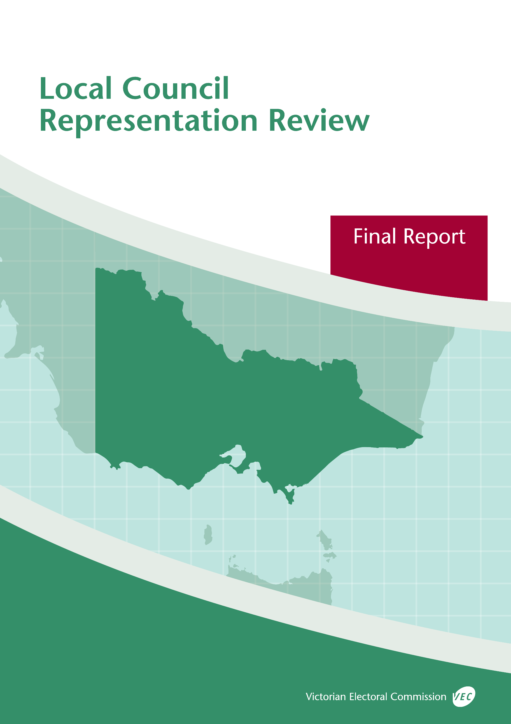



**Maroondah City Council**

**October 2019**

© State of Victoria (Victorian Electoral Commission)   
Wednesday 23 October 2019

Version 1  
  
cid:image001.png@01D4D431.F774F3F0

This work, Local Council Representation Review Final Report – Maroondah City Council, is licensed under a Creative Commons Attribution 4.0 licence [<http://creativecommons.org/licenses/by/4.0/>]. You are free to share this work under that licence, on the condition that you do not change any content and you credit the State of Victoria (Victorian Electoral Commission) as author and comply with the other licence terms. The licence does not apply to any branding, including Government logos.

Contents

Recommendation 1

Executive summary 2

Legislative basis 4

Public engagement 4

The VEC’s principles 5

Developing recommendations 6

Maroondah City Council representation review 8

Profile of Maroondah City Council 8

Current electoral structure 10

Preliminary submissions 11

Preliminary report 12

Public response 16

Response submissions 16

Public hearing 18

Findings and recommendation 20

The VEC’s findings 20

The VEC’s recommendation 22

Appendix 1: Public involvement 23

Appendix 2: Map 24

Appendix 3: Public information program 26

Recommendation

The Victorian Electoral Commission recommends that Maroondah City Council consist of nine councillors elected from three three-councillor wards, retaining the current electoral structure and boundaries.

This recommendation is submitted to the Minister for Local Government as required by the *Local Government Act 1989*.

Please see Appendix 2 for a detailed map of this recommended structure.

Executive summary

The *Local Government Act 1989* (the Act) requires the Victorian Electoral Commission (VEC) to conduct an electoral representation review of each municipality in Victoria before every third council general election.

The purpose of an electoral representation review is to recommend an electoral structure that provides fair and equitable representation for people who are entitled to vote at a general election of the council. The matters considered by a review are:

* the number of councillors
* the electoral structure of the council (whether the council should be unsubdivided or divided into wards and, if subdivided, the details of the ward boundaries and the number of councillors per ward).

The VEC conducts all reviews based on three main principles:

1. taking a consistent, State-wide approach to the total number of councillors
2. if subdivided, ensuring the number of voters represented by each councillor is within   
   plus-or-minus 10% of the average number of voters per councillor for that local   
   council
3. ensuring communities of interest are as fairly represented as possible.

Current electoral structure

Maroondah City Council currently comprises nine councillors elected from three three-councillor wards. More information on Maroondah City Council and the current electoral structure is available in the council fact sheet on the VEC website at [vec.vic.gov.au](http://vec.vic.gov.au).

Prior to the last representation review in 2008, Maroondah City Council was comprised of seven councillors elected from seven single-councillor wards. Visit the VEC website at [vec.vic.gov.au](http://www.vec.vic.gov.au/) to access a copy of the 2008 review final report.

Preliminary submissions

Preliminary submissions opened at the commencement of the current review on Wednesday   
3 July 2019. The VEC received eight submissions for the representation review of Maroondah City Council by the deadline at 5.00 pm on Wednesday 31 July 2019.

Preliminary report

A preliminary report was released on Wednesday 28 August 2019 with the following options for consideration:

* Option A (preferred option)  
  **Maroondah City Council consist of nine councillors elected from three wards, retaining the current electoral structure and ward boundaries (three three‑councillor wards).**
* Option B (alternative option)  
  **Maroondah City Council consist of nine councillors elected from three wards, with adjustments to the current ward boundaries (three three-councillor wards).**

Response submissions

The VEC received nine submissions responding to the preliminary report by the deadline at   
5.00 pm on Wednesday 25 September 2019.

Public hearing

The VEC conducted a public hearing for those wishing to speak about their response submission at 7.30 pm on Wednesday 2 October 2019. One person spoke at the hearing.

Recommendation

**The Victorian Electoral Commission recommends that Maroondah City Council consist of nine councillors elected from three three-councillor wards, retaining the current electoral structure and boundaries.**

This electoral structure was designated as Option A in the preliminary report. Please see Appendix 2 for a detailed map of this recommended structure.

Background

Legislative basis

The Act requires the VEC to conduct a representation review of each local council in Victoria before every third general council election, or earlier if gazetted by the Minister for Local Government.

The Act states that the purpose of a representation review is to recommend the number of councillors and the electoral structure that provides ‘fair and equitable representation for people who are entitled to vote at a general election of the Council.’[1]

The Act requires the VEC to consider:

* the number of councillors in a local council
* whether a local council should be unsubdivided or subdivided.

If a local council is subdivided, the VEC must ensure that the number of voters represented by each councillor is within plus-or-minus 10% of the average number of voters per councillor for that local council.[2] On this basis, the review must consider the:

* number of wards
* ward boundaries
* number of councillors that should be elected for each ward.

Public engagement

### Public information program

The VEC conducted a public information program to inform the community of the representation review, including:

* public notices printed in local and State-wide papers
* a public information session to outline the review process and respond to questions from the community
* media releases announcing the commencement of the review and the release of the preliminary report
* a submission guide to explain the review process and provide background information on the scope of the review
* an information email campaign targeted at known community groups and communities of interest in the local council area
* sponsored social media advertising geo-targeted to users within the local council   
  area
* ongoing information updates and publication of submissions on the VEC website.

More information on the VEC’s public information program for the representation review of Maroondah City Council can be found at Appendix 3.

### Public consultation

Public input was accepted by the VEC via:

* preliminary submissions at the start of the review
* response submissions to the preliminary report
* a public hearing that provided an opportunity for people who had made a response submission to expand on their submission.

Public submissions are an important part of the review process but are not the only consideration. The VEC ensures its recommendations comply with the Act and are formed through careful consideration of public submissions, independent research, and analysis of all relevant factors.

The VEC’s principles

Three main principles underlie all the VEC’s work on representation reviews:

1. **Taking a consistent, State-wide approach to the total number of councillors.**

The VEC is guided by its comparisons of local councils of a similar size and category to the council under review. The VEC also considers any special circumstances that may warrant the local council having more or fewer councillors than similar local councils.

1. **If subdivided, ensuring the number of voters represented by each councillor is within plus-or-minus 10% of the average number of voters per councillor for that local council.**

This is the principle of ‘one vote, one value’, which is enshrined in the Act. This means that every person’s vote counts equally.

1. **Ensuring communities of interest are as fairly represented as possible.**

Each local council contains a number of communities of interest. Where practicable, the electoral structure should be designed to ensure they are fairly represented, and that geographic communities of interest are not split by ward boundaries. This allows elected councillors to be more effective representatives of the people and interests in their particular local council or ward.

Developing recommendations

The VEC bases its recommendations for particular electoral structures on the following information:

* internal research specifically relating to the local council under review, including data from the Australian Bureau of Statistics and .id[3]; voter statistics from the Victorian electoral roll; and other State and local government data sets
* small area forecasts provided by .id for relevant local council areas
* the VEC’s experience conducting previous electoral representation reviews of local councils and similar reviews for State elections
* the VEC’s expertise in mapping, demography and local government
* careful consideration of all input from the public in written submissions received during the review and via oral submissions at the public hearing
* advice from consultants with extensive experience in local government.

### Deciding on the number of councillors

The Act allows for a local council to have between five and 12 councillors but does not specify how to decide the appropriate number.[4] In considering the number of councillors for a local council, the VEC is guided by the Victorian Parliament’s intention for fairness and equity in the local representation of voters under the Act.

The starting point in deciding the appropriate number of councillors for a local council is comparing the local council under review to other local councils of a similar size and type (Principle 1). Generally, local councils that have a larger number of voters will have a higher number of councillors. Often large populations are more likely to be diverse, both in the nature and number of their communities of interest and the issues of representation.

However, the VEC also considers the particular circumstances of each local council which could justify fewer or more councillors, such as:

* the nature and complexity of services provided by the Council
* geographic size and topography
* population growth or decline
* the social diversity of the local council.

### Deciding the electoral structure

The Act allows for a local council ward structure to be unsubdivided—with all councillors elected ‘at-large’ by all voters—or subdivided into a number of wards.

If the local council is to be subdivided into wards, there are three options available:

1. single-councillor wards
2. multi-councillor wards
3. a combination of single-councillor and multi-councillor wards.

A subdivided electoral structure must have internal ward boundaries that provide for a fair and equitable division of the local council.

The Act allows for wards with different numbers of councillors, as long as the number of voters represented by each councillor is within plus-or-minus 10% of the average number of voters per councillor for that local council (Principle 2). For example, a local council may have one   
three-councillor ward with 15,000 voters and two single-councillor wards each with 5,000 voters. In this case, the average number of voters per councillor would be 5,000.

Over time, population changes can lead to some wards in subdivided local councils having larger or smaller numbers of voters. As part of the review, the VEC corrects any imbalances and considers likely population changes to ensure ward boundaries provide equitable representation for as long as possible.

In considering which electoral structure is most appropriate, the VEC considers the following matters:

* the VEC’s recommendation at the previous representation review and the reasons for that recommendation
* the longevity of the structure, with the aim of keeping voter numbers per councillor within the 10% tolerance for as long as possible (Principle 2)
* communities of interest, consisting of people who share a range of common concerns, such as geographic, economic or cultural associations (Principle 3)
* the number of candidates in previous elections, as outcomes from previous elections indicate that large numbers of candidates can lead to an increase in the number of informal (invalid) votes
* geographic factors, such as size and topography
* clear ward boundaries.

Maroondah City Council representation review

Profile of Maroondah City Council

Maroondah City Council is located about 25 kilometres east of Melbourne’s CBD and covers approximately 61 square kilometres. The City of Maroondah is a predominantly residential area, with a concentration of industry in the south (Bayswater North) and semi-rural areas in the north.[5] It is bordered by Manningham City Council in the north, Yarra Ranges Shire Council in the east, Knox City Council in the south and Whitehorse City Council in the west.

The City of Maroondah’s traditional owners are the Wurundjeri people of the Kulin Nation. Maroondah is an Indigenous word meaning ‘leaf’, which symbolises the City of Maroondah’s green environment.[6] The City has 42 bushland reserves that offer residents and visitors the enjoyment of wildflowers, wildlife, bush walks and wetlands. Rolling topography, the presence of established trees and gardens, and views to the surrounding ridgelines are important features of living in this local council area.[7]

Maroondah City Council’s population was 110,376 at the 2016 Census. Croydon (with a population of 26,946) and Ringwood (17,471) are the two largest suburbs. Other suburbs include Ringwood East (10,265), Ringwood North (9,832), Heathmont (9,688), Bayswater North (8,789), Croydon North (7,860), Croydon Hills (4,992), Croydon South (4,572), Kilsyth South (2,988) and Warranwood (4,807). Parts of Vermont and Wonga Park are also within the local council area.

There are 21 local neighbourhood shopping centres and the City’s two largest activity centres are in Ringwood and Croydon.[8] The Ringwood Activity Centre includes Eastland Shopping Centre, which serves all of Melbourne’s eastern suburbs. According to the State Government’s planning strategy *Plan Melbourne*, which aims to manage growth in metropolitan Melbourne, the Ringwood Activity Centre is one of nine Metropolitan Activity Centres that will provide diverse jobs, activities and housing for regional catchments that are connected by public transport.[9] Metropolitan Activity Centres are the highest priority areas for commercial and residential development and renewal outside of Melbourne’s CBD.[10]

There are many businesses (about 9,000) operating in the City of Maroondah with small businesses comprising over 96% of these organisations. Most local businesses are in construction; property and business services; finance and insurance; retail trade; and manufacturing.[11] Another key employer of residents is Maroondah Hospital, located in Ringwood East, which provides secondary acute care and specialist adult mental health services for metropolitan Melbourne.[12]

The City of Maroondah’s residents are mainly employed in health care and social assistance (12.1%), retail trade (11.6%), manufacturing (11.5%), construction (10.4%) and education and training (8.5%). The most common occupations are professionals (23.7%), clerical and administrative workers (15.1%), technicians and trades workers (14.9%), managers (12.5%) and community and personal service workers (10.6%).[13]

The median age in the City of Maroondah is 38 years, which is slightly older than the median age of 36 years for Greater Melbourne generally. Overall, the City has a similar age profile to that of Greater Melbourne, except for a slightly higher proportion of residents aged 65 years and over, at approximately 15.5% compared to the average for Greater Melbourne at 13.6%.[14]

Approximately 23% of people in the City of Maroondah were born overseas. The top five countries of birth other than Australia are England (4%), China (excluding Special Administrative Regions and Taiwan) (2.7%), India (1.7%), Myanmar (1.6%) and New Zealand (1.2%). The top five languages other than English spoken in the City are Mandarin, Cantonese, Chin Haka, Italian and Hindi. Approximately 18.8% of households speak a language other than English at home.[15] Since 2013, the City of Maroondah has helped to resettle Burmese refugees in Victoria.[16] Overall, the percentage of the overseas-born population who are proficient in English (at 87.7%) is greater in the City of Maroondah compared to the average for Greater Melbourne at 85.9%.

The unemployment rate in the City of Maroondah is approximately 5.2%, which is lower than the unemployment rate for Victoria at 6.6%. The median weekly household income is $1,544, which is higher than the average median weekly household income for Victorians at $1,419, but similar to the average for households in Greater Melbourne at $1,542.[17]

The City of Maroondah ranks well on the Socio-Economic Index for Area (SEIFA) Index of Relative Socio-Economic Disadvantage.[18] The City has a score of 1,045, which places it above approximately 80% of local government areas across Victoria. There are some differences across the local council area. For example, while areas such as the activity centres in Ringwood and Croydon are more disadvantaged in the City of Maroondah, the suburb of Warranwood is the least disadvantaged.[19]

The population in the City of Maroondah has grown from 99,200 in 2006 to 110,376 in 2016. The population is forecast to grow at an annual average rate of 1.1% to reach 143,790 by 2036.[20]

Current electoral structure

Maroondah City Council currently comprises nine councillors elected from three three-councillor wards. More information on Maroondah City Council and the current electoral structure is available in the council fact sheet on the VEC website at [vec.vic.gov.au](http://vec.vic.gov.au).

Prior to the last representation review in 2008, Maroondah City Council was comprised of seven councillors elected from seven single-councillor wards. Visit the VEC website at [vec.vic.gov.au](http://www.vec.vic.gov.au/) to access a copy of the 2008 review final report.

Preliminary submissions

At the close of submissions on Wednesday 31 July 2019, the VEC received eight submissions for the representation review of Maroondah City Council. A list of people who made a preliminary submission can be found in Appendix 1.

### Number of councillors

Most submitters (six out of eight submitters) supported retaining nine councillors. Submitters’ preference for nine councillors was often in relation to the current electoral structure, which consists of three three-councillor wards. Three submitters (including Maroondah City Council) also commented that nine is an odd number and would continue to assist in avoiding tied votes during the Council’s decision-making.

Two submitters supported a different number of councillors. One submitter supported eight councillors to achieve four two-councillor wards. The other submitter supported an extra councillor for each ward, which would bring the total number of councillors to 12. This submitter reasoned that an additional councillor for each ward would better represent an ‘increasingly diverse’ City of Maroondah.

### Electoral structure

Almost all submitters (seven out of eight) supported the current multi-councillor ward electoral structure.

Submitters generally commented that multi-councillor wards were more likely to ensure that geographic communities of interest would be kept together. Submitters also noted that the proportional representation counting system provided voters with the option to support candidates representing geographic areas or candidates who represented interests spread across the local council area. Submitters were generally of the view that the current electoral structure promoted the representation of diverse interests and views among constituents and provided residents with a greater choice of councillors to approach. In addition, submitters often pointed out that multi-councillor wards were more likely to remain within the legislated tolerance of plus-or-minus 10% of the average number of voters-to-councillor across the local council area, compared to single-councillor wards.

The Proportional Representation Society of Australia (Victoria-Tasmania) Inc. (PRSA) supported the current arrangement of three three-councillor wards. The PRSA reasoned that multi-councillor wards with an equal number of councillors were inherently fairer as candidates across the local council area would need to reach the same quota of votes to be elected.

There was only one alternative electoral structure proposed in the submissions. Stephen Hickman from Croydon supported a change to eight councillors elected from four two-councillor wards. Mr Hickman reasoned that smaller wards would do more to ensure that local issues were represented on the Council.

Some submitters expressed opposition to single-councillor wards. These submitters were generally of the view that a single-councillor ward structure would not be able to represent the diverse views and interests among constituents as well as multi-councillor ward structures. No submitter supported returning to a single-councillor ward structure.

Three submitters also considered an unsubdivided structure as an alternative but ultimately favoured multi-councillor wards. The PRSA provided some support for a nine-councillor unsubdivided structure but considered that the total number of candidates at Maroondah City Council’s elections ‘ranging from 32 to 39’ would ‘clutter the ballot paper’. The PRSA reasoned that an unsubdivided structure would not be practical for the City’s voters who would need to number all boxes on their ballot paper for their votes to count. Similarly, Ian Ashman from Croydon believed that an unsubdivided structure would be ‘too large and unwieldy’ to allow for effective representation. Mr Hickman considered that an unsubdivided structure could make it easier for candidates with ‘party backing’ to gain election, while placing strong local candidates at a disadvantage.

Preliminary report

A preliminary report was released on Wednesday 28 August 2019. The VEC considered public submissions and research findings when formulating the options presented in the preliminary report.

### Number of councillors

The VEC considered that nine councillors continued to be appropriate for Maroondah City Council.

The VEC found that Maroondah City Council was at the lower end of the band of nine-councillor metropolitan local councils in terms of the voter­‑to‑councillor ratio. Despite this, the VEC did not consider there to be good reasons to reduce the number of councillors. The population is expected to continue growing steadily at an annual average rate of 1.1%, which is moderate for metropolitan local council areas.

The VEC also considered there to be no strong reasons to increase the number of councillors. The VEC noted that Maroondah City Council was growing at a moderate pace compared to other metropolitan local council areas. It also noted that the local council area was not distinctly large or densely populated and did not indicate more complex land use, which would suggest that there were more challenges for the Council and representational needs among constituents.

While the City of Maroondah’s population had become more culturally and linguistically diverse since the last review, the VEC noted that the City had a smaller percentage of people born overseas compared to Greater Melbourne generally.[21] The population born overseas in the City of Maroondah was also more likely to be proficient in English compared to the average for Greater Melbourne.[22] The SEIFA Index of Relative Socio-Economic Disadvantage score for Maroondah City Council further indicated that the City’s population was generally less socio-economically disadvantaged compared to many other local council areas in Victoria.[23] As a result, the VEC considered there was no need for more councillors based on these social characteristics and both options in the preliminary report continued with nine councillors.

### Electoral structure

The VEC’s analysis of Maroondah City Council’s last three general elections (2008, 2012 and 2016) indicated a relatively healthy democracy. This was demonstrated by measures such as a consistent and reasonable number of candidates, average informal voting rate, and a higher than average voter turnout compared with other local council elections across Victoria.

As part of its background research for this review, the VEC considered alternative multi-councillor models, including the one proposed in a preliminary submission, and found that they did not provide advantages compared to the current electoral structure.

**Option A: Retaining the current model**

Based on the support for the current model among submitters and the VEC’s findings that the current electoral structure appeared to be working well, the VEC presented the current structure unchanged as Option A. All wards in the current structure were comfortably within the legislated plus-or-minus 10% tolerance for their average voter-to-councillor ratio. Population projections indicated that none of the wards would likely move outside of the tolerance by the time of the next scheduled review prior to the 2032 Maroondah City Council general election.

There were also other potential benefits to retaining the current electoral structure. Continuing with the current structure would have no disruption for voters. The VEC reassessed the boundaries set at the last review and found that they still mainly followed clear and easily identifiable roads and natural features.

The VEC did, however, identify some potential drawbacks to the current electoral structure. Firstly, the suburb of Croydon is divided across all wards, suggesting that this geographic community of interest is divided and that there can be further improvements made to the boundaries in the current structure. Secondly, a small area of Heathmont is in Mullum Ward while most of Heathmont is in Arrabri Ward. Thirdly, a part of the current ward boundary in the Croydon area follows minor roads. These observations provided the basis for putting forward an alternative option in the preliminary report for the public to consider as part of this review.

**Option B: Alternative three three-councillor ward model**

During its modelling, the VEC considered several alternative electoral structures to the current model. The model put forward in the preliminary report as Option B was considered to be a viable alternative as it responds to the potential drawbacks of the current electoral structure (and Option A). Option B includes:

* all of Croydon and Croydon North in a proposed ‘East Ward’
* almost all of Ringwood, along with Ringwood North, Warranwood and Croydon Hills in a proposed ‘West Ward’.
* all of Heathmont, Bayswater North, Kilsyth South and Croydon South, along with most of Ringwood East, in a proposed ‘South Ward’.

Like Option A, this option would meet the legislated plus-or-minus 10% tolerance. The VEC considered that there were other potential advantages. In this option, Croydon would no longer be divided across three wards, but would be contained in a proposed ‘East Ward’ with Croydon North, and all of Heathmont united in a proposed ‘South Ward’.

The VEC also considered that Option B could be a better reflection of geographic communities of interest. For example, Warranwood, Croydon Hills and Ringwood North would be grouped with Ringwood, which contained the major activity centre in the local council area. The VEC considered that grouping these suburbs together in the proposed ‘West Ward’ could provide an alternative to the current ward composition to better reflect and support various communities of interest, as indicated by demographic information about those suburbs.

However, there were potential drawbacks to Option B. There was generally no indication in submissions of a desire to change the current boundaries and 20,615 voters (23% of the local council’s total enrolment) would be affected by the boundary changes proposed.

### Options

After careful consideration, the VEC put forward the following options:

* Option A (preferred option)  
  **Maroondah City Council consist of nine councillors elected from three wards, retaining the current electoral structure and ward boundaries (three three‑councillor wards).**
* Option B (alternative option)  
  **Maroondah City Council consist of nine councillors elected from three wards, with adjustments to the current ward boundaries (three three-councillor wards).**

**Ward names**

The VEC suggested ward names to identify the wards in Option B and invited comments from the community on these ward names as part of submissions responding to the preliminary report.

Public response

Response submissions

The VEC accepted submissions responding to the preliminary report from Wednesday 28 August 2019 until 5.00 pm on Wednesday 25 September 2019. The VEC received nine response submissions. A list of people who made a response submission can be found in Appendix 1. Table 1 indicates the level of support for each option.

|  |  |  |
| --- | --- | --- |
| Preferences expressed in response submissions | | |
| **Option A** | **Option B** | **Other** |
| 5* | 2 | 3† |

*This includes one submission supporting both Options A and B

†This includes one submission that supported either Option A or B or an unsubdivided electoral structure (which was not put forward as an option in the preliminary report)

### Number of councillors

Most submitters supported retaining nine councillors in relation to the current electoral structure. In an independent submission, Councillor Mike Symon of Ringwood stated that nine councillors continued to be ‘suitable for the size of Maroondah City Council’. Cr Symon reasoned that the current number was ‘neither too high nor too low’ and it would maintain an odd number of councillors, which would reduce the chance of tied votes at council meetings. Margaret Handte of Ringwood East believed that nine councillors were appropriate but noted that the number would need to be revised in the future based on population growth. The PRSA also supported nine councillors in relation to the current electoral structure, stating that proportional representation ‘works best’ when all wards return the same number of councillors.

There was one submitter (Robert Humphreys of Ringwood) who supported a different number of councillors. Mr Humphreys wanted more councillors to ‘give greater opportunity for a wider representation of views in the decision making’ on Maroondah City Council. Mr Humphreys proposed increasing the number of councillors to 15 overall, with either three five-councillor wards or five three-councillor wards. The VEC notes that this is outside the parameters prescribed by the Act, which requires a local council to comprise of between five and 12 councillors. As a result, Mr Humphreys preferred model was out-of-scope for this review.

### Electoral structure

A majority of submitters supported Option A. In its response submission, Maroondah City Council stated that the current electoral structure was serving the community well and had been supported by most submitters in this review.

Submitters supporting Option A commonly argued that this option would have no impact on voters whereas Option B would impact a significant number of voters and would cause disruption to the current arrangement.

Susan and Kevin Bailey of Croydon submitted in support of Option A over B because it could better ensure broad representation from diverse perspectives in the local council area, as well as minimise the likelihood of any particular interests dominating the Council. The Baileys did not support Option B, stating that adjusting ward boundaries to make them more ‘suburb specific’ would likely contribute to an ‘adversarial environment’ among voters and councillors in the City of Maroondah.

Cr Symon also supported Option A as it would have no impact on voters, while Option B (affecting over 20,000 voters) would have a flow-on impact on community groups and organisations that have ‘built up relationships of many years based on the current Ward structure’.

Cr Symon’s submission did not support the proposal in Option B to bring Warranwood and Croydon Hills into the proposed ‘West Ward’ with Ringwood and Ringwood North. Cr Symon stated that both Warranwood and Croydon Hills were areas developed to a lesser intensity than Ringwood and were in closer proximity to the activity centre in Croydon rather than Ringwood.   
Cr Symon also considered that the ‘long established area of Ringwood East’ south of the railway line in Mullum Ward was much closer and more accessible by transport to Ringwood, but in Option B, this area of Ringwood East would be placed in the proposed ‘South Ward’ and grouped with areas that have different demographic profiles.

In contrast, two submitters supported Option B. Adam Newman (from outside the local council area) commented that while Option A would minimise disruption, Option B would do more to recognise communities of interest. In Option B, Mr Newman argued that Croydon would not be divided across the existing wards but united. Mr Newman also supported the grouping of areas in the proposed ‘West Ward’ as almost all of Ringwood would be united in the ward, alongside Warranwood, Croydon Hills and Heathmont.

Shaun Ruigrok of Ringwood North also supported Option B, stating that it was a ‘better’ way to group the suburbs in the City of Maroondah. Mr Ruigrok suggested a minor boundary adjustment to Option B and added that the current ward names should be retained for Option B.

The submissions from the PRSA and Ms Handte each provided some support for an unsubdivided electoral structure, which was not put forward in the preliminary report as an option for this review. The PRSA emphasised its support for electoral structures requiring all candidates to reach the same quota of votes to be elected. The PRSA considered this to be the fairest arrangement. Ms Handte supported an unsubdivided electoral structure without detailed reasons but also supported multi-councillor wards in general, as they would encourage councillors to share their work and their skills.

Public hearing

The VEC conducted a public hearing for those wishing to speak about their response submission at 7.30 pm on Wednesday 2 October 2019 in the Council Chamber, City Offices, Braeside Avenue, Ringwood. The VEC heard from one speaker, Cr Symon who spoke to his personal submission.

At the public hearing, Cr Symon reiterated his support for Option A over Option B.

At the outset, Cr Symon agreed with the VEC’s preliminary finding that the most suitable number of councillors continued to be nine and reiterated his support for a three three-councillor ward structure. Cr Symon then noted that the three wards in Maroondah City Council’s current electoral structure were unlikely to require boundary adjustments in the next decade to accommodate population changes, as all wards were within the legislated plus-or-minus 10% tolerance. Cr Symon commented that although Mullum Ward (which he represented on the Council) currently had the lowest voter-to-councillor deviation of the three wards (at -2.64%), expected population growth in Ringwood would bring the voter-to-councillor ratio closer to the average number of voters per councillor across the local council area.

Regarding the representation of communities of interest, Cr Symon reiterated his support for Option A’s grouping of areas over Option B. Cr Symon stated that there were noticeable differences not only in the types of properties in Mullum Ward compared to Wyreena Ward, but also ‘the issues’ and ‘the focus’ of the two wards. Cr Symon commented that properties in Wyreena Ward, especially in Warranwood and Croydon Hills, were generally larger, with greater tree cover and less population density compared to Ringwood. Warranwood and Croydon Hills also included more areas with a Bushfire Management Overlay. Cr Symon commented that these two suburbs were better aligned with Croydon in the current Wyreena Ward rather than with Ringwood in the proposed ‘East Ward’ in Option B.

Cr Symon also argued that the part of Ringwood East north of the railway line in the current Mullum Ward was better placed in Mullum Ward than in the proposed ‘South Ward’ in Option B. Cr Symon commented that this area relied on the Ringwood Activity Centre and shared more interest with Ringwood than with the suburbs of Bayswater North and Kilsyth South. Cr Symon noted that Bayswater North and Kilsyth South were less established residential areas with younger families. Cr Symon reiterated that Option A better reflected the City’s voters and their issues than Option B.

The VEC’s public hearing panel questioned Cr Symon about the distribution of work among the current councillors in Option A and sought his thoughts on the effect on councillor workloads in Option B. Cr Symon responded that the workloads for current councillors tended to ‘go in waves’ depending on particular projects but was generally ‘balanced’ for councillors across all three wards. With Option B, however, Cr Symon considered that councillors in the proposed ‘East Ward’ would have a greater workload than those in the other two wards. In Option B, Cr Symon argued the inclusion of a part of Ringwood East in the proposed ‘South Ward’ would increase the workload for the three councillors in this ward, while the councillors for the proposed ‘West Ward’ would potentially have less work.

Findings and recommendation

The VEC’s findings

The VEC proposed two options in its preliminary report. Both options would provide fair and equitable representation in accordance with the Act. Each option had certain advantages and disadvantages, which were discussed in the preliminary report. At the final stage of the review, the VEC carefully considered both options in relation to its own research, the submissions received, the evidence given at the public hearing and, on balance, it considered that the no-change option (Option A) provided greater advantages to ensure fair and equitable representation for voters in Maroondah City Council.

### Numbers of councillors

Determining the number of councillors for Maroondah City Council was not a substantially disputed element of this review. The VEC recommends continuing with nine councillors. While Maroondah City Council is currently at the lower end of the band of metropolitan local council areas with nine councillors, the local council area is forecast to continue growing at a moderate rate. The VEC considers that there is no justification for reducing the number of councillors.

The VEC’s analysis and the submissions did not identify any special circumstances that would justify increasing the number of councillors. The VEC’s research indicated that the local council area is mostly residential with an industrial area concentrated in the south. Land use in the City of Maroondah did not indicate a level of complexity that would warrant more councillors. The VEC also found that the City of Maroondah is less socio-economically disadvantaged compared to most other local council areas in Greater Melbourne. These findings reinforced the view that Maroondah City Council did not require more councillors. The VEC therefore recommends continuing with nine councillors.

### Electoral structure

At the preliminary stage, the VEC found that the current electoral structure provided fair and equitable representation and presented this structure as Option A in the preliminary report. The VEC also developed Option B to test whether the same electoral structure with alternative ward boundaries could better reflect communities of interest in the City of Maroondah. For this final stage of the review, the VEC considers Option A to be the most appropriate option.

The VEC did not consider Option B to be the better option for a range of reasons. Firstly, there was no evidence that the current structure was not delivering fair and equitable representation in the City of Maroondah. Instead, most submitters indicated that the current structure was working well and supported Option A. The VEC noted Option B would disrupt 20,615 voters (approximately 23% of Maroondah City Council voters) for little benefit. Further, and in light of the positive feedback received about Option A, the VEC reasoned that there were no compelling circumstances to warrant change.

The VEC considered Option A to be the more appropriate option as it would have no impact on voters and retained an electoral structure that was comfortably meeting the legislated requirements prescribed by the Act.

The VEC also considered Option A to be the more appropriate option because there was evidence that Option B would not represent communities of interest as well as Option A. At the public hearing, Cr Symon commented that Option B would group areas in a way that was not as reflective of communities of interest. Cr Symon commented especially on the boundary changes that would bring Warranwood and Croydon Hills into the proposed ‘West Ward’ with Ringwood. Cr Symon believed that Warranwood and Croydon Hills were better represented in the current Wyreena Ward as these two suburbs were more likely to rely on the Croydon Activity Centre and shared more in common with other areas in Wyreena Ward. Ringwood, Cr Symon noted, had a distinctly urban character and a different demographic profile compared to Warranwood and Croydon Hills.

The VEC considered Maroondah City Council’s planning scheme as well as relevant maps, which indicated that the northern sections of the City of Maroondah, including Warranwood, Croydon Hills and Croydon North, included more areas under a Bushfire Management Overlay, compared to the south of the City.[24] This suggested that the northern parts of the City had different issues and considerations compared to other areas of the City. Therefore, the VEC considered that the northern and eastern parts of the local council area were more likely to be better represented as a community of interest in Wyreena Ward in Option A.

Demographic information about the suburbs also supported the view that there were differences between Warranwood and Croydon Hills compared to Ringwood. Ringwood is more culturally and linguistically diverse with about 23% of residents born overseas. In contrast, in Warranwood, 17.3% of residents were born overseas, and 15.7% in Croydon Hills.[25] Ringwood has a distinctly higher unemployment rate at 6.8% than the rest of the local council area.[26] The Ringwood Metropolitan Activity Centre also has a more urban character to the rest of the local council area and, over time, will support more apartments and higher density living. This demographic information provided support for the view that Warranwood and Croydon Hills shared less in common with Ringwood and were better represented in Option A. As such, the VEC considered Ringwood and its specific needs to be better represented in Option A.

The VEC had considered that Option B could present a possible improvement to the current structure by encompassing the whole of Croydon in the proposed ‘East Ward’. A few submitters commented that wards which grouped the major suburbs were a positive feature of Option B. However, the VEC received few submissions in support of this option, and no substantial opposition from the community to the current electoral structure and its division of Croydon between the three wards.

While the VEC did not receive a large number of submissions in this review (eight preliminary and nine response submissions), most submitters supported Option A, and stronger arguments were presented in support of this option. The VEC noted that there was no substantial opposition to the current electoral structure. Based on the submissions and its research, the VEC considered that Option A would continue to best represent the communities of interest in the City of Maroondah.

The VEC’s recommendation

**The Victorian Electoral Commission recommends that Maroondah City Council consist of nine councillors elected from three three-councillor wards, retaining the current electoral structure and boundaries.**

This recommendation is submitted to the Minister for Local Government as required by the *Local Government Act 1989*. The model was designated as Option A in the VEC’s preliminary report for this review.

Please see Appendix 2 for a detailed map of this recommended structure.

# Appendix 1: Public involvement

Preliminary submissions

Preliminary submissions were made by:

Ashman, Ian

Baber, Margaret J

Heathmont History Group

Hickman, Stephen

Humphreys, Robert

Maroondah City Council

Proportional Representation Society of Australia (Victoria-Tasmania) Inc.

Sammons, Justin-Paul

Response submissions

Response submissions were made by:

|  |
| --- |
| Ashman, Ian |
| Bailey, Susan and Kevin |
| Handte, Margaret |
| Humphreys, Robert |
| Maroondah City Council |
| Newman, Adam |
| Proportional Representation Society of Australia (Victoria-Tasmania) Inc. |
| Ruigrok, Shaun |
| Symon, Mike (Councillor) |

Public hearing

The following individuals spoke at the public hearing:

Symon, Mike (Councillor)

# Appendix 2: Map

The map is provided on the next page.

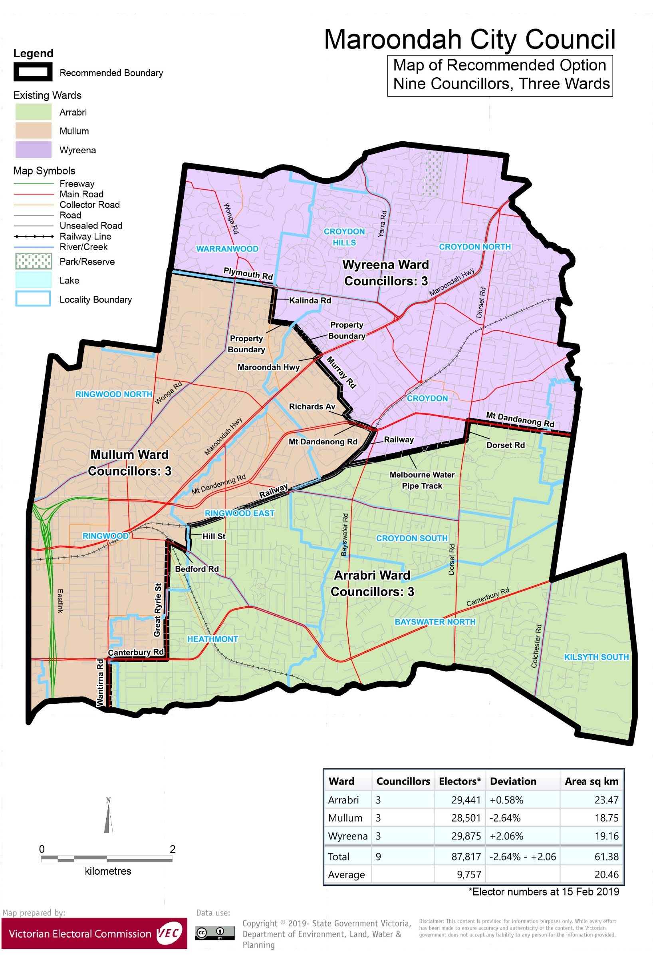

# Appendix 3: Public information program

Advertising

In accordance with the Act, public notices of the review and the release of the preliminary report were placed in the following newspapers:

|  |  |  |
| --- | --- | --- |
| **Newspaper** | **Notice of review** | **Notice of preliminary report** |
| *Herald Sun* | Thursday 6 June | Wednesday 7 August |
| *Maroondah Leader* | Tuesday 25 June | Tuesday 27 August |

Media releases

A media release was prepared and distributed to local media to promote the commencement of the review. A further release was distributed with the publication of the preliminary report. A final media advisory was circulated on the publication date of this final report.

Public information session

A public information session for people interested in the review process was held on Thursday 4 July 2019 in the Council Chamber, City Offices, Braeside Avenue, Ringwood.

Submissions guide

A submission guide was developed and made available on the VEC website, or in hardcopy on request, throughout the review timeline. The submission guide provided information about the review, the review timeline and how to make submissions to the review.

Online submission tool

An online submission tool was developed and made available during the submission periods of the review. The tool allowed people to make a submission from the VEC website. During the preliminary submission stage, users also had the opportunity to map out their preferred subdivisions through the online submission tool using Boundary Builder. Boundary Builder included real elector numbers so that users could see if their preferred structures and numbers of councillors met the plus-or-minus 10% rule.

VEC website

The VEC website delivered up-to-date information to provide transparency and facilitate public participation during the review process. All public submissions were published on the website.

Email and social media engagement

The VEC delivered an information email campaign targeted at known community groups and communities of interest in the local council area. This included a reminder email at each milestone of the representation review process.

The VEC also published sponsored social media advertising that was geo-targeted to users within the local council area. This included advertising at both the preliminary submission and response submission stages. The total reach of these posts was 8,420 during the preliminary submission stage and 7,390 during the response submission stage.

Council communication resources

The VEC provided the Council with a communication pack that included information on the review in various formats. While the council is encouraged to distribute this information and raise awareness about the review, the VEC is an independent reviewer and all communications resources include reference and links to the VEC website and core materials.

This page has been left intentionally blank

This page has been left intentionally blank

This page has been left intentionally blank

This page has been left intentionally blank

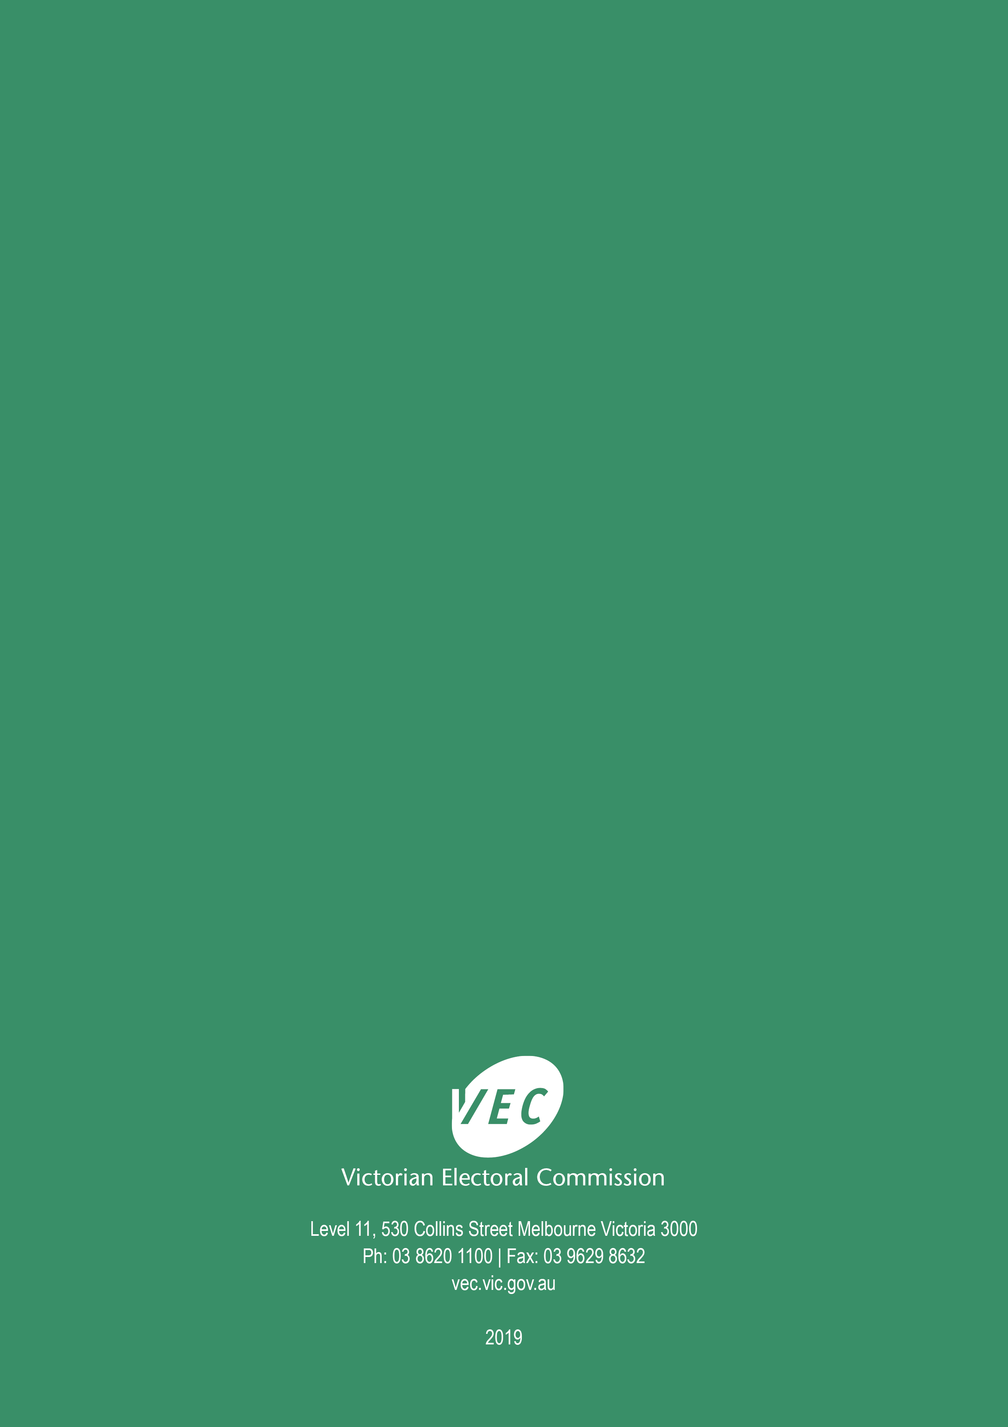

1. Section 219D of the *Local Government Act* *1989.*
2. Ibid.
3. .id is a consulting company specialising in population and demographic analysis and prediction information products in most jurisdictions in Australia and New Zealand.
4. Section 5B(1) of the *Local Government Act 1989.*
5. Know Your Council, ‘Maroondah City’, Department of Environment, Land, Water and Planning, State Government of Victoria, accessed 21 August 2019, <https://knowyourcouncil.vic.gov.au/councils/maroondah>.
6. Maroondah City Council, ‘Interesting facts’, accessed 21 August 2019, <http://www.maroondah.vic.gov.au/Explore/About-our-city/Interesting-facts>.
7. Maroondah City Council, ‘Neighbourhood character study’, accessed 21 August 2019, <http://www.maroondah.vic.gov.au/Development/Planning/Planning-Framework/Neighbourhood-character-study>.
8. Maroondah City Council, Council Plan 2017-2021, Maroondah City Council, 2017, p.6, accessed 21 August 2019, <http://www.maroondah.vic.gov.au/files/assets/public/documents/strategies/council-plan-2017-2021-year-1-2017-18.pdf>.
9. Department of Environment, Land, Water and Planning (DELWP), *Plan Melbourne 2017-2050*, State Government of Victoria, (2017), p. 14, accessed 21 August 2019, <https://www.planmelbourne.vic.gov.au/__data/assets/pdf_file/0007/377206/Plan_Melbourne_2017-2050_Strategy_.pdf>.
10. Maroondah City Council, ‘Ringwood Metropolitan Activity Centre’, Maroondah City Council, accessed 18 June 2019, <http://www.maroondah.vic.gov.au/Development/Developing-Maroondah/Planning-for-future-development/Ringwood-Metropolitan-Activity-Centre>. Department of Environment, Land, Water and Planning, ‘Activity centres overview’, accessed 21 August 2019, <https://www.planning.vic.gov.au/policy-and-strategy/activity-centres/activity-centres-overview>.
11. Maroondah City Council, *Council Plan 2017-2021*, Maroondah City Council, 2017, p.11.
12. Eastern Health, ‘Maroondah Hospital’, accessed 22 August 2019, <https://www.easternhealth.org.au/locations/maroondah-hospital>.
13. Australian Bureau of Statistics (ABS), ‘Data by Region: Maroondah (C) (LGA) (24410)’, accessed 21 August 2019, <https://itt.abs.gov.au/itt/r.jsp?RegionSummary&region=24410&dataset=ABS_REGIONAL_LGA2018&geoconcept=LGA_2018&maplayerid=LGA2018&measure=MEASURE&datasetASGS=ABS_REGIONAL_ASGS2016&datasetLGA=ABS_REGIONAL_LGA2018&regionLGA=LGA_2018&regionASGS=ASGS_2016>.
14. ABS, ‘Data by Region: Maroondah (C) (LGA) (24410)’.
15. ABS, ‘2016 Census Quickstats: Maroondah (C)’, accessed 21 August 2019, <https://quickstats.censusdata.abs.gov.au/census_services/getproduct/census/2016/quickstat/LGA24410?opendocument>.
16. The City of Maroondah became a Refugee Welcome Zone in 2013. These zones are local government areas that have chosen to make a commitment to welcoming refugees into the community. See Refugee Council of Australia, ‘Refugee Welcome Zones’, Refugee Council of Australia, accessed 19 June 2019, <https://www.refugeecouncil.org.au/refugee-welcome-zones/>. The number of people born in Myanmar in the City of Maroondah was 2,580 at the 2016 Census.
17. ABS, ‘2016 Census Quickstats: Maroondah (C)’.
18. The City of Maroondah is in the ninth decile in Victoria. See, ABS, *Census of Population and Housing: Socio-Economic Indexes for Areas (SEIFA), Australia, 2016*, 2033.0.55.001. Socio-Economic Indexes for Areas (SEIFA) is developed by the Australian Bureau of Statistics (ABS) to rank areas in Australia according to relative socio-economic advantage and disadvantage. The rankings use variables, such as income, education, employment, occupation and housing, derived from Census data to indicate relative socio-economic advantage and disadvantage for particular areas, including Local Government Areas, <https://www.abs.gov.au/ausstats/abs@.nsf/mf/2033.0.55.001>, accessed 15 August 2019.
19. For the City of Maroondah’s SEIFA Index of Disadvantage scores see: .id, ‘City of Maroondah: SEIFA by profile area’, accessed 21 August 2019, <https://profile.id.com.au/maroondah/seifa-disadvantage-small-area>.
20. Department of Environment, Land, Water and Planning (Victoria), *Victoria in Future 2019: population projections 2016 to 2056*, Melbourne: State Government of Victoria, 2019, p. 12.
21. At the 2016 Census, about 31% of the population were born overseas in Greater Melbourne compared to 23% in the City of Maroondah. ABS, ‘Data by Region Maroondah (C) (LGA) (24410)’. See also, ABS, ‘Data by Region Greater Melbourne (GCCSA) (2GMEL)’, accessed 12 August 2019, <https://itt.abs.gov.au/itt/r.jsp?RegionSummary&region=2GMEL&dataset=ABS_REGIONAL_ASGS2016&geoconcept=ASGS_2016&measure=MEASURE&datasetASGS=ABS_REGIONAL_ASGS2016&datasetLGA=ABS_REGIONAL_LGA2018&regionLGA=LGA_2018&regionASGS=ASGS_2016>.
22. ABS, ‘Data by Region Maroondah (C) (LGA) (24410)’. ABS, ‘Data by Region Greater Melbourne (GCCSA) (2GMEL)’.
23. .id, ‘City of Maroondah: SEIFA by profile area’.
24. For relevant maps showing Bushfire Management Overlays in the City of Maroondah, see: Department of Environment, Land, Water and Planning (DELWP), ‘Maroondah Planning Scheme’, accessed 8 October 2019, <http://planning-schemes.delwp.vic.gov.au/schemes/maroondah/maps>.
25. See for example, .id, ‘Ringwood: birthplace’, accessed 8 October 2019, <https://profile.id.com.au/maroondah/birthplace?WebID=180>.
26. See ABS, ‘2016 Census Quickstats’ for Warranwood, Croydon Hills, Croydon North, Croydon and Ringwood.